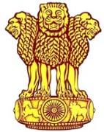 | Embassy of India  Ashgabat  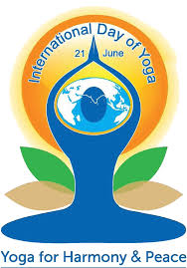 | 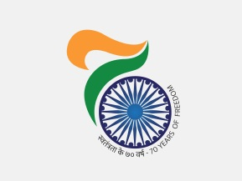

4th International Day of Yoga (IDY): Shanti Mantra Recitation

June 21 has been recognized by UN as International Day of Yoga (IDY). This was the fourth year of the International Day of Yoga. To encourage maximum participation of the local Turkmens, IDY celebration was held on 17th June, 2018 (Sunday) at the Yoga & Traditional Medicine Centre, Bagtyyarlyk Sports Complex in Ashgabat.

To conclude the 4th IDY celebrations, a special Shanti Mantra (Mantra for Peace) recitation session was organized in Chancery premise on June 21 2018. Ambassador H. E. Azar A H Khan accompanied by other Embassy official recited participated in the event.
***

