PRESS RELEASE

CELEBRATION OF INTERNATIONAL DAY OF YOGA

The International Day of Yoga was celebrated in Minsk on Saturday, June 16, 2018. The event was attended by several government officials of Belarus. There was a sizeable presence of Diplomatic community, enthusiastic yoga practitioners and admirers as well as Indians living in Belarus.

The programme began with a brief introductory speech by Ambassador, followed by speeches by the Mayor of Minsk – our Chief Guest at the event who made an appearance for the very first time – and the UNICEF Resident Representative to the gathered audience. Despite the cold and rainy weather, a crowd of around 300 people gathered to participate and observe. The CYP, conducted and led by the TIC posted in this Mission and representatives of most Yoga Studios based in Minsk, was followed by some innovative additions. Not only did Embassy organize a painting competition for children with the theme of ‘Sun as the source of Energy and Yoga’; there also held a comparative demonstration of similarities between the mudras and asanas of Yoga with classical Indian dance postures, a ‘Yoga for Children’ demo by kids under the age of 12, an electrifying performance of aerial Yoga by a couple who are leading practitioners of Yoga in Minsk, and a Surya Namaskar challenge that attracted almost a hundred participants who completed either 28 or 54 rounds and were accordingly awarded silver or gold certificates by the Embassy.

The Belarusian media gave excellent coverage to IDY celebrations on the days leading up to June 16 through broadcasting Ambassador’s interviews, mentioning the event during their news hour and running ticker-tapes on the screen, and also turning out in good numbers on the day itself. Some links to the media coverage and a few photographs are provided below:

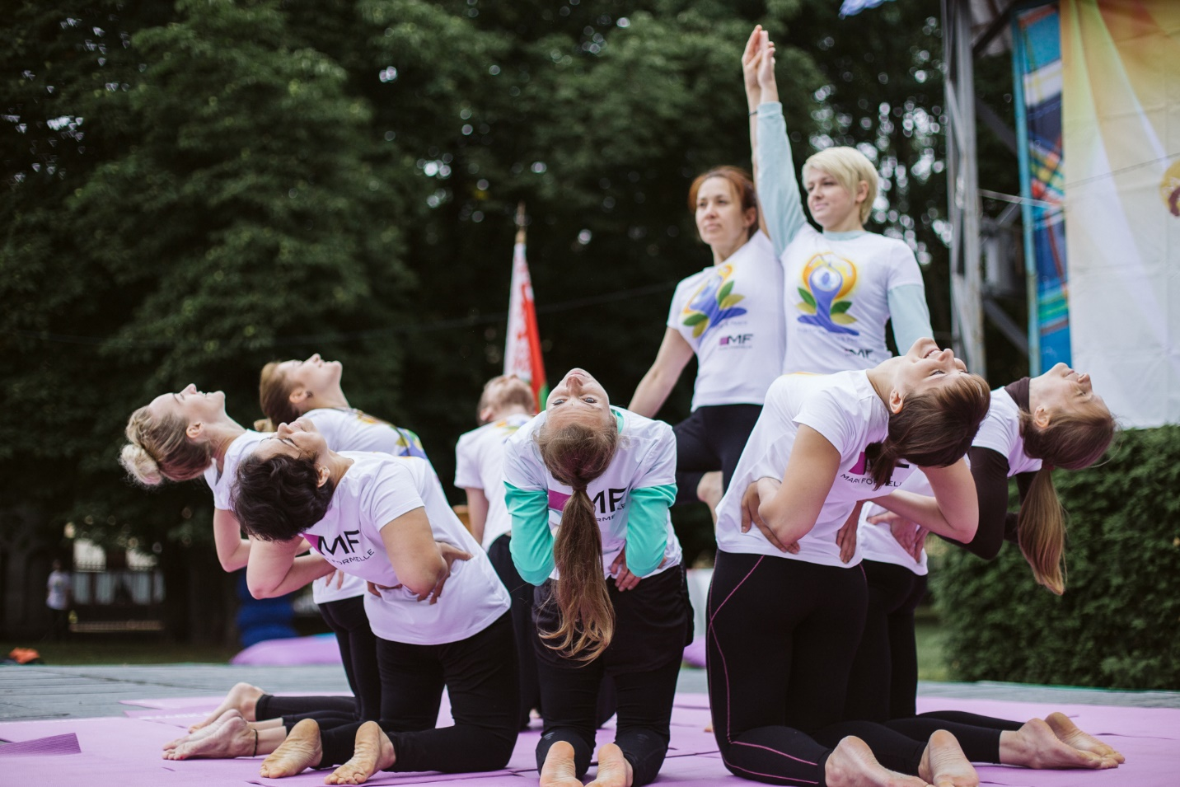
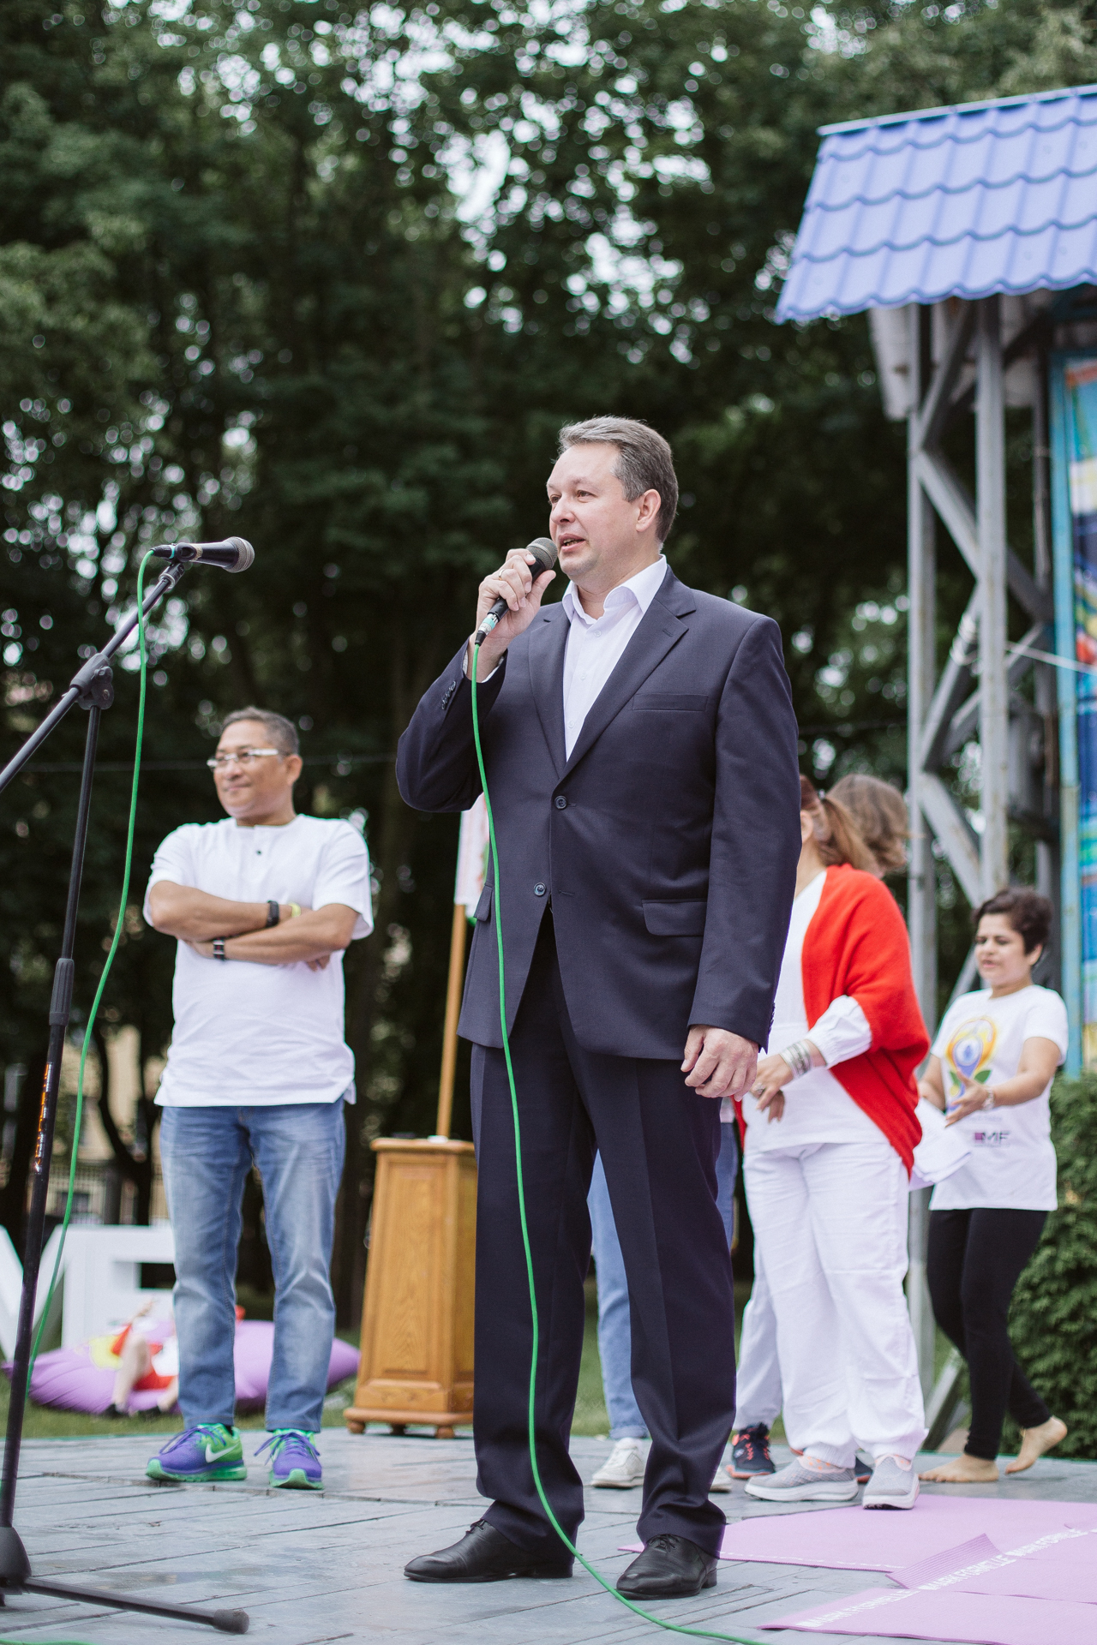

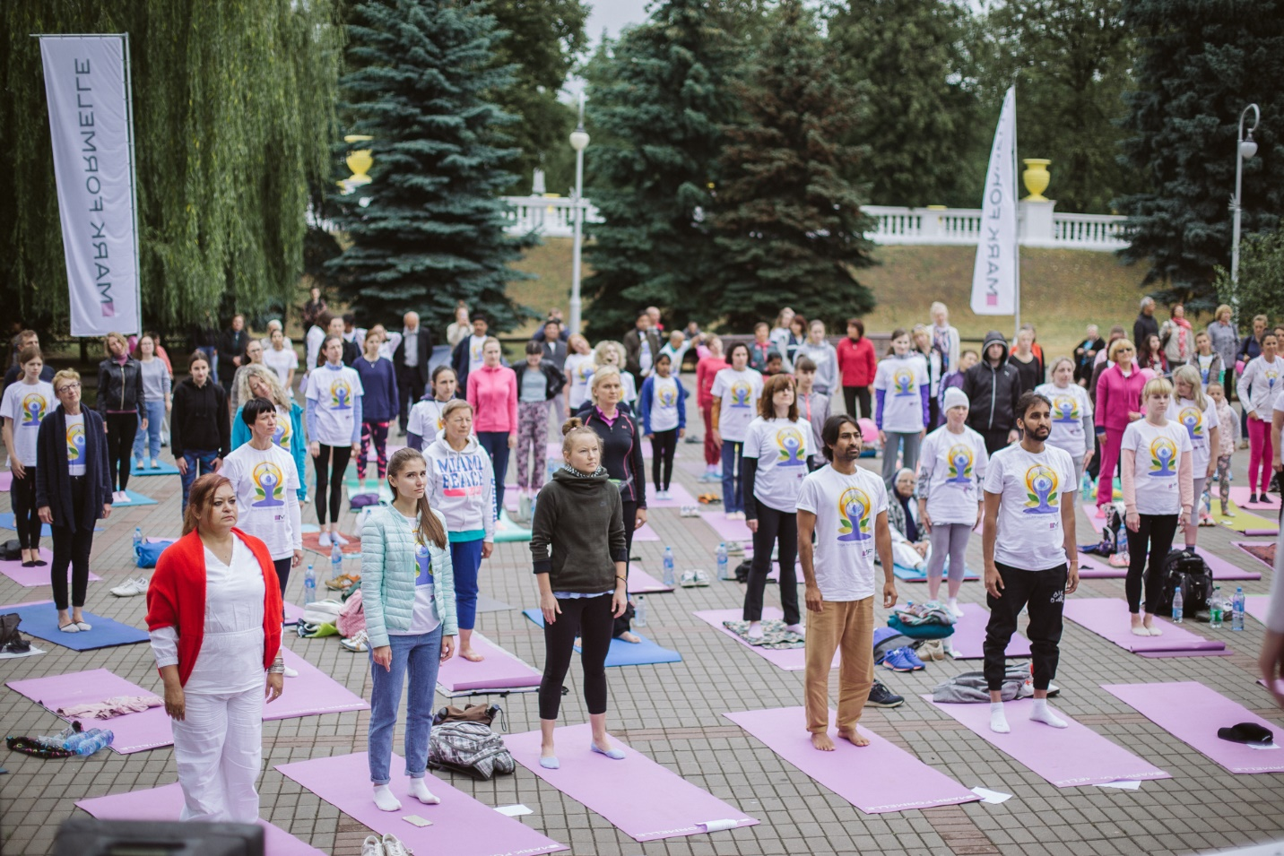

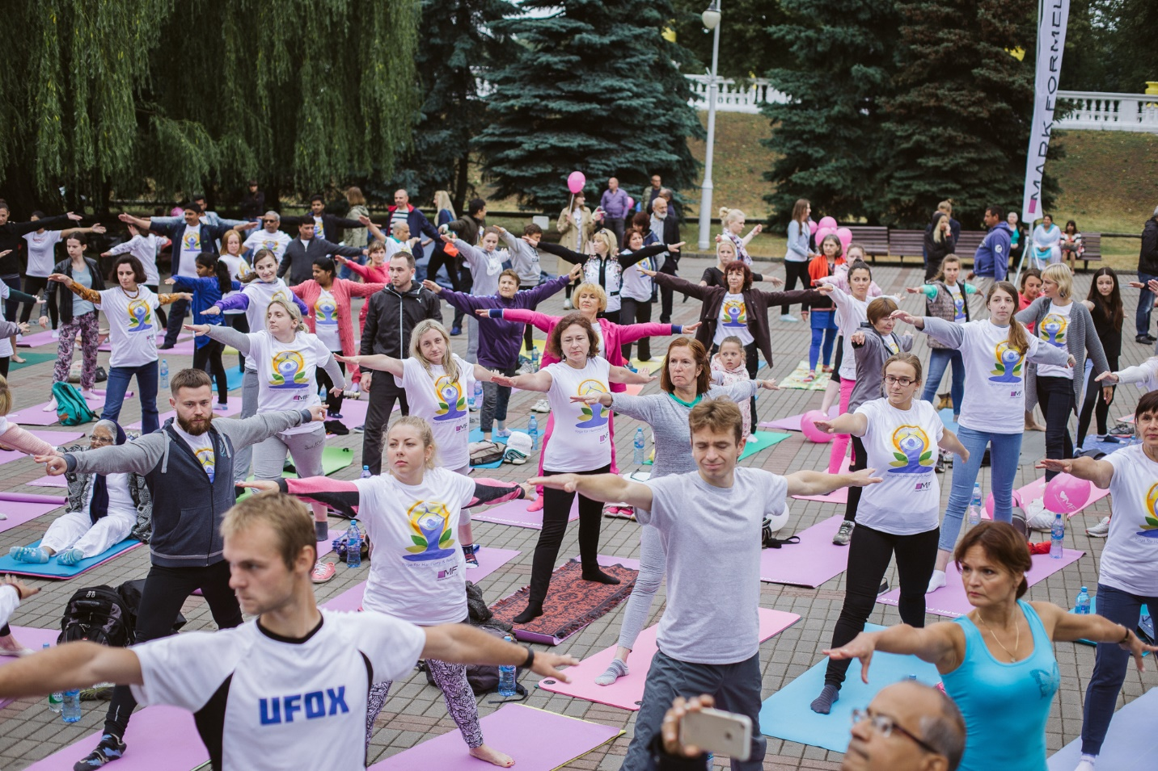

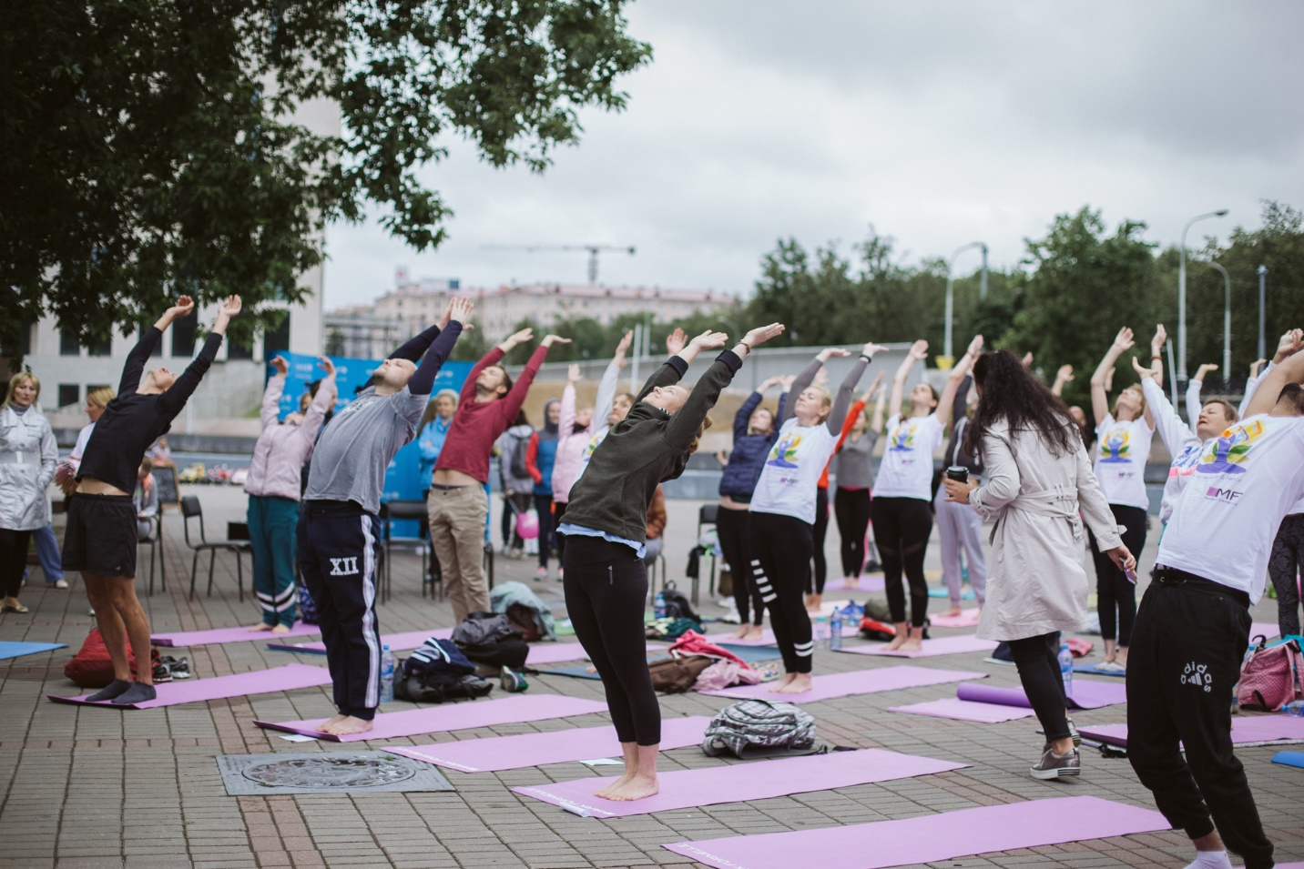

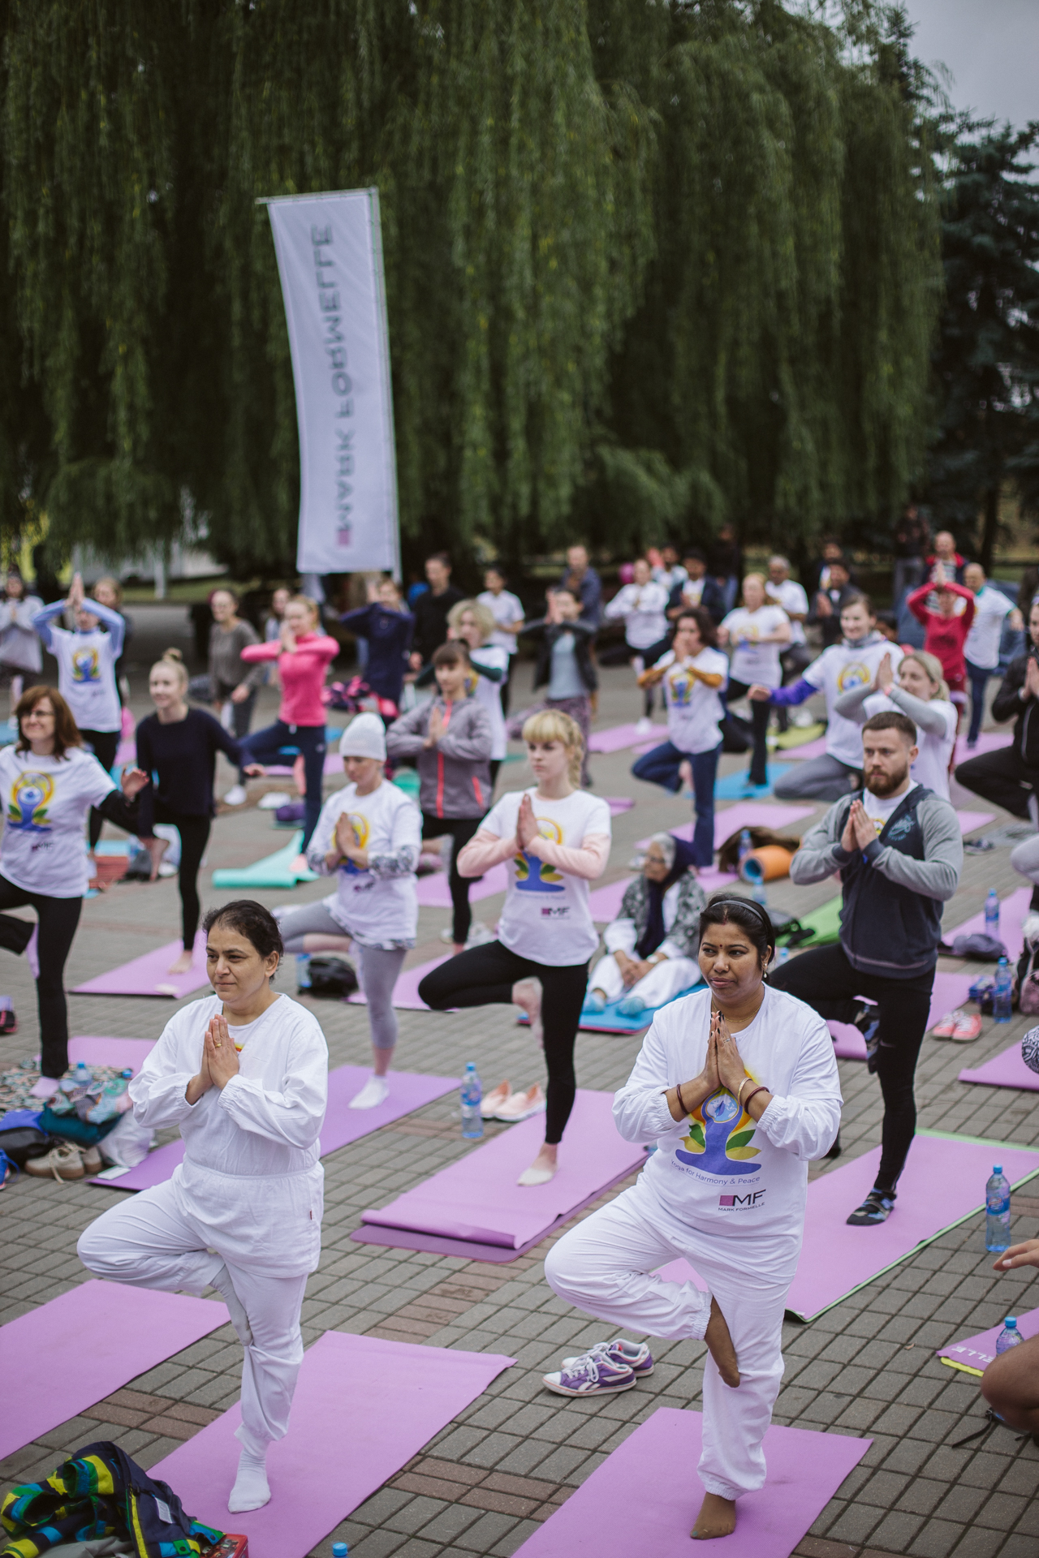
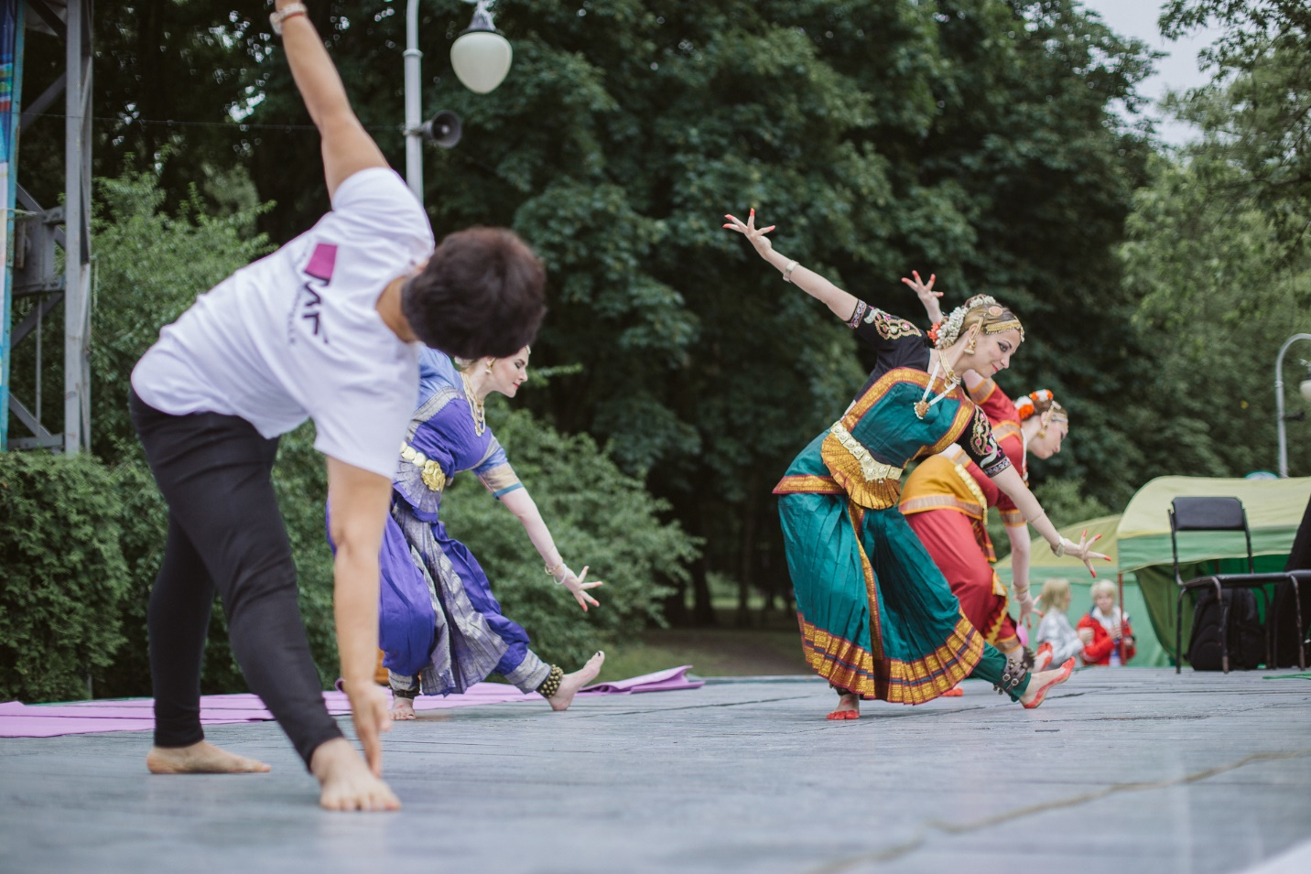

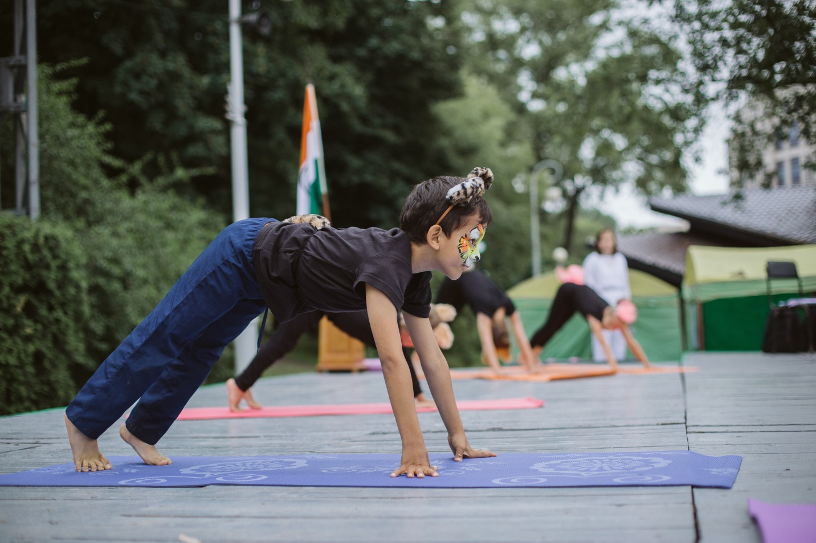

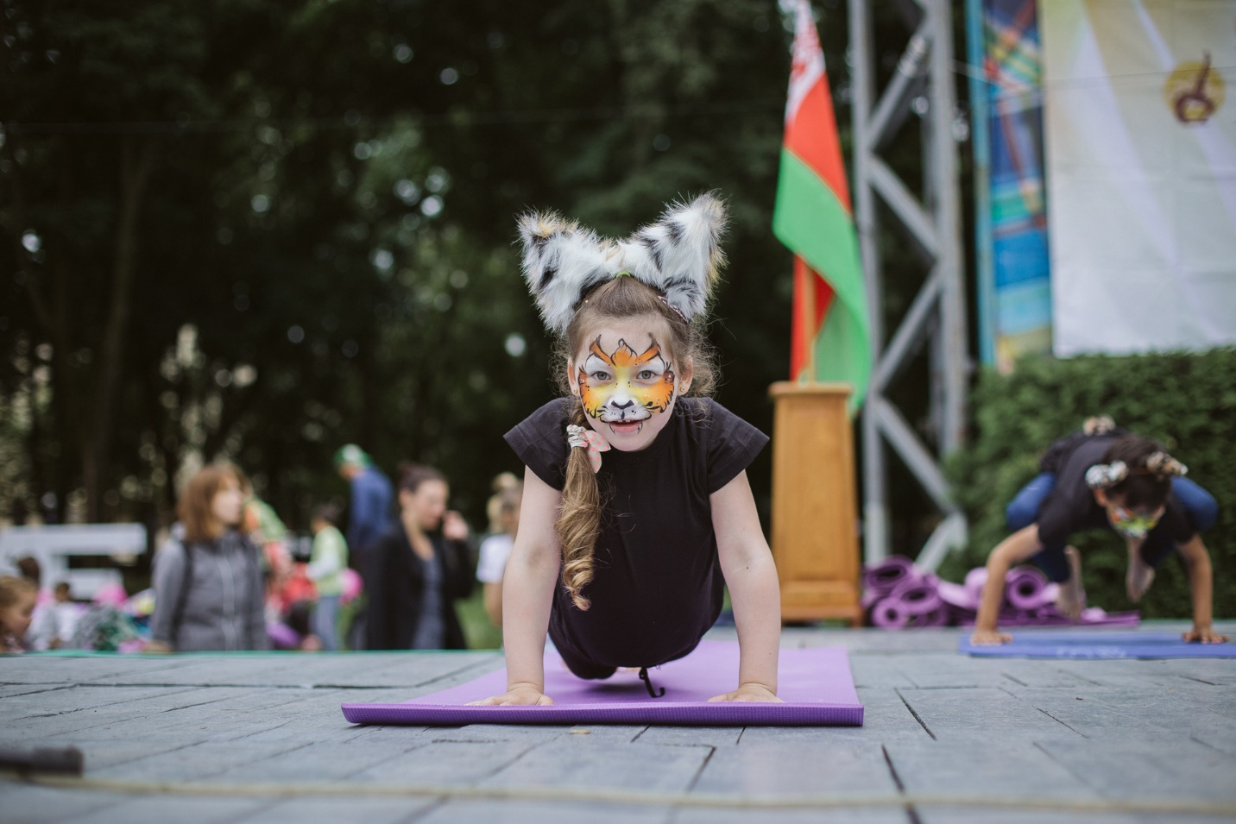

https://news.tut.by/go/597264.html
https://www.google.by/amp/s/sputnik.by/amp/lifestyle/20180616/1036050082/minsk-den-jogi-foto.html
http://www.belta.by/printv/regions/view/fotoreportazh-den-jogi-otprazdnovali-v-minske-307109-2018/

17 June 2018

