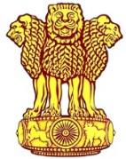 | Embassy of India  Ashgabat  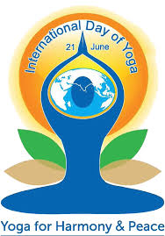 | 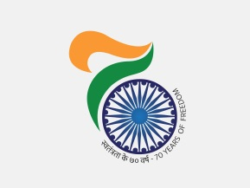

4th International Day of Yoga (IDY) celebrated in Ashgabat, Turkmenistan, on 17th June 2018

June 21 has been recognized by UN as International Day of Yoga (IDY). This was the fourth year of the International Day of Yoga. To encourage maximum participation of the local Turkmens, IDY celebration was held on 17th June, 2018 (Sunday) at the Yoga & Traditional Medicine Centre, Bagtyyarlyk Sports Complex in Ashgabat. The ceremony started at 0730 hrs with great joy and enthusiasm. A gathering of more than 700 yoga practitioners including senior officers of local Foreign Office and other Turkmen Officials, local and foreign nationals, students of State Medical University and the Diplomatic community participated in the event. Ambassador of India H. E. Mr. Azar A. H. Khan and the Deputy Minister of Healthcare and Medical Industry H.E. Mr. Tacmyrat Siliyev inaugurated the Yoga Day Celebrations.

The entire Yoga Protocol, led by the Indian Yoga teacher, was performed by the participants in the beautiful surroundings of Bagtyyarlyk Sports Complex. Later, special performance of highly advanced Yoga postures was presented by a group of 6 practitioners. A cultural local Turkmen dance performance by young Turkmen boys & girls made the occasion more festive. PM’s Message on 4th IDY followed by updated Common Yoga Protocol (CYP) was screened on the big electronic screen at the venue.

In run up to the 4th IDY, the Embassy also conducted a special quiz competition on June 09, 2018. Winners of the competition were given prizes during the IDY celebration on June 17, 2018.
***

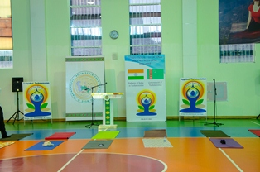
4th International Day of Yoga
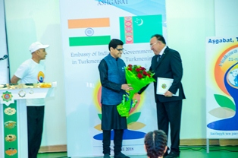
4th IDY Ambassador of India to Turkmenistan welcoming the chief Guest Deputy Minister of Healthcare and Medical Industry H.E. Mr. Mr. Tacmyrat Siliyev
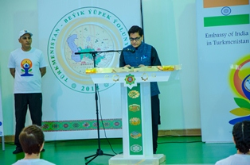
4th IDY Ambassador of India to Turkmenistan H. E. Mr. Azar A H Khan addressing the audience

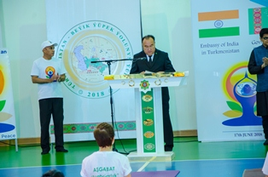
4th IDY Chief Guest H.E. Mr. Tacmyrat Siliyev addressing the audience

 | 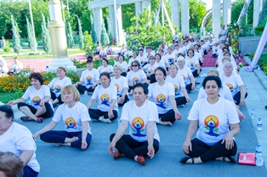
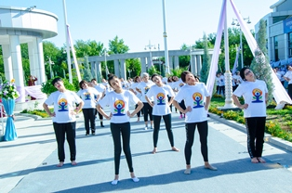 | 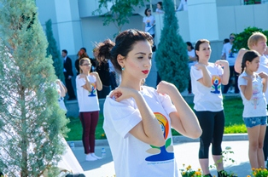
4th IDY: Performance of Yoga Protocol

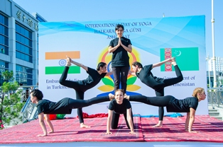 | 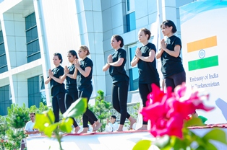
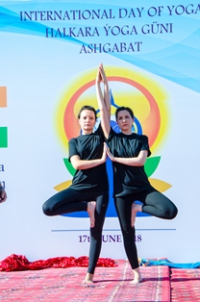 | 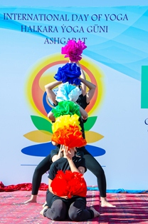
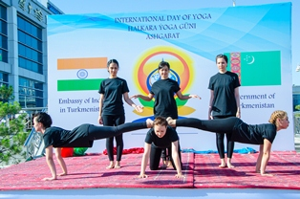 | 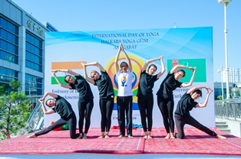
4th IDY Special Performance by 6 Yoga Practitioners

4th IDY: Cultural Performance

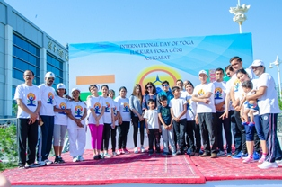
4th IDY: Embassy Family
***

