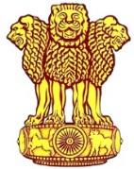 | Embassy of India  Ashgabat | 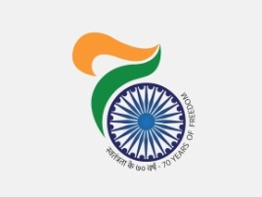

Ambassador pays a courtesy call on Foreign Minister of Turkmenistan.
Ambassador H.E. Mr. Azar A.H.Khan called on H.E. Mr. Rashid Meredov, Chairman of the Cabinet of Ministers and Foreign Minister and presented copies of his credentials.
During the meeting both side discussed and reviewed different aspects of friendly and historic bilateral relations, ongoing projects including inauguration of the next phase of TAPI Gas pipeline project scheduled on February 23, 2018.

February 5, 2018, Ashgabat

