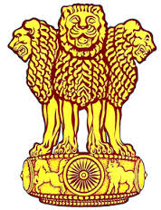
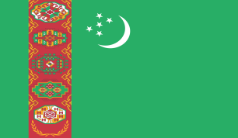
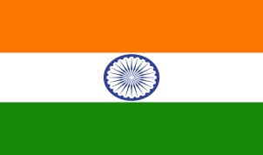

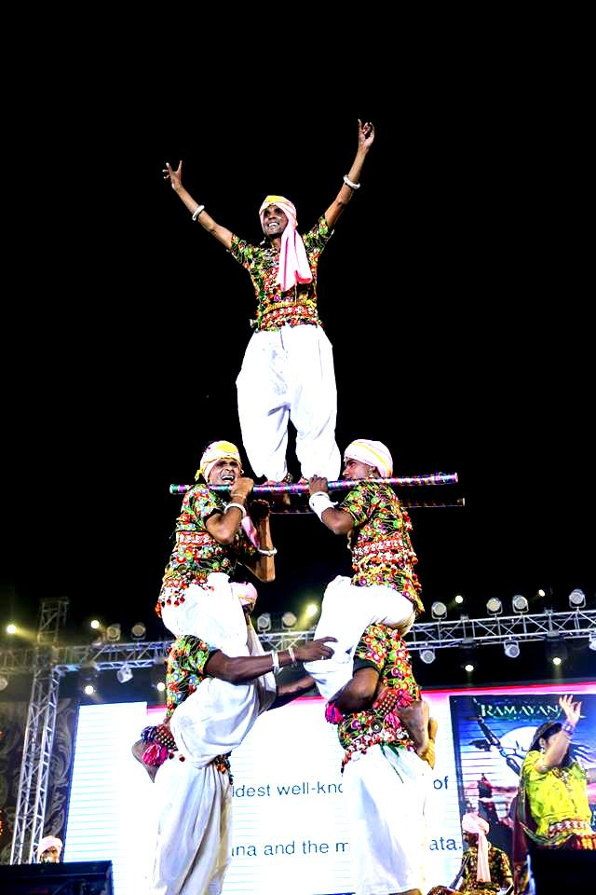
I
N
D
I
A
@
70

To celebrate 70 years of Independence of India and Silver Jubilee of India - Turkmenistan Diplomatic Relations. Embassy of India in Ashgabat in collaboration with Ministry of Culture, India, and Government of Turkmenistan presents
Folk Dance by “Nepanagar Jagruti Kala Kendra”

Schedule
Date: Thursday, 23rd November,2017  Time: 1900 hrs.  Venue: Watan Kino Theatre, Ashgabat | Date : Friday, 24th November,2017  Time: 1900 hrs.  Venue: State Drama Threatre named after Kemine, Mary
Entry free

