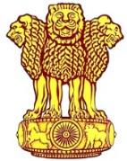 | Embassy of India  Ashgabat | 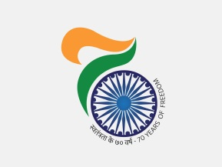

ITEC Day Celebration 2017

ITEC Day 2017 was celebrated on Monday, 16 October, 2017 in Ashgabat. The Guest of honour was the Deputy Minister of Education of Government of Turkmenistan Mr. Nagym Taganov. It was a well-attended function with ITEC alumni, officials of Ministry of Foreign Affairs and Department of Education. Welcoming the guests Ambassador Dr. T.V. Nagendra Prasad gave an overview of the ITEC programme, stressing ITEC is the flag bearer of the Indian Government’s development partnering, not only because of its wide geographical coverage but also for innovative forms of technical cooperation. On the occasion Deputy Minister highly appreciated assistance received from India in up scaling Turkmens and hoped to work mutually for further collaboration. The ITEC alumni also spoke very positively about their experience during ITEC training emphasizing that they are utilizing the knowledge obtained in ITEC training.
***

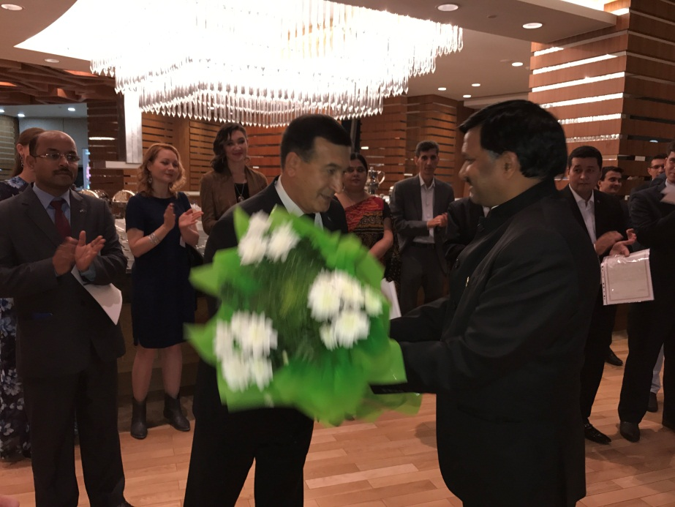

Ambassador Dr. T.V. Nagendra Prasad welcoming Deputy Minister of Education Mr. Nagym Taganov

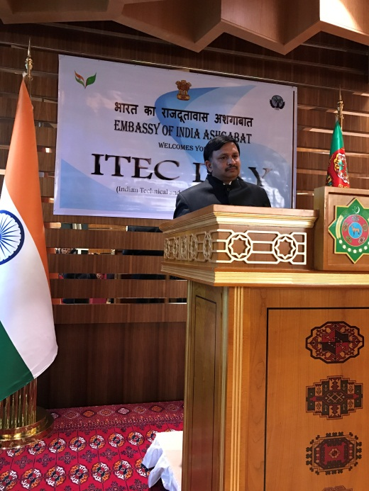

Ambassador Dr. T V Nagendra Prasad addressing the participants

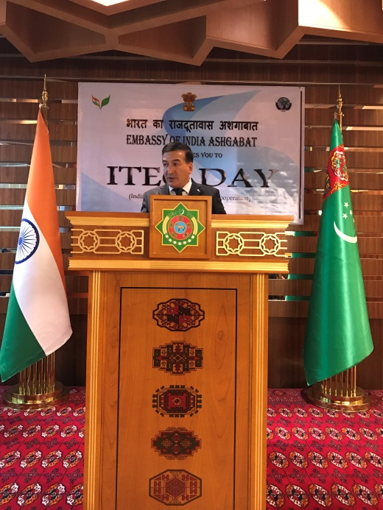
Deputy Minister of Education of Government of Turkmenistan Mr. Nagym Taganov addressing the participants

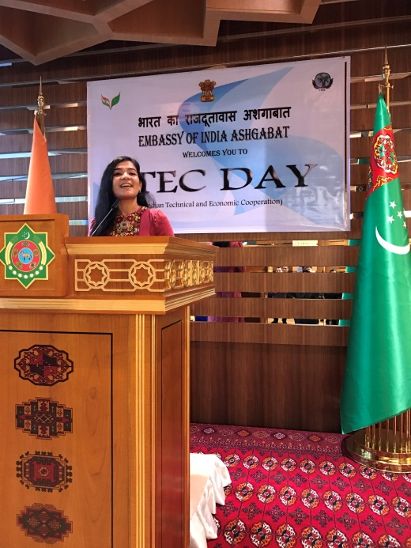 | 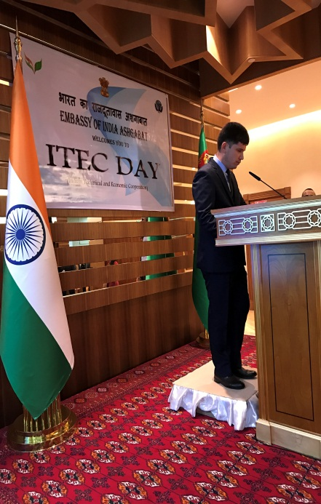 | 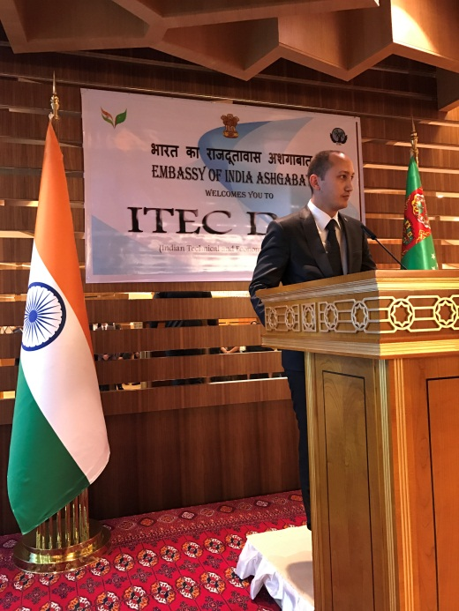

Alumni sharing their experience

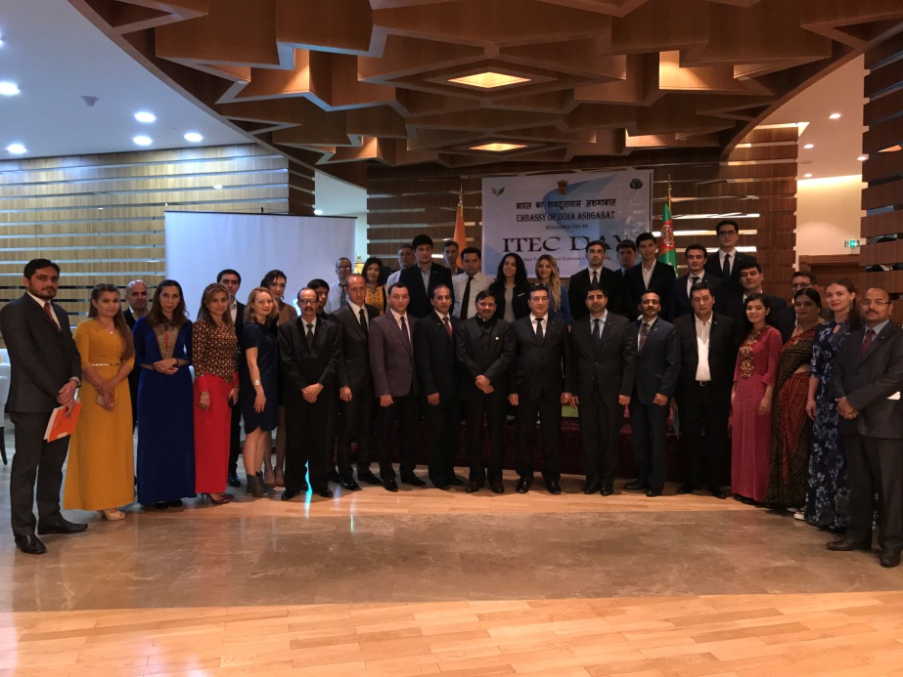
ITEC DAY 2017 Group Photograph

