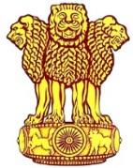 | Embassy of India  Ashgabat | 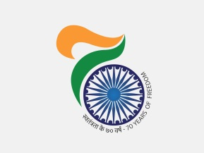

AIMAG 17: India picked its sixth Gold on 24th September. 2017
India picked its sixth gold medal on 24th September, 2017. Bajrang picked gold in wrestling (Men’s Freestyle -65kg). India’s tally of medals, as on 24th September, 2017, reached to 24 including 6 gold 7 silver and 11 bronze.
***
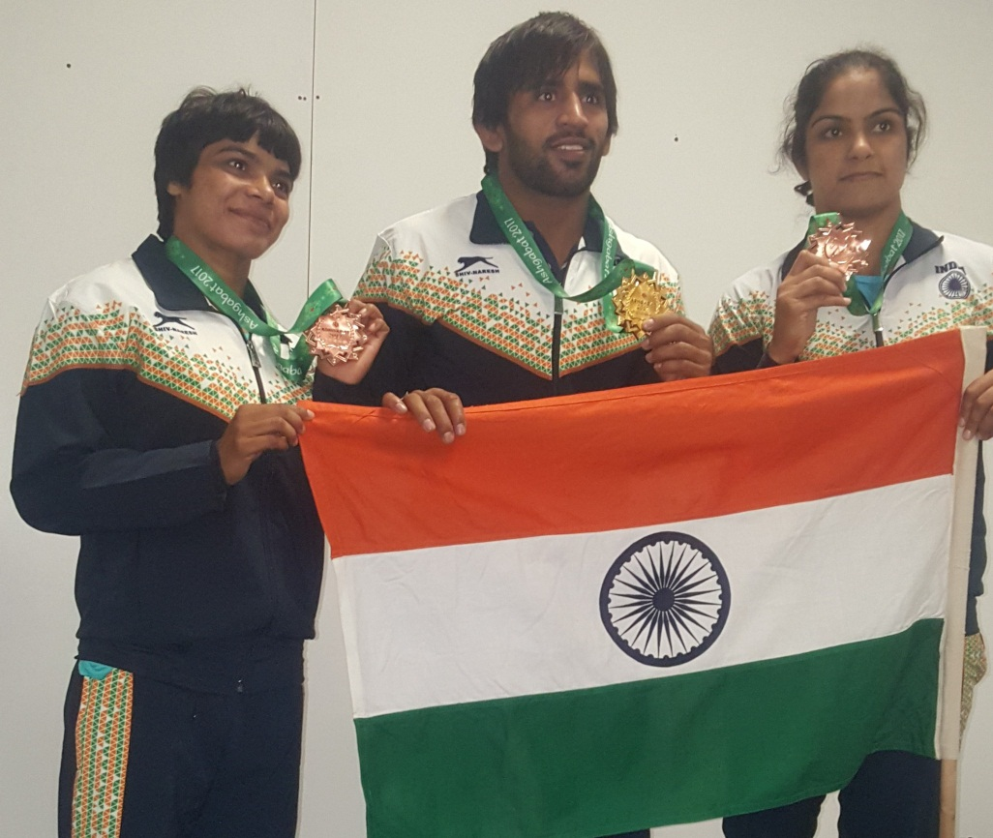
AIMAG 17: Bajrang (center) winner of Gold in Men’s Freestyle -65 kgs wrestling with Shetal Tomar (left) winner of bronze in Women’s Freestyle -48 kg wrestling and Ms. Navjot Kaur (right) winner of bronze in Women’s Freestyle -69 kg wrestling.

