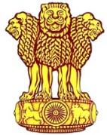 | Embassy of India  Ashgabat | 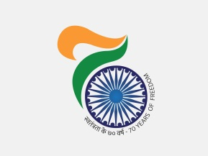

Independence Day 2017 Celebration in Ashgabat Turkmenistan

The Independence Day celebrations were held at the Embassy of Residence on Tuesday, 15 August, 2017. Indian community in Turkmenistan, PIOs and Embassy Officials' families participated in the celebration.

Ambassador Dr. T.V. Nagendra Prasad hoisted the Flag followed by the national anthem. Ambassador read out the address of Hon'ble President Shri to the nation on the occasion. He urged all to work towards realization of “New India”. About 70 people assembled at the Residence for the celebrations. It was followed by patriotic songs and refreshments.

***

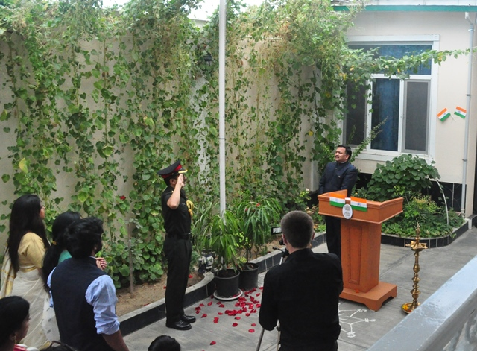
Independence Day 2017 Flag hoisting by Ambassador, H.E Dr. T V Nagendra Prasad
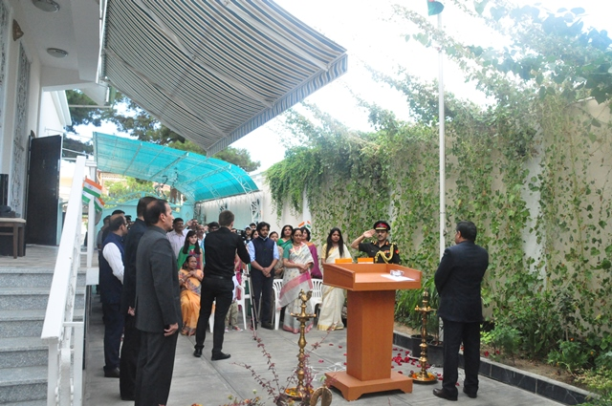
Independence Day 2017 Recitation of National Anthem

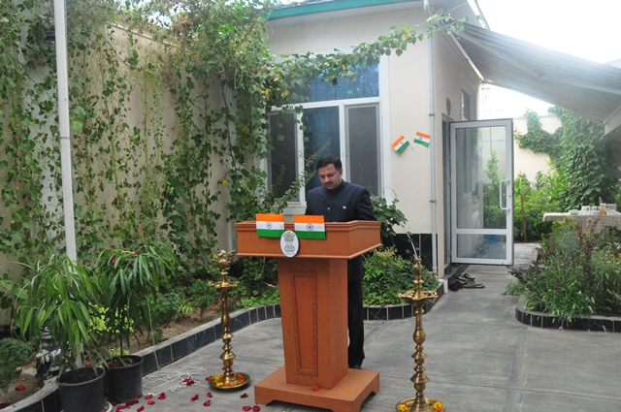
Independence Day 2017 Address by Ambassador H.E Dr. T V Nagendra Prasad
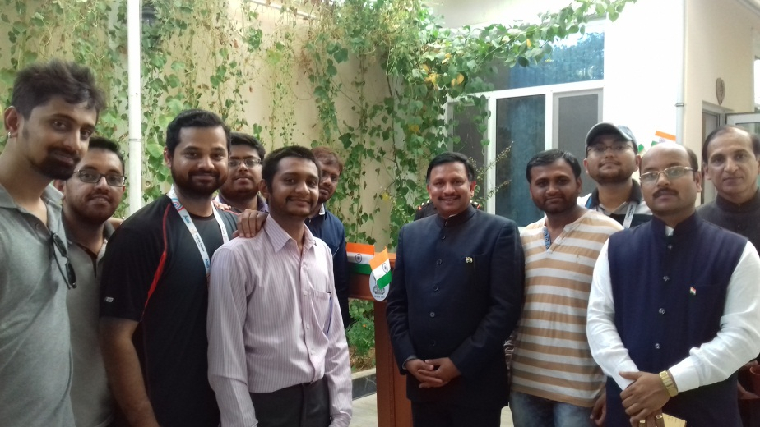
Independence Day 2017 Ambassador with Indian Community
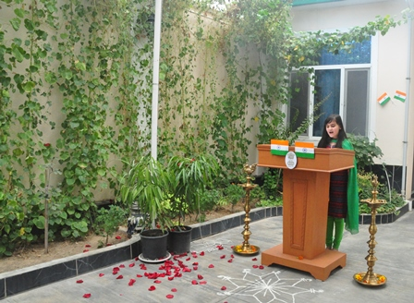 | 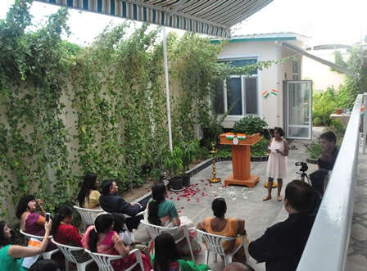
Independence Day 2017 Patriotic songs by children

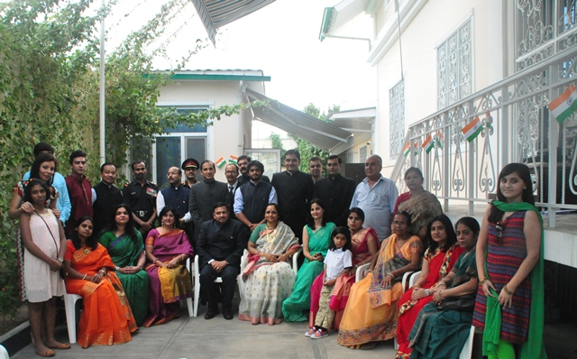
Independence Day 2017 Embassy Family

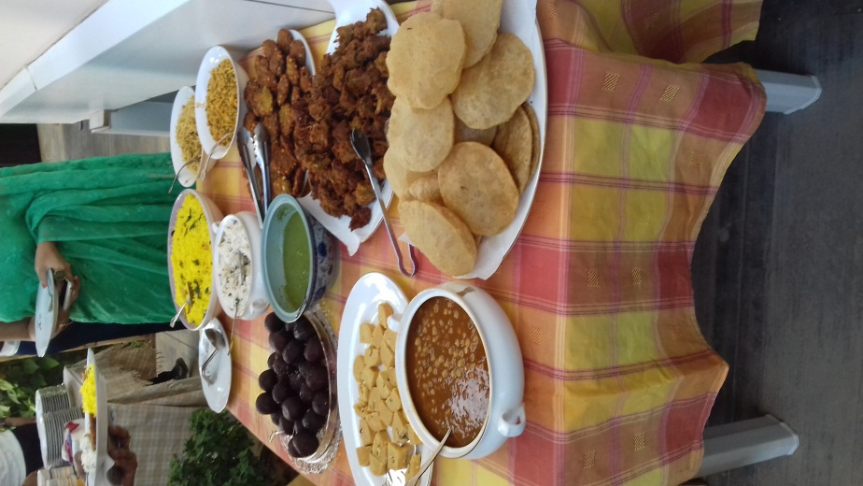
Independence Day 2017 Refreshment

