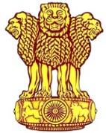 | Embassy of India  Ashgabat | 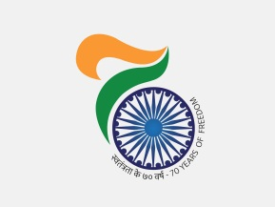

Visit of Deputy Chairman of the Cabinet of Ministers and Minister of Foreign Affairs of Turkmenistan to India

His Excellency Mr. Rashid Meredov, Deputy Chairman of the Cabinet of Ministers and Minister of Foreign Affairs of Turkmenistan, visited India from 13-15 August 2017, on the invitation of External Affairs Minister, Smt Sushma Swaraj.

On Monday 14th August, 2017 EAM and H.E. Mr. Rashid Meredov co-chaired the sixth meeting of the India-Turkmenistan Intergovernmental Commission on Trade, Economic, Scientific and Technological Cooperation. (6th IGC).

India and Turkmenistan held bilateral talks on trade, economic, energy and cultural cooperation to strengthen relations between the two countries. During the visit Mr. Meredov also held other meetings on important bilateral relations.
***
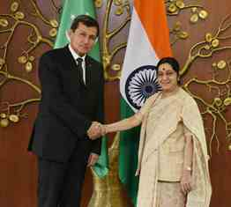
External Affairs Minister, Smt Sushma Swaraj welcomes Mr. Rashid Meredov, Deputy Chairman of the Cabinet of Ministers and Minister of Foreign Affairs of Turkmenistan
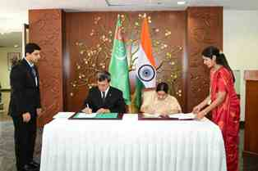
Signing of documents by External Affairs Minister, Smt Sushma Swaraj & Mr. Rashid Meredov, Deputy Chairman of the Cabinet of Ministers and Minister of Foreign Affairs of Turkmenistan.

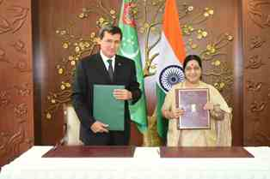
Release of documents by External Affairs Minister, Smt Sushma Swaraj & Mr. Rashid Meredov, Deputy Chairman of the Cabinet of Ministers and Minister of Foreign Affairs of Turkmenistan.

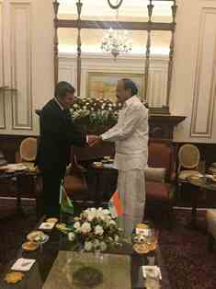 | 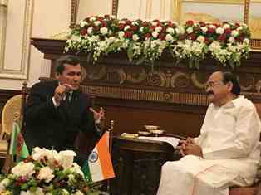
Mr. Rashid Meredov, Deputy Chairman of the Cabinet of Ministers and Minister of Foreign Affairs of Turkmenistan calls on Shri Venkaiah Naidu, Hon’ble Vice President of India.

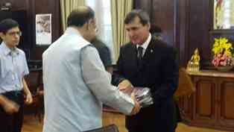
Mr. Rashid Meredov, Deputy Chairman of the Cabinet of Ministers and Minister of Foreign Affairs of Turkmenistan calls on Shri Arun Jaitley , Minister of Finance, Minister of Defence and Minister of Corporate Affairs

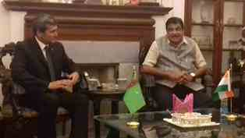
Mr. Rashid Meredov, Deputy Chairman of the Cabinet of Ministers and Minister of Foreign Affairs of Turkmenistan calls on Shri Nitin Gadkari, Union Road Transport and Highways Minister.

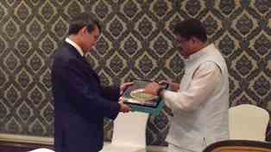
Mr. Rashid Meredov, Deputy Chairman of the Cabinet of Ministers and Minister of Foreign Affairs of Turkmenistan calls on Shri Dharmendra Debendra Pradhan, Minister of State for Petroleum and Natural Gas.

