 | Embassy of India  Ashgabat | 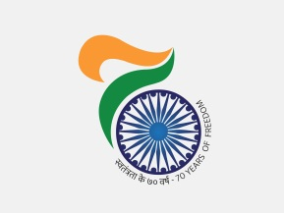

Transit halt of Hon’ble Raksha Mantri in Ashgabat

During the transit halt in Ashgabat on June 20, 2017, Hon’ble Defence Minister H. E. Shri Arun Jaitley held discussions on bilateral cooperation with his Turkmen counterpart H. E Col Gen Berdiyev.

Mr. Vepa Hajiyev, First Deputy Foreign Minister Affairs was also present to greet the Hob’ble Minister at the Airport.

***

