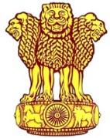 | Embassy of India  Ashgabat  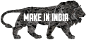 | 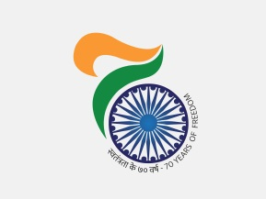

International Economic Cooperation Exhibition, 2017 at Ashgabat

The Chamber of Commerce & Industry of Turkmenistan organized International Exhibition "International Economic Cooperation Exhibition, 2017" for the period 20-21 June, 2017. This is a universal trade exhibition and around 12 countries including India, Iran, China, Turkey, USA, Uzbekistan are participating in the Exhibition apart from numerous Turkmen industries.

The exhibition was inaugurated by Mr. Orazmyrat Gurbannazarov Deputy Prime Minister of Trade, Government of Turkmenistan in presence of high profile personalities of Turkmen Industries, Politics and Diplomatic Community including Mrs. Mkja Nurberdiyeva , Chairperson of Mejlis and the Cabinet Minister of the Government of Turkmenistan.

Ambassador of India, to Turkmenistan Dr. T V Nagendra Prasad inaugurated the Indian stalls at the Exhibition. Keeping in view the policy of promoting Indian States at International fora, Mission invited the Indian States to participate in the exhibition under the banner “Make in India”. Three states: Punjab, Andhra Pradesh & Telangana, participated in the exhibition.

Punjab Markfed and Punjab Milkfed (Verka) (Punjab Government's Cooperative Departments), agro and food producer from Punjab promoted products in the exhibition. Telangana Tourism showcased tourism potential while Andhra Pradesh showcased itself as an investement destination. Mission facilitated participation as part of promoting States. is showing the tourist place in Telangana. IT Companies and leather shoes producing companies are also participating from Andhra Pradesh.

***

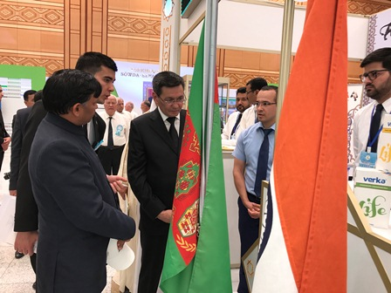
8 International Economic Cooperation Exhibition 2017 -Mr. Orazmyrat Gurbannazarov Deputy Prime Minister of Trade, Government of Turkmenistan visiting Indian Stalls
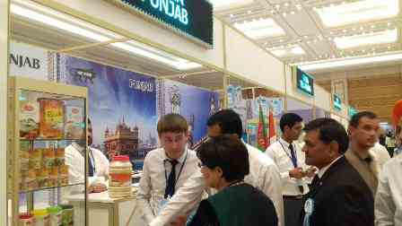
International Economic Cooperation Exhibition Mrs. Mkja Nurberdiyeva , Chairperson of Mejlis and Mr. Annageldi Garajayev Deputy Prime Minister on Culture visiting Indian stalls

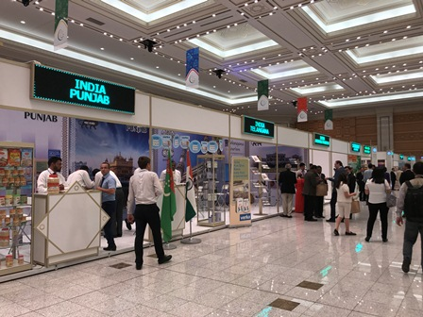 | 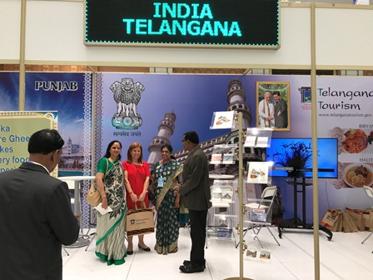
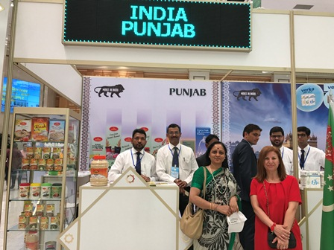 | 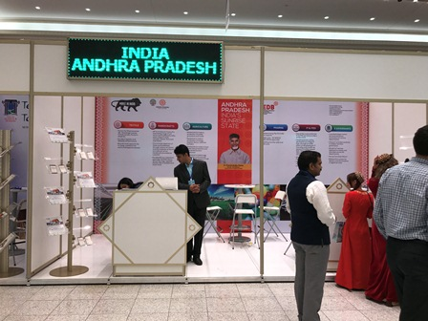
3International Economic Cooperation Exhibition, 2017 Indian Stalls

