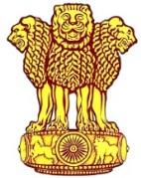 | Embassy of India  Ashgabat  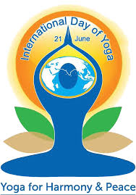 | 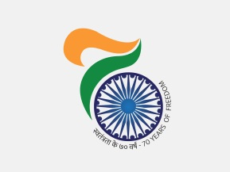

3rd International Day of Yoga (IDY) celebrated in Ashgabat, Turkmenistan, on 18th June 2017

21st June is recognized by UN as International Day of Yoga (IDY). This year was the third chapter of the International Day of Yoga. To encourage the maximum participations of the local Turkmen in the celebration the public function for the third IDY was celebrated on 18th June, 2017. Ceremony was held at the Yoga Centre in Ashgabat at 0730 hrs with great joy and enthusiasm. A large gathering of more than 700 yoga practitioners including the Diplomatic community, students of State Medical University participated at the event. Ambassador of India Dr. T.V. Nagendra Prasad and the Minister of Healthcare and Industry H.E. Mr. Amannepesov Nurmuhammet inaugurated the Yoga Day Celebrations.

Hon’ble Minister of Healthcare and Industry of Turkmenistan in his address mentioned about the opening of the Yoga Centre by Hon’ble Prime Minister Shri Narendra Modi in July, 2015 which had attracted over 2200 Turkmen citizens to learn and practice Yoga.

In the beautiful surroundings of Bagtyarlyk Sports Complex led by the Indian Yoga teacher, the entire Yoga Protocol was performed by the participants. Later, special performances of very advanced Yoga postures were presented by a group of 10 practitioners which were highly appreciated by the gathering.

Speaking on the occasion, Ambassador Dr. T.V. Nagendra Prasad extolled the virtues of Yoga in bringing balance, sustainability and peace to the society. He highly appreciated the support of President of Turkmenistan H.E. Mr. Gurbanguly Berdimuhamedov and the Government for their support to the Yoga and also in maintaining the Yoga Centre, which was set up during the visit of Hon’ble Prime Minister Shri Narendra Modi in July, 2015. The orchestra of the Turkmen Cultural Ministry added to the occasion with its melodious music to make the celebrations truly festive.
To the run up to the 3rd IDY, Embassy had conducted Essay competition and a special quiz competition to the run up to the 3rd IDY. Winners of the Essay competition and Quiz competition were given prize during the IDY celebration.
***
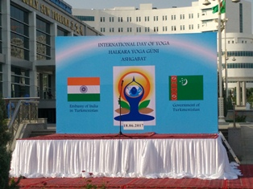
3rd International Day of Yoga
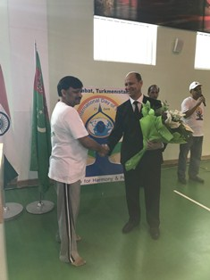
3rd IDY Ambassador of India to Turkmenistan welcoming the chief Guest Minister of Healthcare and Industry H.E. Mr. Amannepesov Nurmuhammet
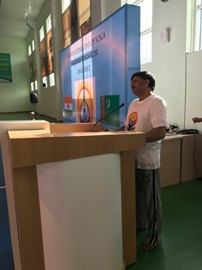
3rd IDY Ambassador of India to Turkmenistan Dr. T V Nagendra Prasad addressing the audiences

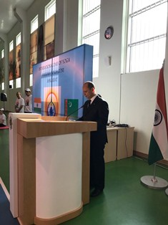
3rd IDY Chief Guest addressing the audiences
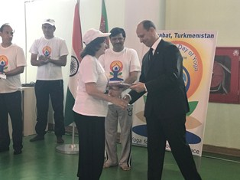
3rd IDY H.E. Mr. Amannepesov Nurmuhammet giving prizes to the winners
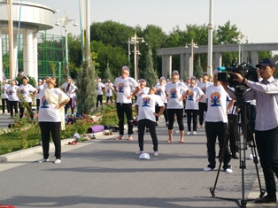 | 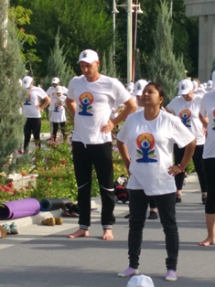
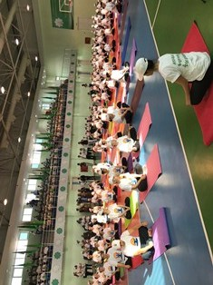 | 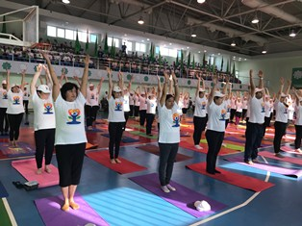
3rd IDY: Performance of Yoga Protocol

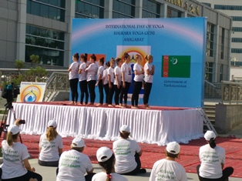 | 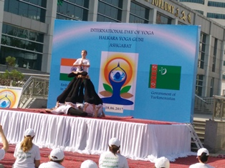
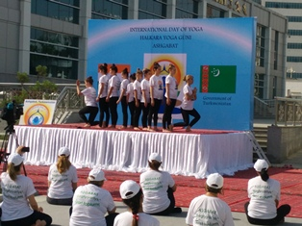 | 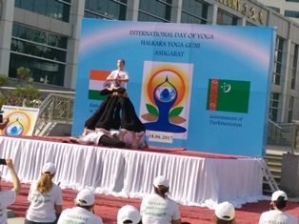
3rd IDY Special Performance by 10 Yoga Practitioners

***

