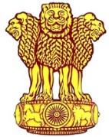 | Embassy of India  Ashgabat

Visit of Yoga Kendra by delegation led by Dr, Arvind Gupta, DNSA & Secretary , NSCS.

On the sideline of the working visit of 4 member delegation led by Dr. Arvind Gupta, Dy. National Security Adviser (DNSA)&Secretary National Security Council Secretariat(NSCS ) to Ashgabat, a short visit was made to Ashgabat Yoga Kendra

Dr. Gupta and other delegation members offered floral tribute at the bust of Mahatma Gandhi at the premise.
Dr. Gupta expressed pleasure at the successful functioning of the Yoga Kendra. Delegation also participated briefly in the ongoing yoga session.
***

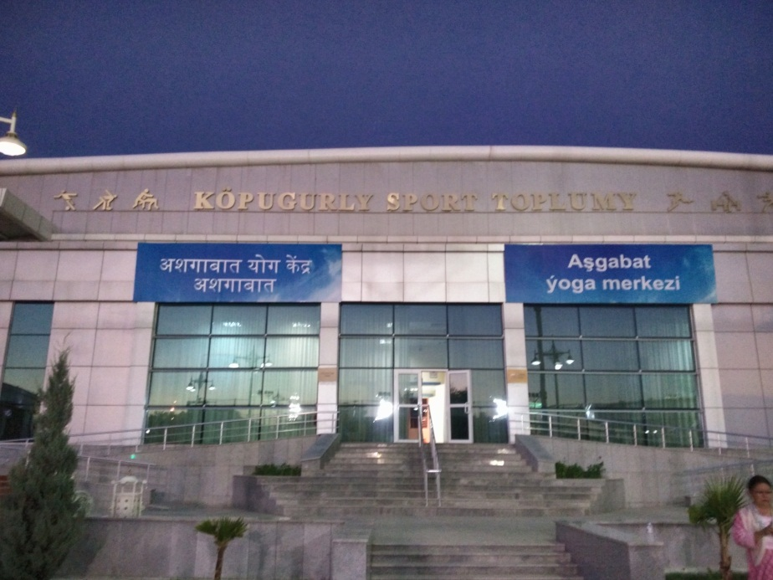
Ashgabat Yoga Kendra, Ashgabat, Turkmenistan

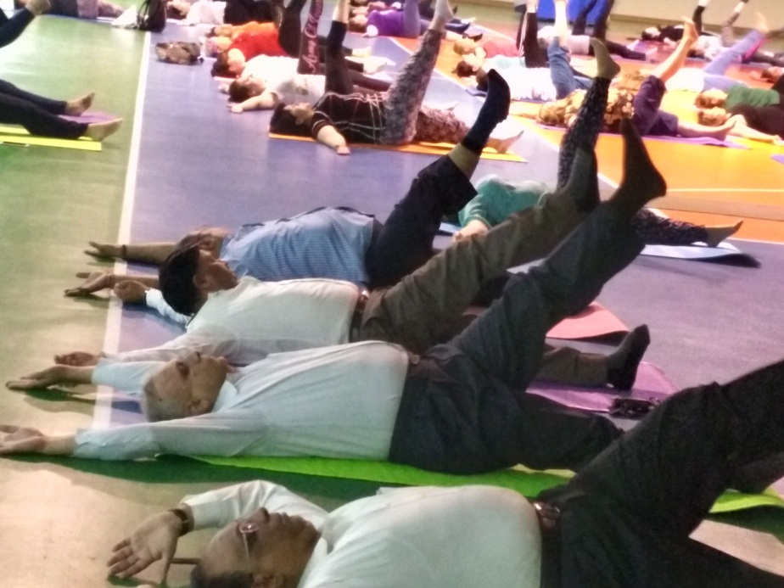

Dy. NSA Dr. Arvind Gupta and other delegation members participating in the the yoga Session at the Ashgabat Yoga Kendra

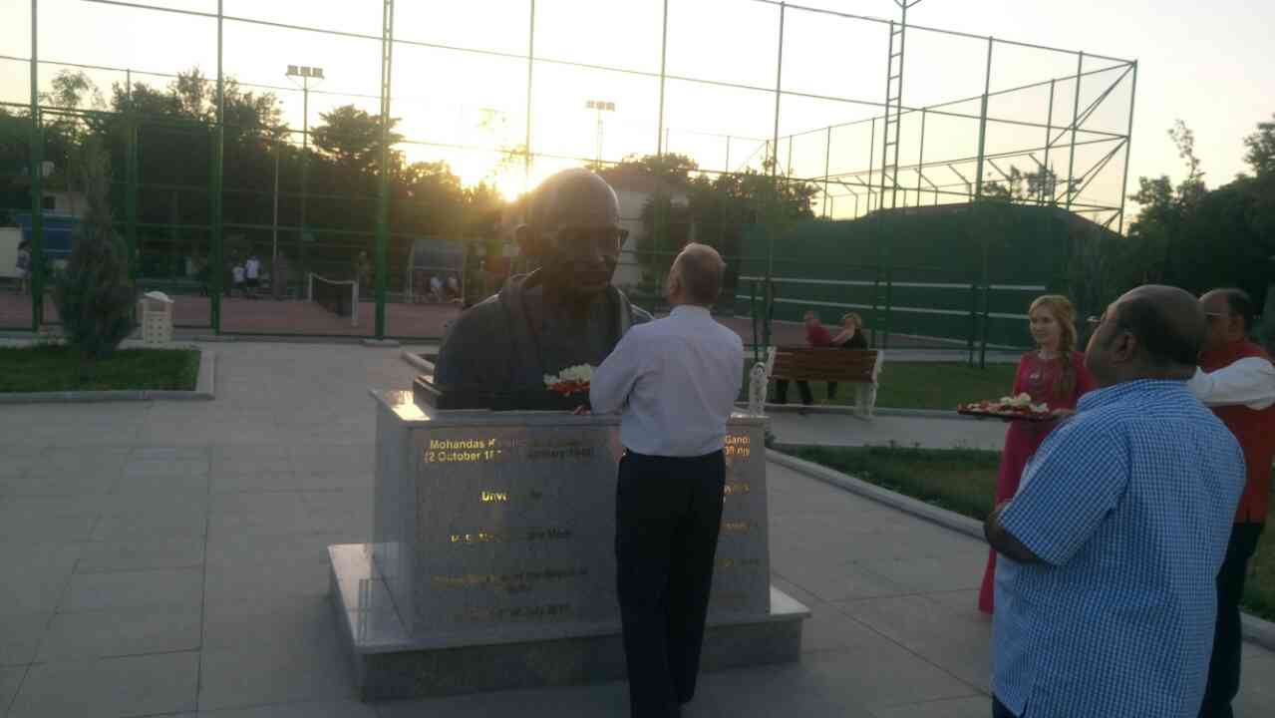
Dy. NSA Dr. Arvind Gupta and other delegation members offering floral tribute at Mahatma Gandhi Bust, Ashgabat

