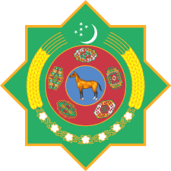 | 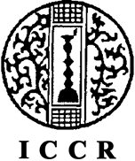 | 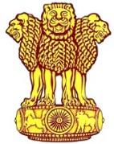
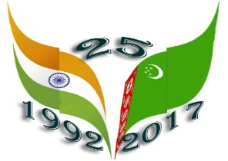
Embassy of India
Ashgabat
Celebration of “Indian Cultural Week” to commemorate 25th Anniversary of Diplomatic Relations between India and Turkmenistan
Thursday, April 20, 2017 marked the 25th Anniversary of the Diplomatic Relation between India and Turkmenistan. To mark the occasion Embassy of India in Ashgabat, in association with Ministry of Culture, Government of Turkmenistan, Indian Council for Cultural Relations (ICCR), India Tourism Office, Frankfurt and Ministry of Tourism, Government of India, announces the organization of “Indian Cultural Week” from 16th May, 2017 to 23rd May, 2017.
The details of the programmes are as follows:
Date | Program | Venue | Associates
16-19th May, 2017 | Exhibition titled “Vastram Splendid World of Indian Textiles”,  Inauguration on 16.05.17 (1000 hrs.) | Museum of Fine Arts, Ashgabat-Entry Free | Ministry of Culture, Govt of Turkmenistan,  Indian Council for Cultural Relations
17th May, 2017  1830 hrs. | Cultural performance by Bollywood group | Turkmenistan Kino Theatre, Ashgabat-Entry Free | Ministry of Culture,  Govt of Turkmenistan,  Indian Council for Cultural Relations
18th May, 2017  1830 hrs. | Cultural performance by Bollywood group. | Watan Kino Theatre, Ashgabat-Entry Free | Ministry of Culture,  Govt of Turkmenistan,  Indian Council for Cultural Relations
19-21May, 2017 1830 hrs. | Indian Film Festival | Ashgabat Kino theatre, Ashgabat-Entry Free | Ministry of Culture, Govt of Turkmenistan,
22-23May, 2017 1830 hrs. | Indian Food Festival | Yyldyz Hotel-Entry by invitation only | Ministry of Culture, Govt. of Turkmenistan,  India Tourism Office, Frankfurt,  Ministry of Tourism, Govt of India
***

