ITEC Day Celebration

ITEC Day 2016 was celebrated on Tuesday, 28 February, 2017. The Guest of honour was the Deputy Minister of Education of Government of Turkmenistan Ms. Aknabat Atabayeva. It was attended by more than 30 ITEC participants including a member of Mejlis. Speaking on the occasion Deputy Minister appreciated India’s assistance received from India in form of training to Turkmen citizens and she appreciated India’s rapid growth in education sector. Ambassador Dr. T.V. Nagendra Prasad gave an overview of the ITEC programme, stressing that ITEC training offers expertise in several areas such as engineering and technology. The ITEC alumni spoke about their experience during ITEC training.

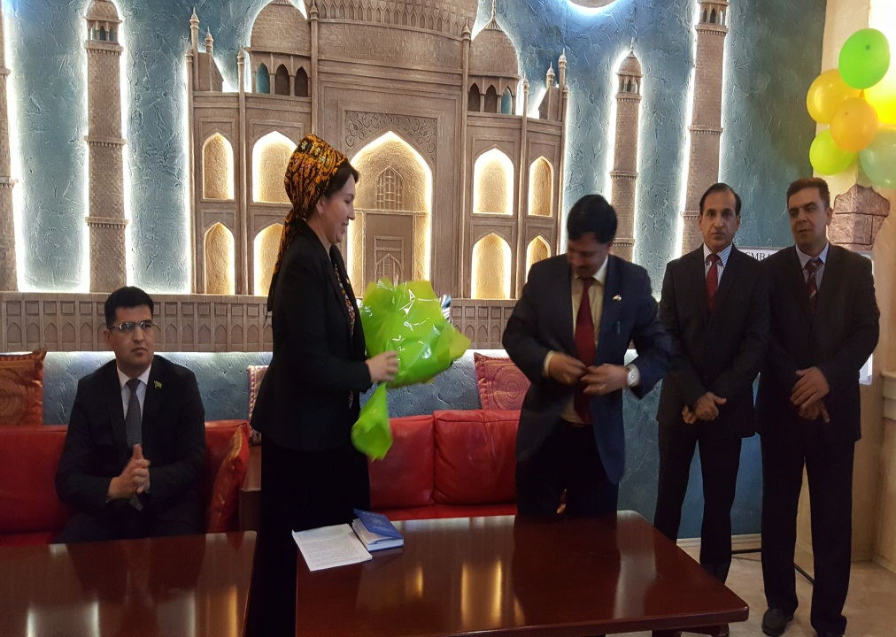

Ambassador Dr. T.V. Nagendra Prasad welcoming Deputy Minister of Education

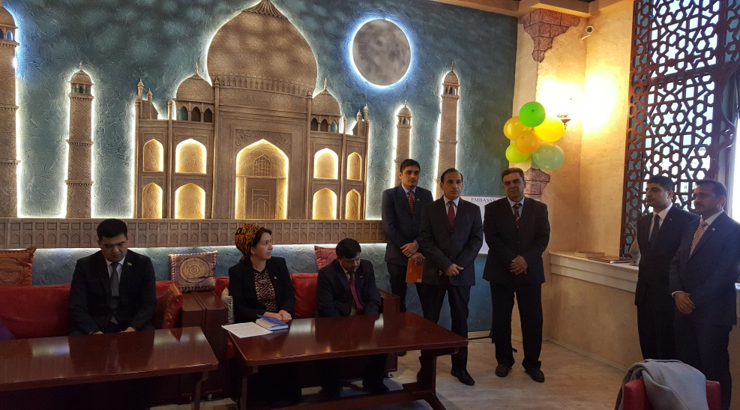

Head of Chancery addressing the participants
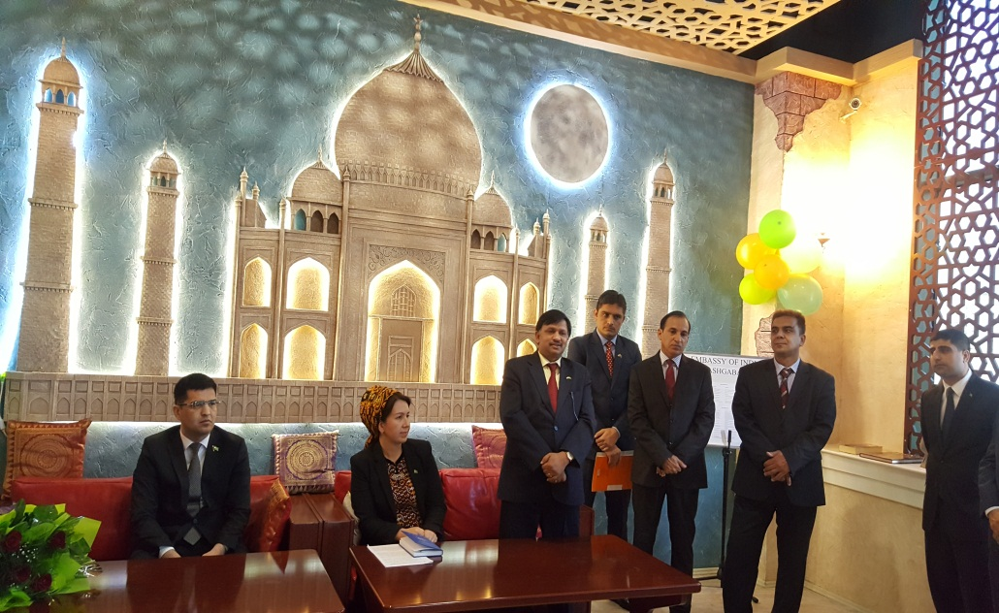

Ambassador addressing the participants

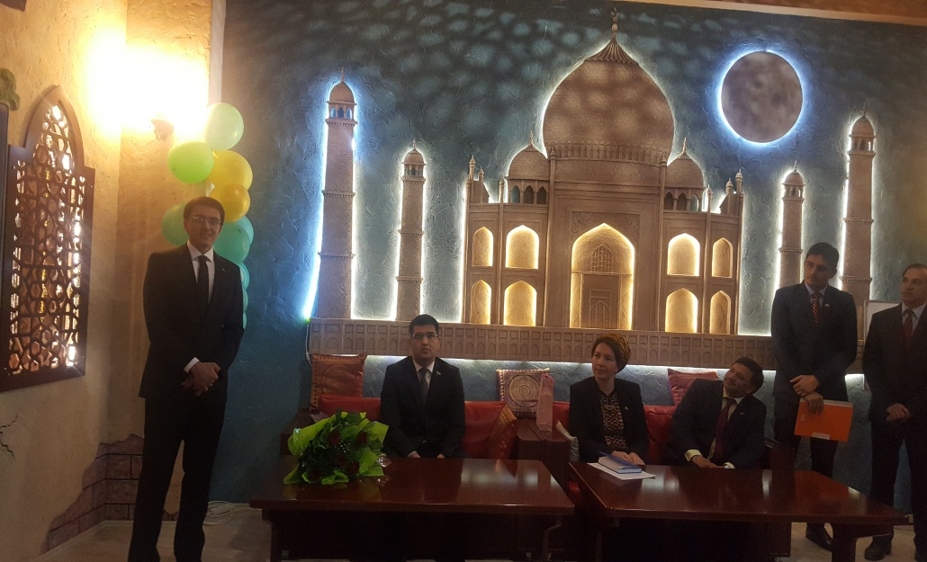

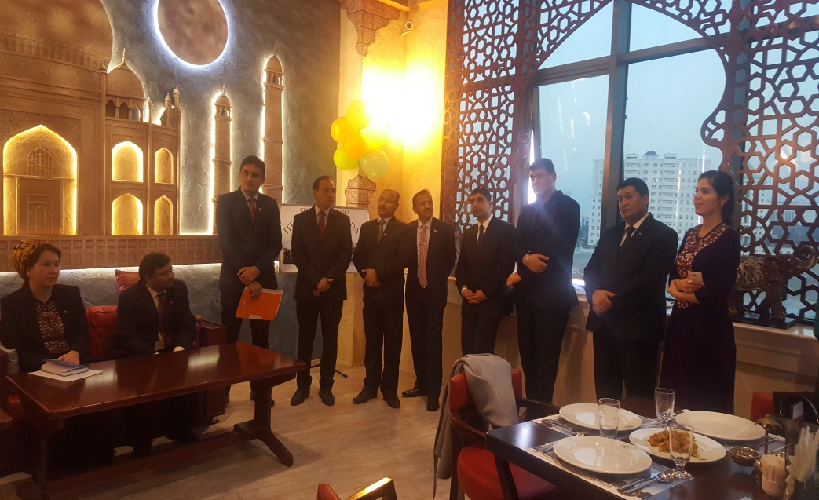
Alumni sharing their experience

