Embassy of India
Ashgabat

Indian Stall at International Food and Culture Festival, 2017

International University of Humanitarian Sciences and Development, Ashgabat, has organized International Food and culture Festival 2017. Food and culture of 14 countries, including, India were displayed at the occasion. Students displaying Indian food and culture were among three groups selected for appreciation
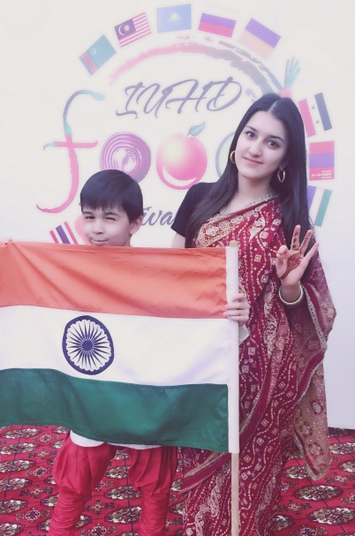 | 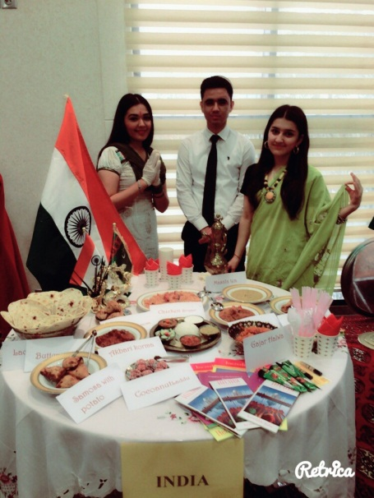
1. Food and Culture Festival 2017 at International University of Humanitarian Science and Development | 2.Food and Culture Festival 2017 at International University of Humanitarian Science and Development-Indian Food Stall
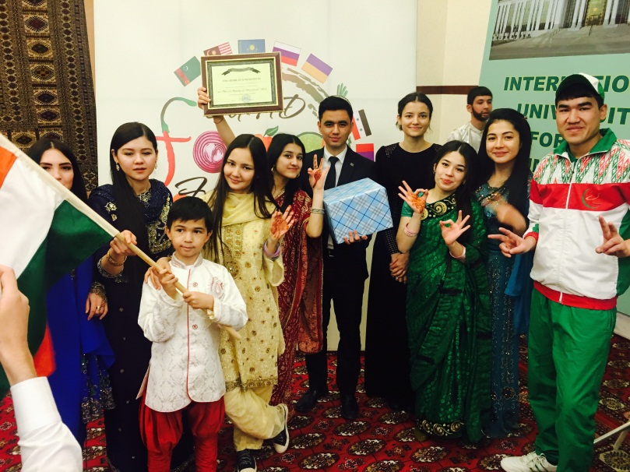
3.Food and Culture Festival 2017 at International University of Humanitarian Science and Developement-certificate of appreciation to Indian group

