EMBASSY OF INDIA
YOGA CENTRE, ASHGABAT
Yoga is a combination of practice and philosophy. In addition to the regular practical classes at Bakhtyrlyk Sports Complex, a series of lectures have been started by the Yoga Teacher Shri R R Panigrahi to enlighten the students in different yoga related subjects. Accordingly, on 16.02.2017, there were two lectures. One on “Concept of Yoga”- for newly admitted students for the month of February and the other lecture on “Yoga and Diet”. Diet along with Yoga makes faster progress in Yogic achievement. This was for all students.
There were around 250 students present in the class. In addition to the above subject, the importance of Savasana and sun salutation , step by step, were explained. Savasana gives a good relaxation to the whole body. It should be practiced at the end of yoga postures.
Yoga and Diet- both are equally important for the purpose of good health. In the power point presentation, the three classification of food, i.e. sattvic, Rajasic, and Tamasic were mentioned. The effect of food on mind was discussed. The importance of vegetarian food was mentioned. Diet should be profession based need, energy based need.
After the lecture, there were many questions from the audience and were discussed.
***
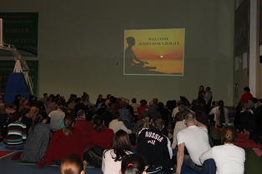
Yoga Day Lecture on 16.02.2017 by Shri R R Panigrahi, Yoga Teacher
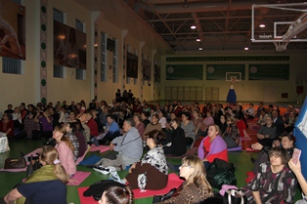
Yoga Day Lecture on 16.02.2017- engrossed participants
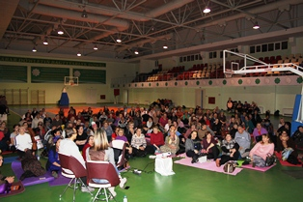
Yoga Day Lecture on 16.02.2017- Interactive Session

