Celebrations of 68th Republic Day of India in Nairobi
The 68th Republic Day of India was celebrated on 26 January 2017 in Nairobi with traditional enthusiasm and new vigour. High Commissioner Ms. Suchitra Durai unfurled the Indian tricolour at India House. National Anthem and patriotic songs were sung by the members of the Indian Diaspora.

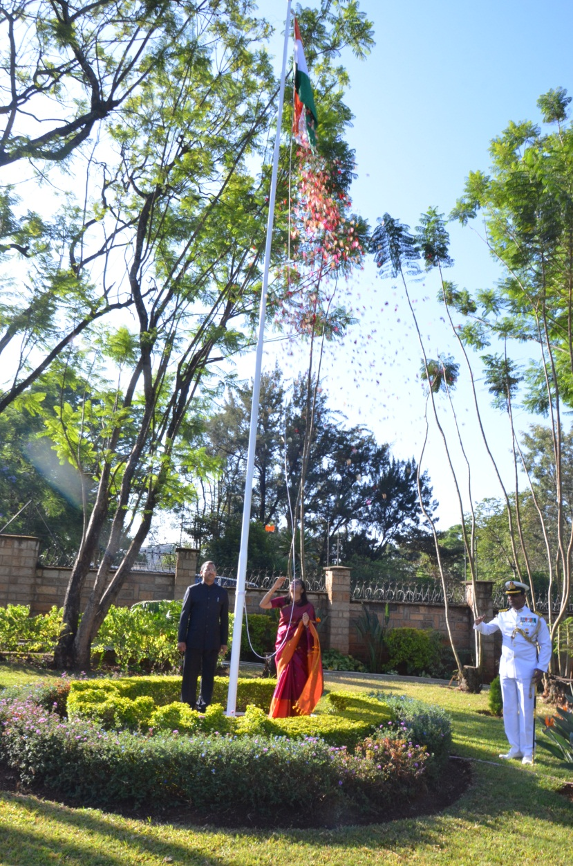

The High Commissioner read out the President’s Address to the Nation on the eve of the Republic Day. Around 400 people including members of the Indian community and friends of India attended the function. High Commissioner briefed the guests about the developments in India-Kenya relations and activities of the High Commission. The High Commissioner and Ambassador R. Swaminathan felicitated Mr. Avtar Singh Sehmi, a Kenyan of Indian origin, who has been attending Indian National Day events in Nairobi since 1948.
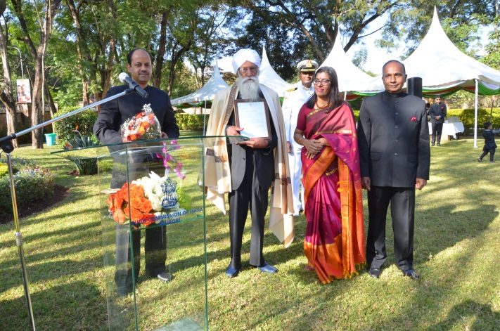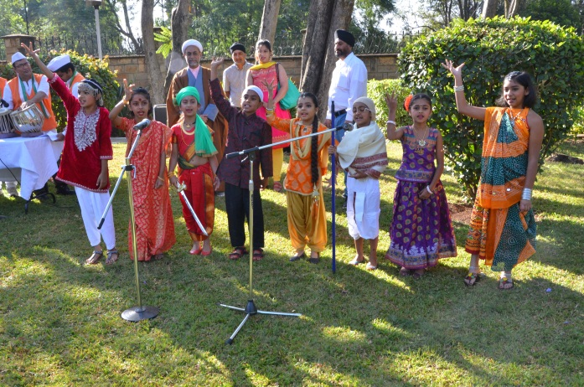
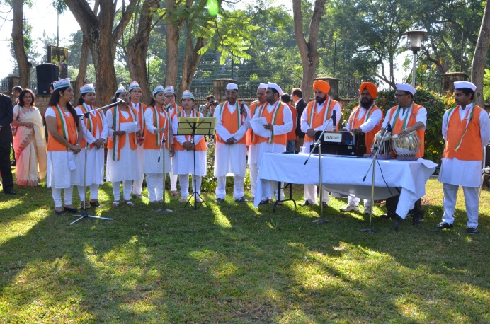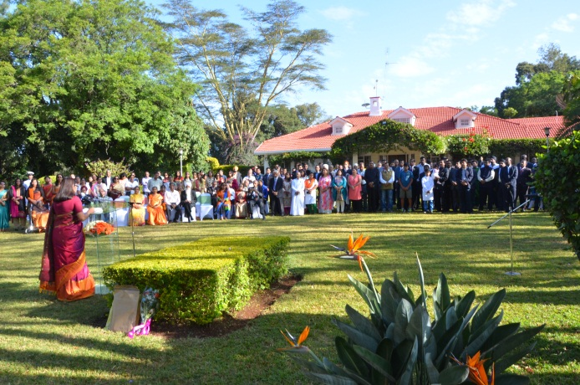
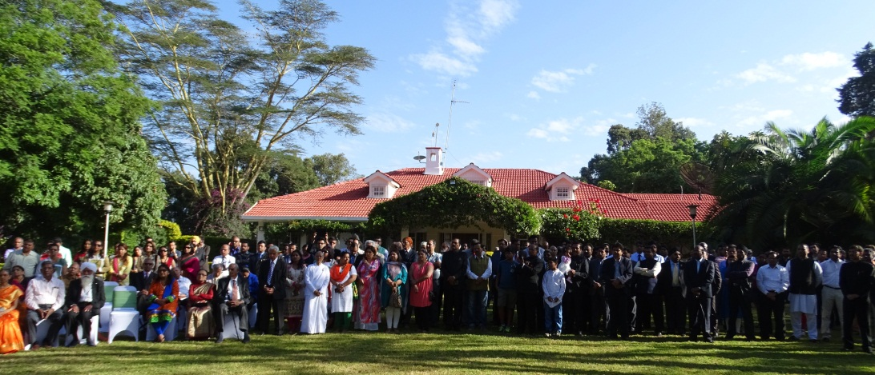
Nairobi
26th January 2017

