High Commission of India
Port Louis
***
Press Release
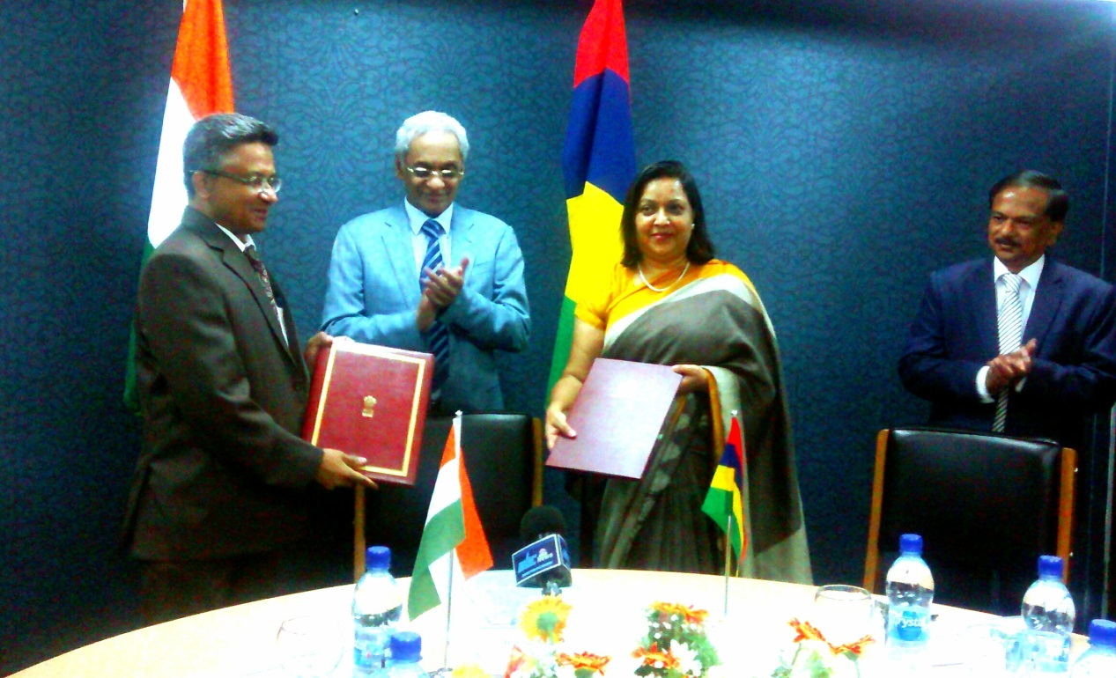

An Arrangement between the Government of the Republic of India and the Government of the Republic of Mauritius on Gainful Employment for Family Members of a Diplomatic Mission or Consular Post was signed today by the High Commissioner of India, Shri Abhay Thakur, and Secretary for Foreign Affairs of Government of Mauritius, Mrs. Usha Dwarka-Canabady, in the presence of Hon’ble Minister of Foreign Affairs, Regional Integration & International Trade, Government of Mauritius, Mr. Seetanah Lutchmeenaraidoo.
The arrangement provides for the members of the family of diplomatic agents of the sending State to engage in gainful employment in the receiving State.
4 January 2017
Port Louis
*****

