HIGH COMMISSION OF INDIA
PORT LOUIS
MAURITIUS

PRESS RELEASE

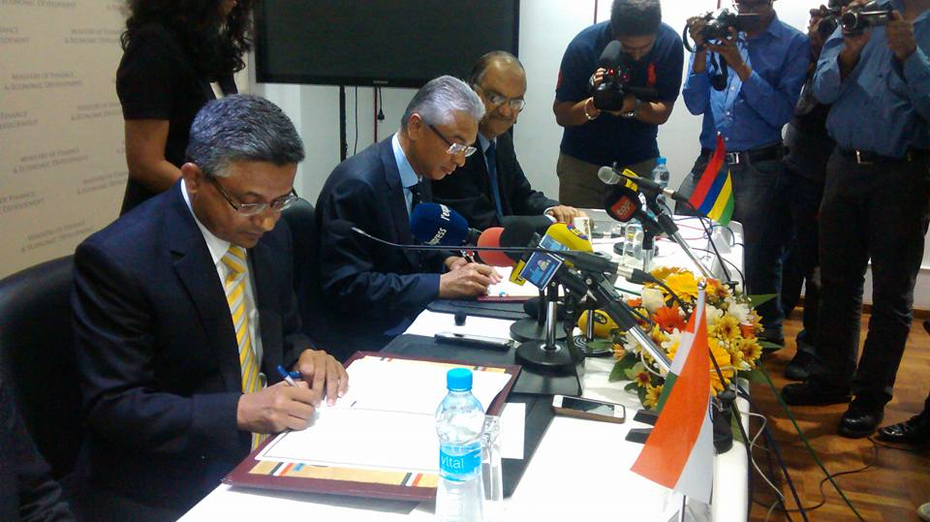

US$ 353 MILLION GRANT ASSISTANCE BY GOVERNMENT OF INDIA FOR PROJECTS IN MAURITIUS
A Memorandum of Understanding (MoU) between India and Mauritius on the implementation of projectSs under Government of India grant assistance of US$ 353 million was signed by the High Commissioner of India H.E. Mr Abhay Thakur and Hon. Pravind Kumar Jugnauth, Minister of Finance and Economic Development on 14 November 2016 at 1130 hrs at the Ministry of Finance and Economic Development, Port Louis. The projects being funded under the MoU include the Metro Express project, a new Supreme Court building, Social Housing project, supply of Digital Tablets to primary schoolchildren and an ENT Hospital.

On this occasion, both sides reiterated their determination to ensure speedy implementation of these projects.
14 November 2016
***

