High Commission of India
Nairobi
Press Release
Festival of India in Kenya (Urafiki-Utsav)
The High Commission of India, Nairobi in collaboration with the Ministry of Culture of the Government of India and the Ministry of Sports, Culture and the Arts of the Government of the Republic of Kenya is organising the first-ever Festival of India in Kenya. The opening ceremony for the Festival of India was held yesterday, October 10, 2016 at Kenya National Theatre. The Chief Guest for the event was Cabinet Secretary for Foreign Affairs Hon’ble Amina Mohammed. Cabinet Secretary for Sports, Culture and the Arts Hon’ble Hassan Wariowas represented by a senior official of the Ministry.
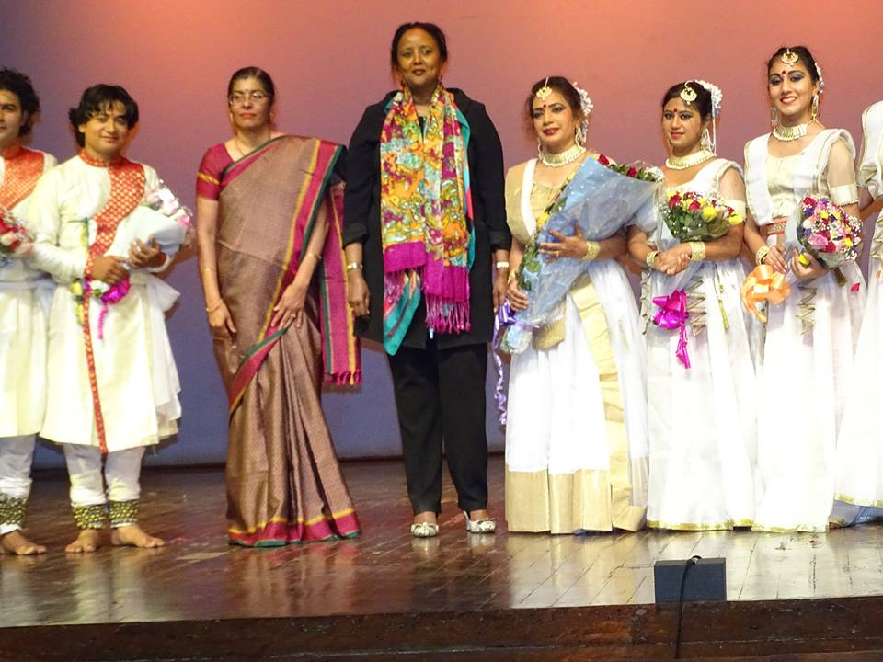
Cabinet Secretary for Foreign Affairs Hon’ble Amina Mohammed, High Commissioner with the dance troupe
India and Kenya are connected by the Indian Ocean. For over two millennia, ever since sailors on both sides mastered the monsoon winds, cultural exchanges and trade exchanges have taken place. Theycontinue to be an important pillar of India-Kenya partnership. Thus, the festival has been named as ‘Urafiki - Utsav’ – A Festival of Friendship (in a combination of Swahili and Hindi words; in Hindi,Utsav means Festival). The three blue wavy lines at the bottom of the special logo designed for the festival celebrate our Indian Ocean links.
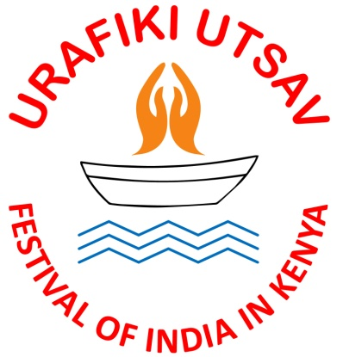
Logo of Festival of India in Kenya
Bilateral engagement between India and Kenya has further strengthened in recent years by regular high-level visits. President Uhuru Kenyatta visited India in October 2015 and India’s Prime Minister Narendra Modi visited Kenya in July 2016.With the launching of the Festival of India in Kenya, the Government of India is implementing one of the announcements made by PM Narendra Modi during his visit.
The Festival of India will show-case music,dance, drama and foodfrom different parts of India. The Festival will presenta music,dance and percussion tradition from the southern State of Kerala by Folkland group of Dr.Jayarajan; a Qawwali(Sufi music) performance by well-known Idris Lateef brothers of Delhi; a contemporary rock music band by Alobo Naga & The Band from the north eastern State of Nagaland; a folk dance from the western State of Gujarat; a classical dance performance of Bharatanatyam by group led by Padma Bhushan Saroja Vaidyanathan from the southern State of Tamil Nadu and delectable and refined cuisine from the State of Kerala. The music and dance troupes will perform all over Kenya apart from Nairobi such as Eldoret, Kisumu, Nakuru, Narok and Mombasa and also in Lamu to participate in the Lamu Cultural Festival. All performances are free and open to the public.
The food festival from 11-16 October, 2016 is being organised in association with Hotel Intercontinental, Nairobi and present the special culinary traditions of Kerala. Two chefs have been flown in from India by the Indian Ministry of Tourism. Those who savour the food (on payment basis at Bandhini restaurant) will also be eligible for winning free air tickets to India, sponsored by Air India and Jet Airways.
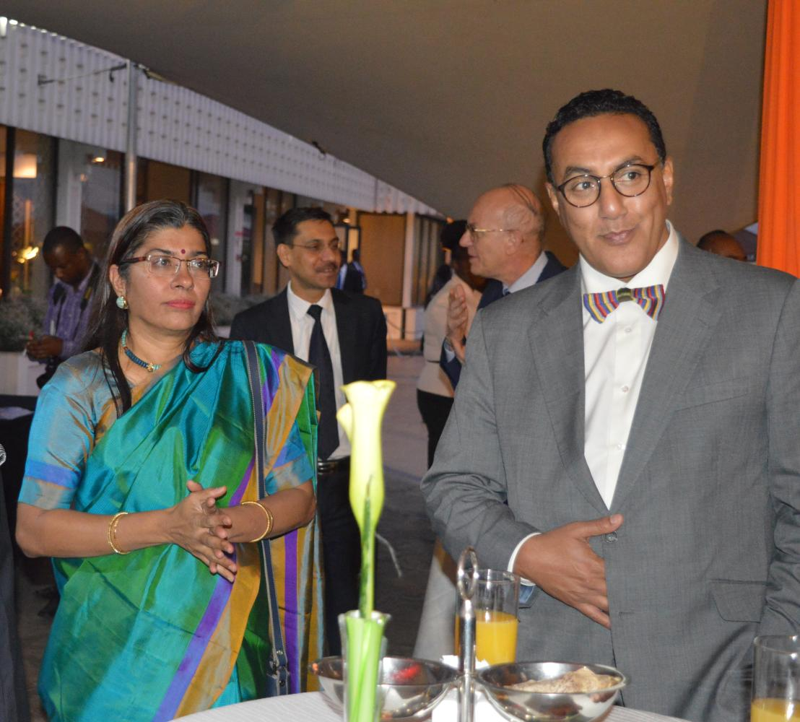
Cabinet Secretary for Tourism, H.E. Mr. Najib Balala and High Commissioner at the inauguration of Food Festival of India
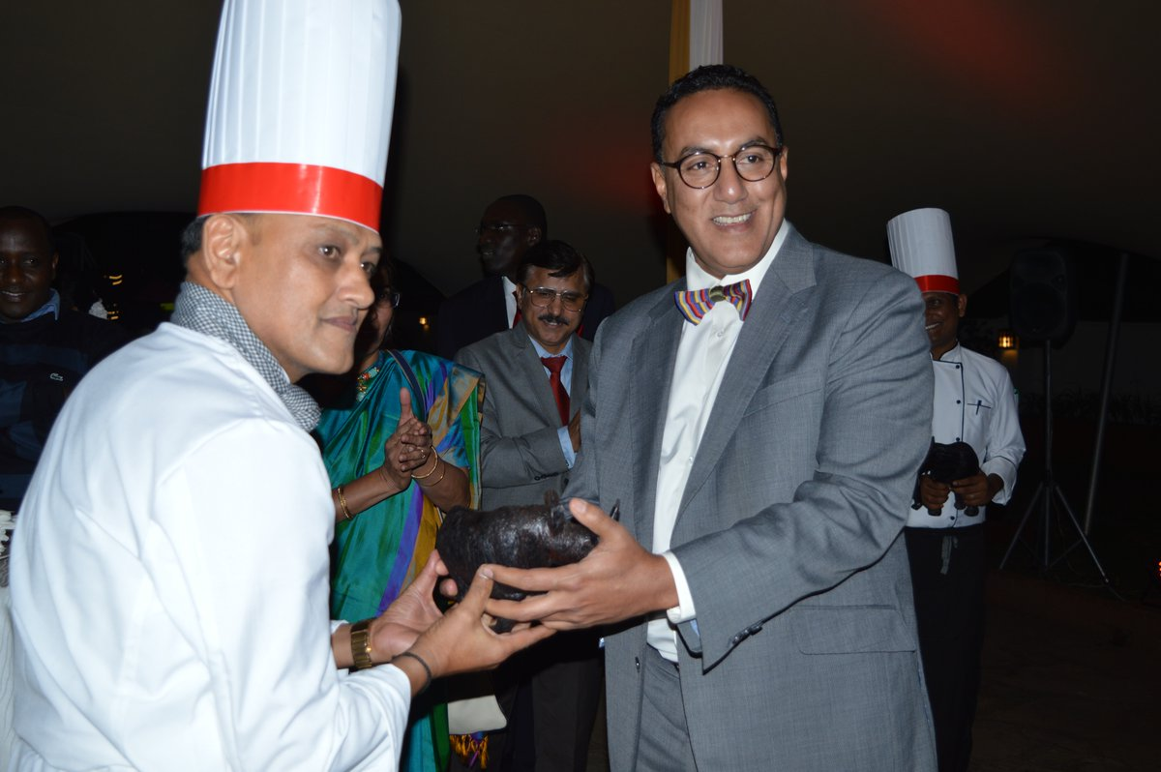
Cabinet Secretary for Tourism, H.E. Mr. Najib Balala presents awards to the Indian Chefs.
At yesterday’s opening ceremony, Kathak, a famous classical dance form of North India was performed by renowned dancer and choreographer Dr.RekhaMehra and her troupe. The troupe members, in exquisite costumes, presented nine dance items, set to the rhythmic and melodious classical music.
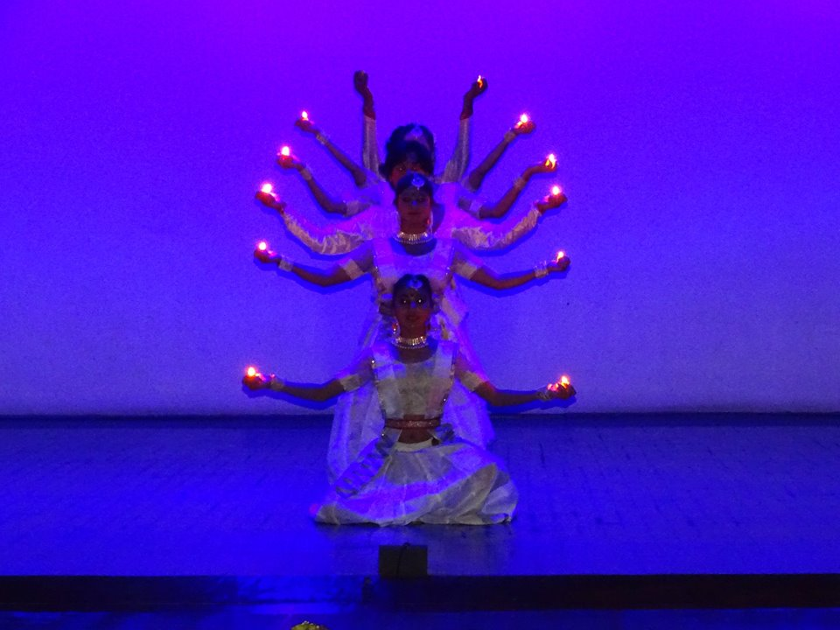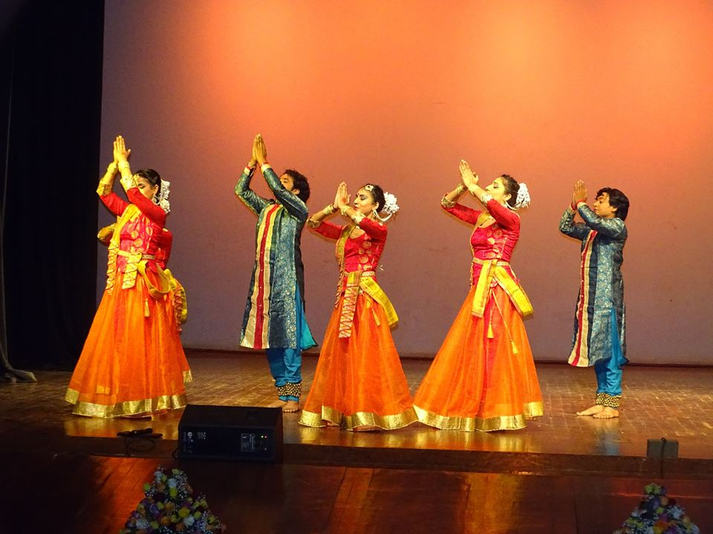

We hope that the Kenyan public takes full advantage of the presence of these talented artistes and participates in these performances which shall last till end November, 2016.
Nairobi, October 11, 2016
***

