Celebration of Gandhi Jayanti, 2016 at Ashgabat

Celebrations of “Gandhi Jayanti 2016 were held at at Bagtiyarlik Sports Complex –in front of Ashgabat Yoga Centre on Sunday 2nd October, 2016. Ambassador H.E Dr. T.V. Nagendra Prasad paide to Mahatma Gandhi by offering flowers and garlands at the Mahatma Gandhi statue at the Bagriryalik Sports Complex followed by other embassy officials, Indian community and members from the Sports complex.

On the occasion, Ambassador enlightened the gathering on the relevance of the thought, philosophy and relevance of teachings of Gandhi in the present world. Ambassador, recalled with gratitude to the leadership of the Turkmenistan for facilitating installation of Gandhi statue at the prime location in Ashgabat in July 2015 during visit of Hon’ble Prime Minister Shri Narendra Modi and attributed the gesture as commitment of the Turkmenistan to the Peace and Non-violence and strong bond it shares with India.. It is a fact that the installation of Gandhi statute coincided with the year of peace and neutrality in Turkmenistan.

Children of the Embassy officials paid tributes to Gandhi by singing songs and a poem followed by recitation of Gandhi jee’s favorite Bhajan ”Raghupati Raghav Raja Ram” Embassy Ladies.
***
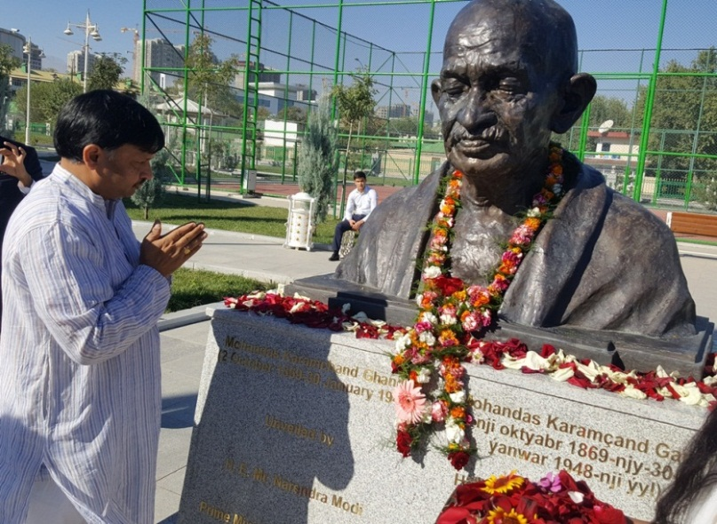
Gandhi Jayanti, 2016-Ambassadro Dr T V Nagendra Prasad paying floral tribute at Gandhi Statue
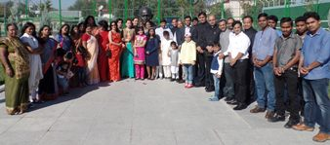
Gandhi Jayanti 2016-Embassy Officials and Indian Community
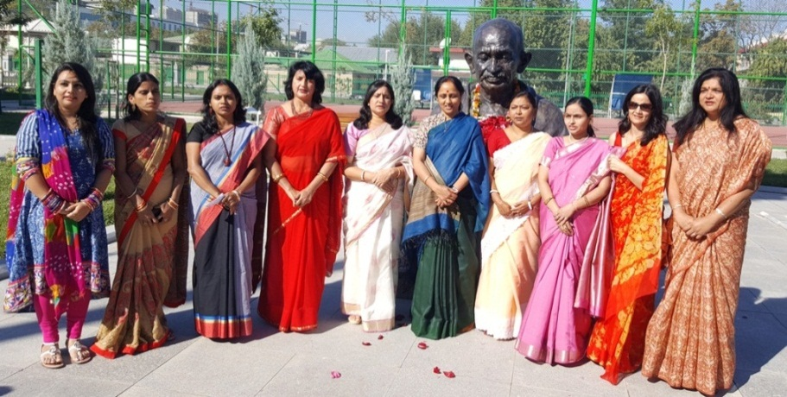
Gandhi Jayanti 2016- Gandhi Bhajan by Embassy Ladies.
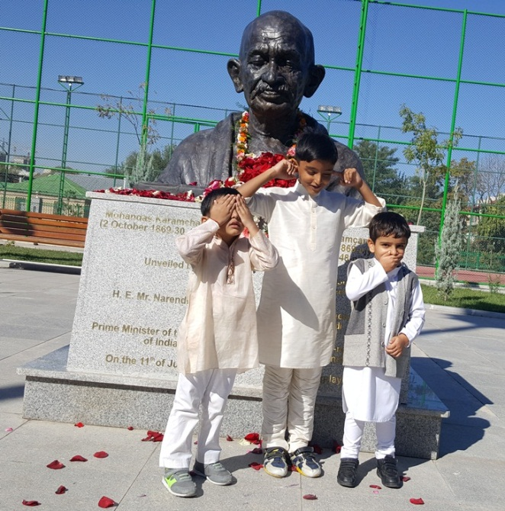
Gandhi Jayanti 2016- Gandhi jee ke teen Bandar

