High Commission of India
Nairobi

Commemoration of the 10th International Day of Non-violence in Nairobi
On the occasion of the 147thbirth anniversary of Mahatma Gandhi, the High Commission of India in Nairobi in association with the United Nations Office at Nairobi (UNON); the University of Nairobi (UoN) and Kenya-India Friendship Association (KIFA) organised an event to celebrate the 10thInternational Day of Non-Violence on 3 October 2016 at Taifa Hall of the University of Nairobi.
2. In heropening remarks,High Commissioner Ms Suchitra Durai underlined the importance of Mahatma Gandhi’s ideas of nonviolence and truth in today’s world. She informed the audience about India’s submission of the instruments of ratification of Paris Agreement to UN on the Gandhi Jayanti and importance ofadaptation of 'Gandhian way of life' to reduce carbon footprints and protect the earth from adverse impact of climate change.Director General of UNON Ms. Sahle Work-Zewderead out a special message of Mr. Ban Ki-Moon, Secretary General of the UN. Ms. Sahle Work-Zewde, highlighted the Gandhi’s ideals for protecting environment and urged the International Community to work towards achieving peaceand sustainable development.
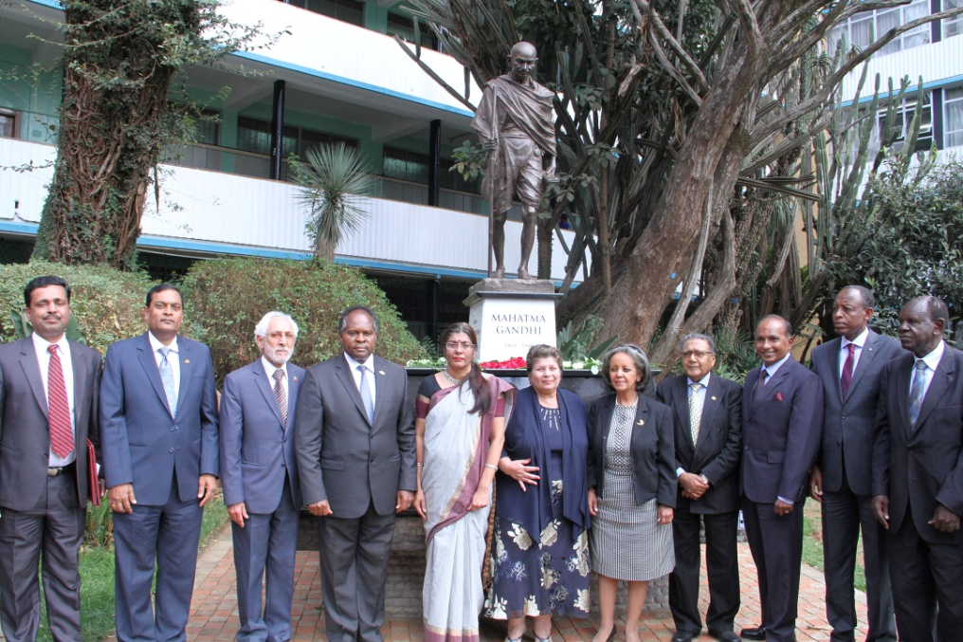
3. Prof PLO Lumumba delivered a special address on the “Relevance of Mahatma Gandhi in today’s world”. He highlighted the multi-dimensionality of Mahatma Gandhi’s personality and his philosophy and its relevance today. He emphasised that several individuals and movements all over the world have been influenced by the Gandhian philosophy and the relevance of the message of Mahatma Gandhi is beyond doubt as people, even today need to develop innovative, non-violent ways to overcome oppression and, combat discrimination particularly in Africa. Chairman of KIFA, Dr. Kenneth Ombongi emceed the event.
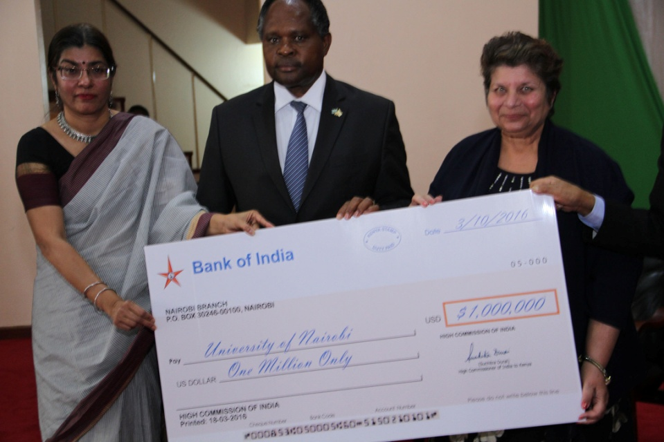
4. As a follow up to the announcement during Prime Minister Narendra Modi’s visit to Kenya in July 2016, the High Commissioner and Vice Chancellor of the UoN, Dr. Peter Mbithi signed an MoU on for renovation of the Mahatma Gandhi Graduate Library at the University of Nairobi. The High Commissioner handed over a cheque of US $ 1 million to the Chancellor of the University Dr. Vijoo Rattansi.
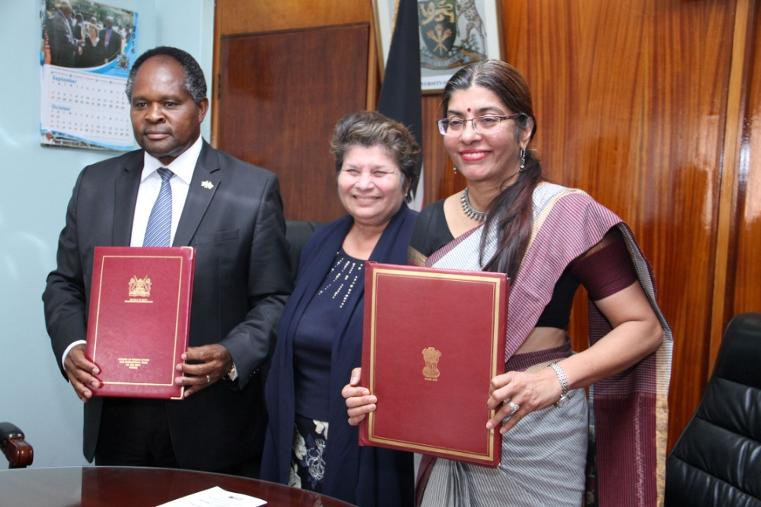
5. A short documentary titled “the Visionary Dreamer” produced by Prasar Bharti was screened. A tribute to Mahatma Gandhi was paid by performing Bhajans. A presentation titled ‘a simple man, the world calls Mahatma” produced by XPD Division, Ministry of External Affairs was screened prior to the event. A special photo exhibition prepared by the High Commission on the life and message of Mahatma Gandhi was displayed at the University.
6. The eventwas attended by around 500 people including High Commissioners/Ambassadors and members of the Diplomatic Corps, faculty and students of the University of Nairobiand representatives of Indian Communityin Kenyaincluding Pravasi Bharatiya Awardee Dr. Manu Chandaria and media.
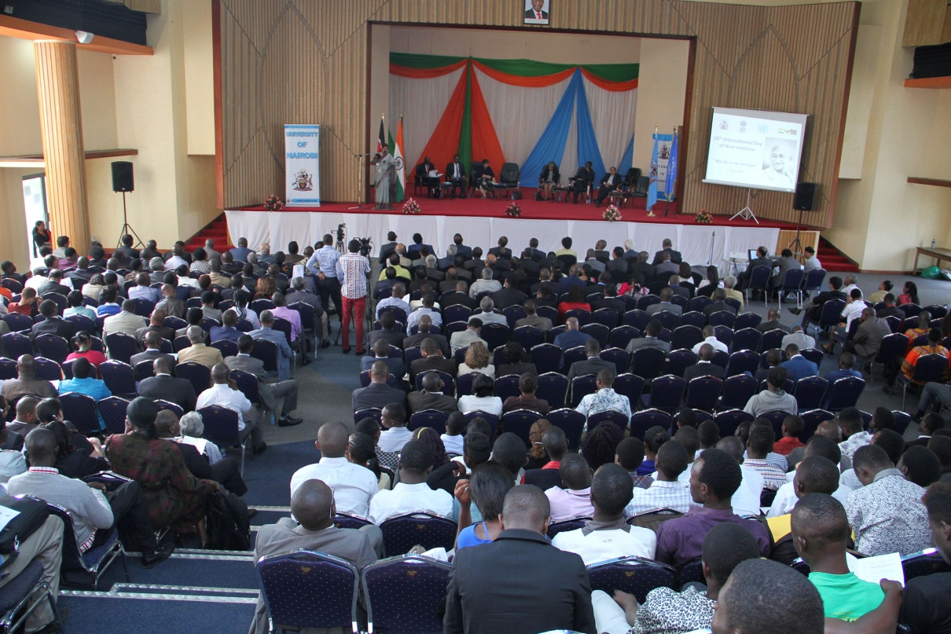
***
(Nairobi – 3 October 2016)

