Celebration of Hindi Diwas 2016
Embassy of India, Ashgabat
21.09.2016

……

Celebrations of “Hindi Diwas 2016’ were held at the Embassy Residence in Ashgabat on Wednesday, 21 September 2016. The programme was earlier scheduled for celebration on 14 September 2016, but due to certain local celebrations, it was celebrated on 21 September 2016.

Ambassador Dr. T.V. Nagendra Prasad presided over the function which was attended by officers, staff and 33 Turkmen students studying Hindi language at Azadi Institute of World Languages in Ashgabat. They were accompanied by Dr. Deepak Naresh, Hindi Chair (ICCR) and their local Hindi teacher Ms. Gulnara.

Speaking on the occasion, Ambassador appreciated the competence of the Turkmen students in understanding and speaking of Hindi. Debate, poetry recitation, essay writing and quiz competition were held among Turkmen students. An interactive session in Hindi between Turkmen students and Embassy officials was also held on the occasion.

The celebrations were concluded by distribution of prizes to the Turkmen Hindi language students and refreshments. The event was well appreciated by the local Hindi students.

------

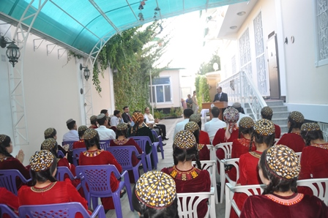
‘Hindi Diwas 2016’ organization of activities

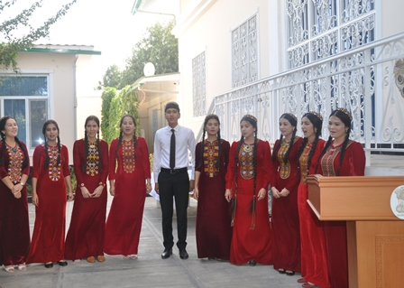
Participants from Azadi Institute of World Languages

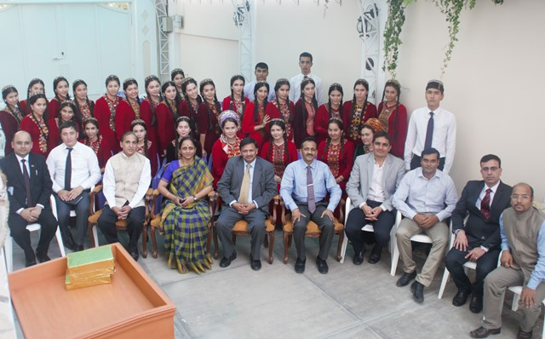
Participants with Ambassador and Embassy officials

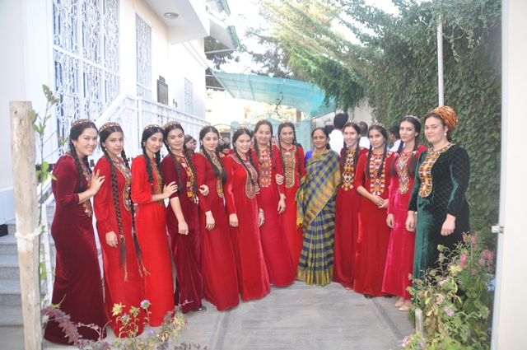
Participants with Mrs. Padmavathi, spouse of Ambassador

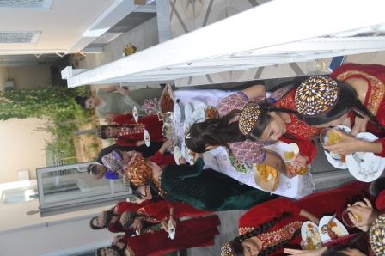
Snacks time

