Independence Day Celebrations in Ashgabat Turkmenistan

The Independence Day celebrations were held at the Embassy of Residence on Monday, 15 August, 2016. Indian community in Turkmenistan, PIOs and Embassy Officials' families participated. Ambassador Dr. T.V. Nagendra Prasad hoisted the Flag followed by the national anthem. Ambassador read out the adress of Hon'ble President Shri Pranab Mukherjee to the nation on the occasion. About 75 people assembled at the Residence for the celebrations. It also had patriotic songs, a yoga protocol for work place and refreshments.

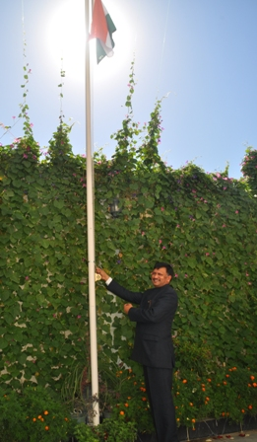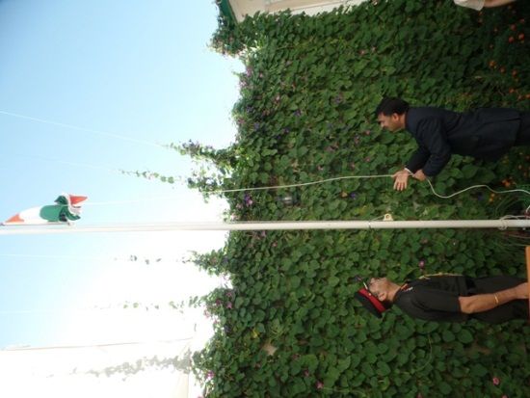
Flag hoisting by Ambassador, H.E T V Nagendra Prasad

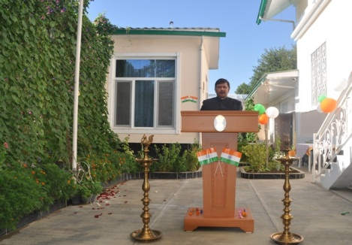
Address by Ambassador H.E T V Nagendra Prasad
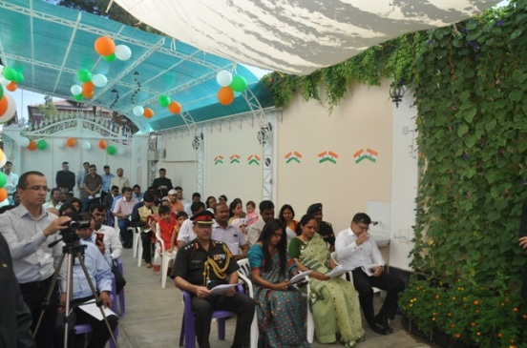
Indian Community and Embassy Members
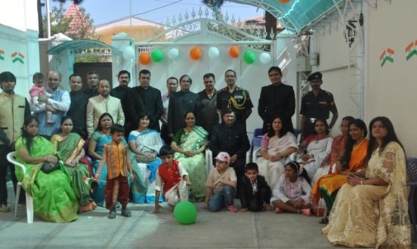
Embassy family picture

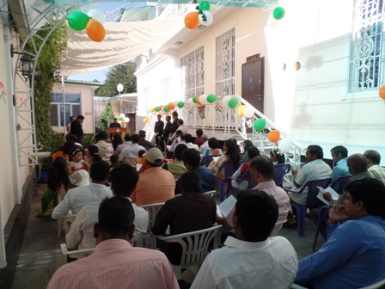
Indian Community
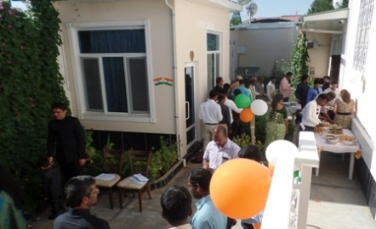
Refereshments

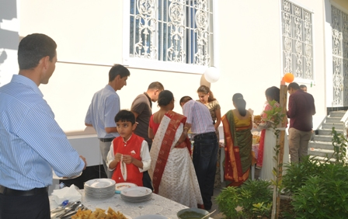
Refreshments

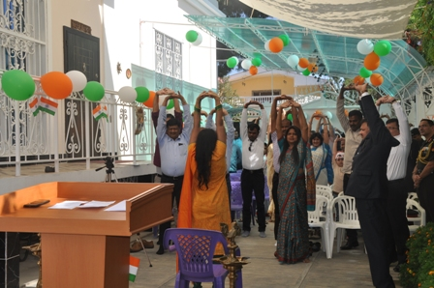
Yoga at Work Place

