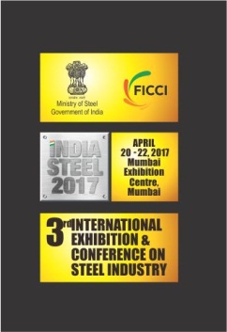
'India Steel Expo 2017'
'India Steel Expo 2017' consists of an International Exhibition and a Conference along with series of concurrent events such as CEOs Forum, Buyer-Seller meet, Investor Conclave etc. It is an exhibition- cum- conference on Indian Steel Industry focusing upon the value enhancement from mining to steel production and delivery of the steel products to end consumers.
2. The objective of the event is to showcase the latest products, technology, machinery and equipment, applications and developments in the Indian Steel Industry besides disseminating knowledge and information about the development and best practices in analysis, design and construction methodology pertaining to steel and mining. During the event, inter-linkages of mining and steel and the mining developments that can impact the Indian Steel Industry would be highlighted. The event will also give opportunity to understand global steel markets and identifying opportunities in Indian steel supply chain and logistics.
3. The event will provide a platform to the global investment community to connect with stakeholders in the steel, mining, logistics and equipment manufacturing for business alliances and partnerships. The participants would interact with policy makers, supply chains, emerging technologies for steel in India. This would also be an ideal platform to launch new products and find sales agents or distributors in new markets.
Contact details of the FICCI for any clarification or additional information is as under:
Ms. Pallavi Thakur, Assistant Director,
Industry's Voice for Policy Change
Federation of Indian Chambers of Commerce and Industry
Federation House, Tansen Marg, New Delhi - 110 001
M : +91 9953038483
T : +91-11- 2348 7225 | F : +91-11-2332 0714
E :pallavi.thakur@ficci.com

