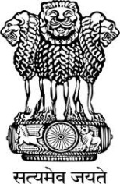
Embassy of India
Belgrade

Press Release

Sub: India@70 Celebration

The Embassy of India has brought out a special supplement titled “India@70 - A Rising Power” on the occasion of 70th Year of India’s Independence, in the prestigious “Diplomacy & Commerce” magazine in Serbia, with interviews and feature articles on India’s trade & economy, culture, flagship programmes, BRICS, space technology, AYUSH, etc. The Embassy has planned Year-long celebrations to mark “India@70”.

The supplement can be read on the Embassy’s website (link: https://issuu.com/cmcpresentation/docs/india_2016_web?e=23862942/37683488).

Belgrade
August 3, 2016

