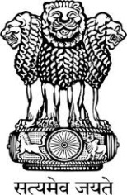
Embassy of India
Belgrade
Press Release

Speaker of National Assembly of Serbia invited to visit India

Hon’ble Chairman, Rajya Sabha Shri Mohammad Hamid Ansari and the Hon’ble Speaker, Lok Sabha Smt. Sumitra Mahajan have congratulated their Serbian counterpart, H.E. Ms. Maja Gojkovic on her recent re-election as the Speaker of the National Assembly of the Republic of Serbia consequent to the April 24 Parliamentary elections.

In their letter of congratulations which was handed over by Ambassador Mrs. Narinder Chauhan, H.E. Ms. Gojkovic has been invited to visit India on mutually convenient dates.

India and Serbia are historic allies with tradition of support to each other on issues of core interest. Parliamentary exchanges will further enhance friendly relations between the two countries.

The National Assembly of Serbia has also been separately invited to avail of Parliamentary training programmes under Government of India’s fully funded ITEC Scheme.

Belgrade
July 8, 2016

*******

