Second International Day of Yoga celebrated in Ashgabat, Turkmenistan
21 June 2016
………….

The 2nd International Day of Yoga was celebrated at the Yoga Centre in Ashgabat at 0730 hrs on June 21, 2016 with great joy and enthusiasm. A large gathering of more than 700 yoga practitioners including the Diplomatic community, students of State Medical University participated at the event. Ambassador of India Dr. T.V. Nagendra Prasad and the Minister of Healthcare and Industry H.E. Mr. Amannepesov Nurmuhammet inaugurated the Yoga Day Celebrations.

Hon’ble Minister of Healthcare and Industry of Turkmenistan in his address mentioned about the opening of the Yoga Centre by Hon’ble Prime Minister Shri Narendra Modi in July, 2015 which had attracted over 1500 Turkmen citizens to learn and practice Yoga during the last ten months. The oldest and youngest practitioners were given presents by the Chief Guest H.E. Amannepesov Nurmuhammet. In the beautiful surroundings of Bagtyarlyk Sports Complex led by the Indian Yoga teachers, the entire Yoga Protocol was performed by the participants. Later, two special performances of very advanced Yoga postures were presented by two groups of practitioners which were highly appreciated by the gathering.

Speaking on the occasion, Ambassador Dr. T.V. Nagendra Prasad extolled the virtues of Yoga in bringing balance, sustainability and peace to the society. He highly appreciated the support of President of Turkmenistan H.E. Mr. Gurbanguly Berdimuhamedov and the Government for their support to the Yoga and also in maintaining the Yoga Centre. The orchestra of the Turkmen Cultural Ministry added to the occasion with its melodious music to make the celebrations truly festive. As compared to the 1st International Day of Yoga, this Yoga Day has seen three-fold increase of participants who are serious practitioners which is solely due to the Ashgabat Yoga Centre which was set up during the visit of Hon’ble Prime Minister Shri Narendra Modi in July, 2015.

On the occasion, a Conference was conducted at the State Medical University auditorium with the participation of medical students which was chaired by Ambassador Dr. T.V. Nagendra Prasad.

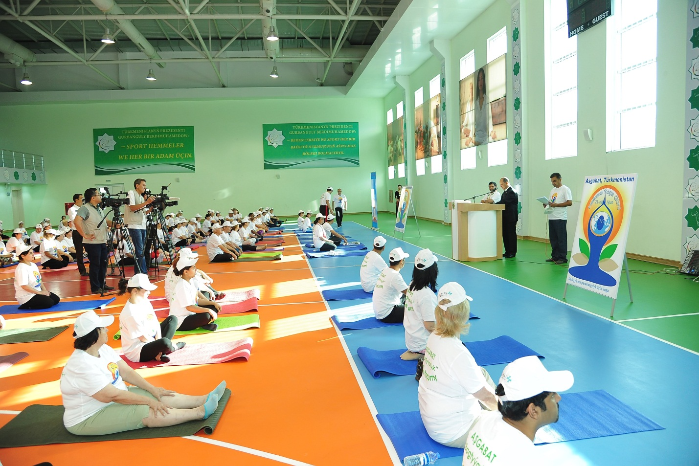

Minister of Healthcare and Industry H.E. Mr. Amannepessov inaugurating the Yoga Day Celebrations

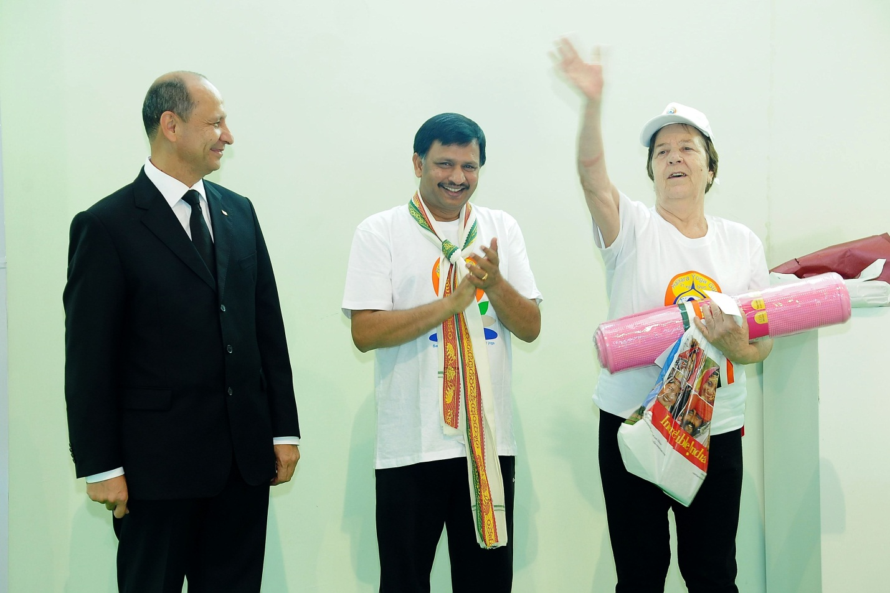
Chief Guest Minister of Healthcare and Industry H.E. Mr. Amannepessov appreciating the oldest Yoga practitioner

Participants showing a Yoga Mudra
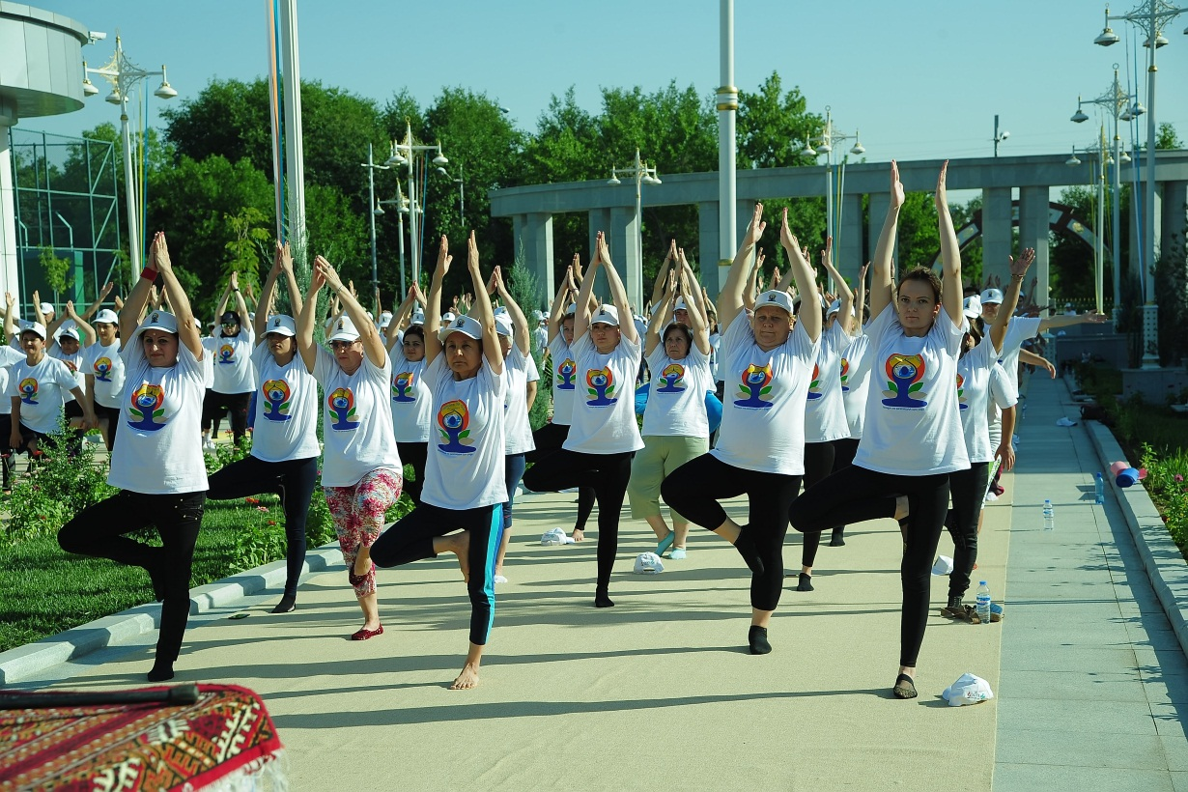
Participants showing a Yoga Mudra
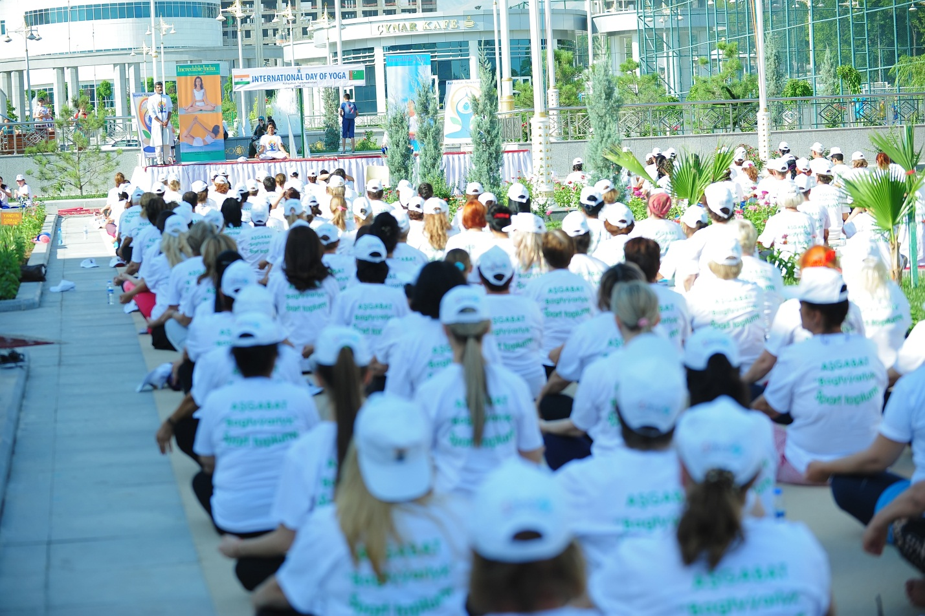
Participants at the 2nd IDY celebrations
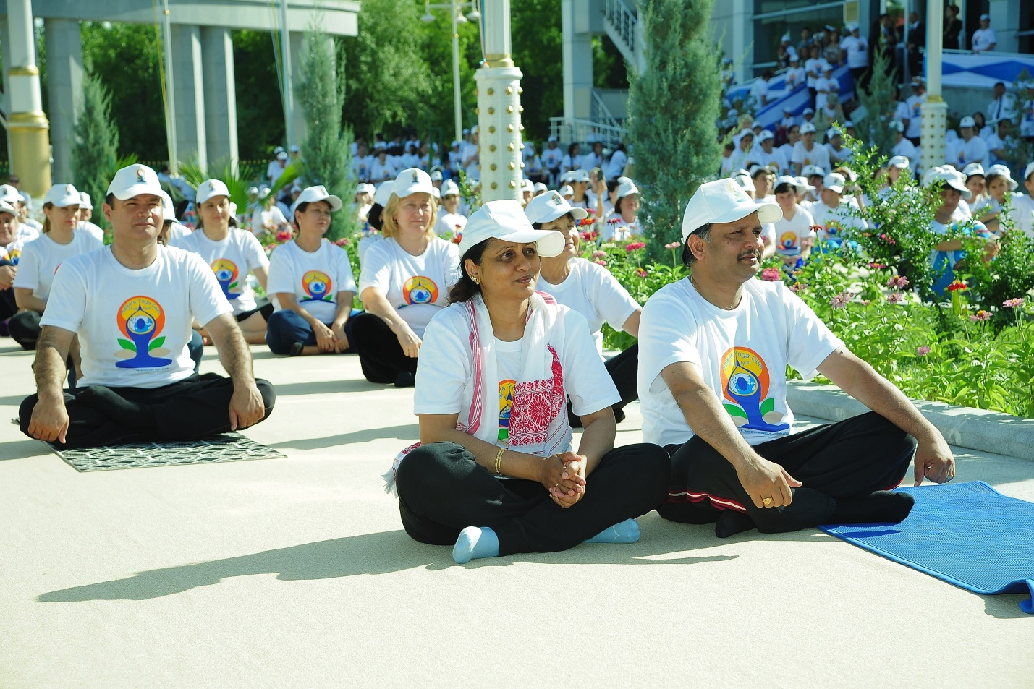
Ambassador Dr. T.V. Nagendra Prasad, Mrs. Padmavathi Nagendra Prasad along with Yoga practitioners at the 2nd IDY celebrations
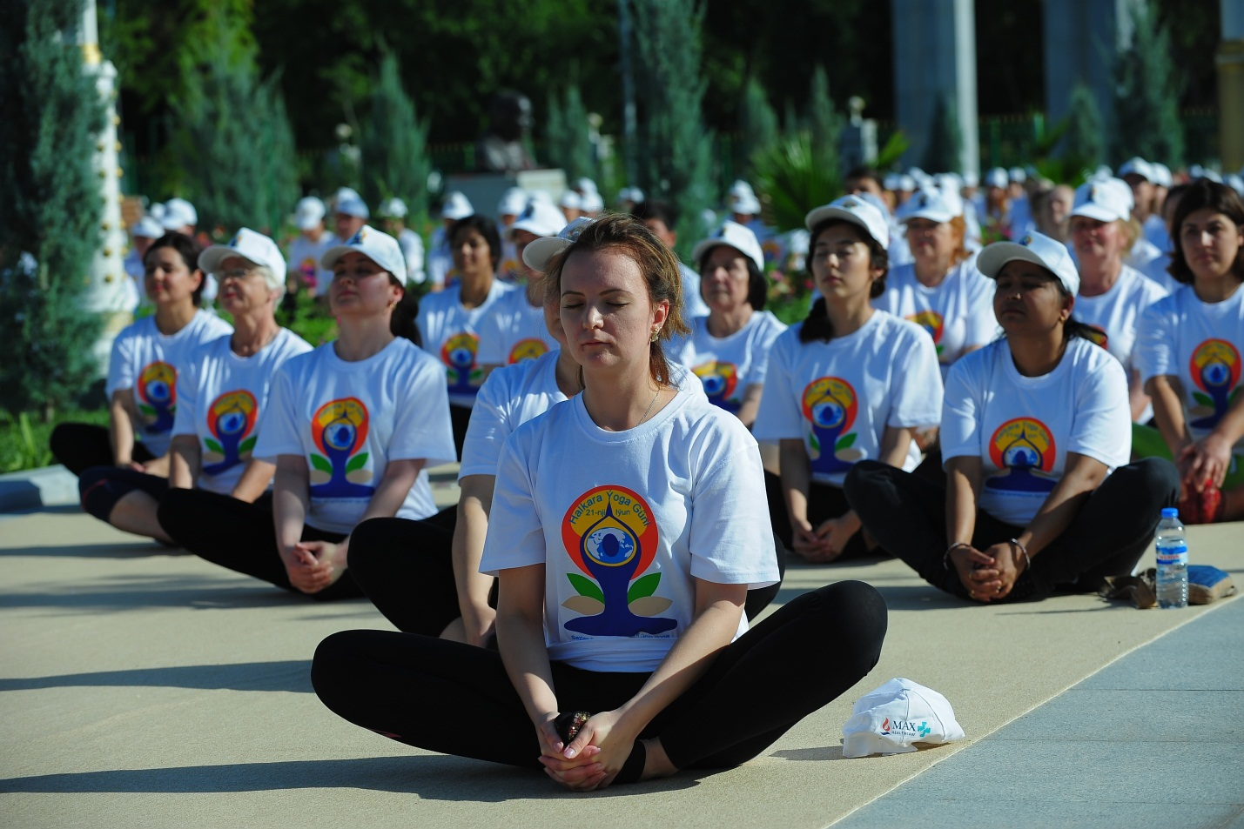
Participants at the 2nd IDY celebrations
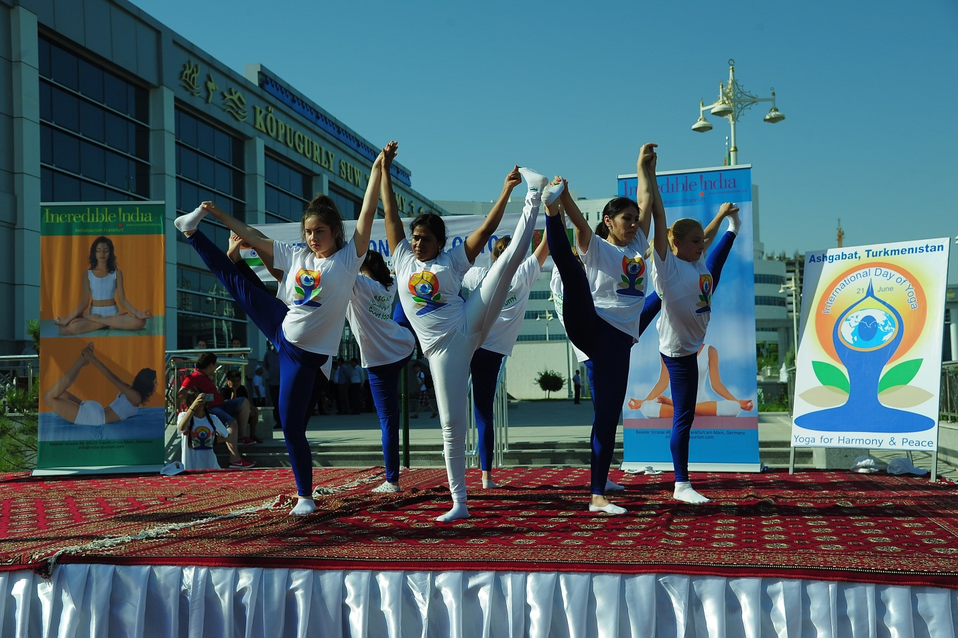
A special performance
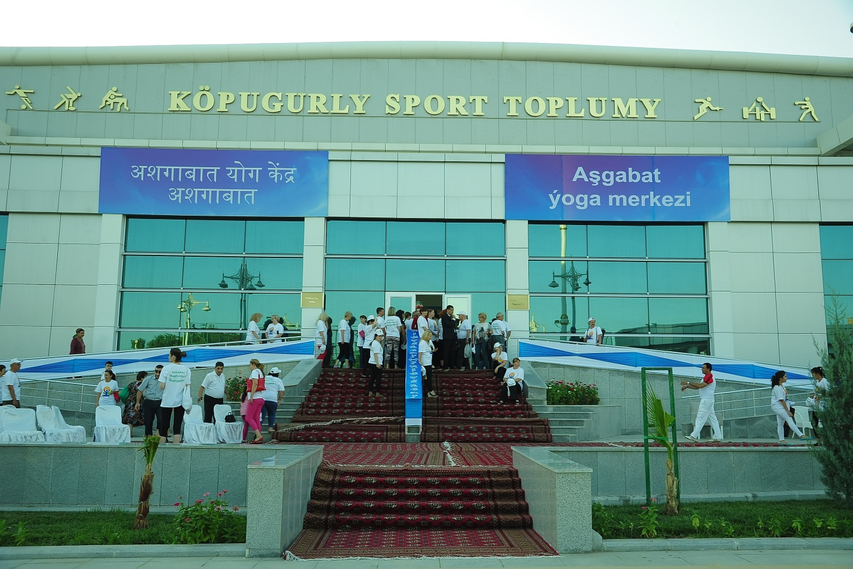
Ashgabat Yoga Centre

Another batch of participants in Yoga Mudra

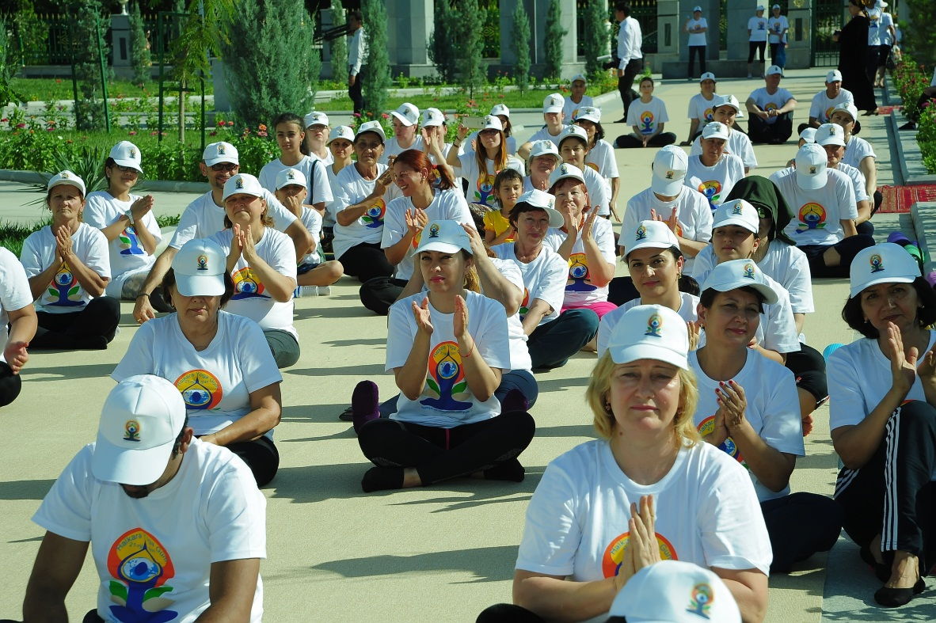
Participants at the 2nd IDY celebrations

