125th Birth Anniversary of Dr. B.R. Ambedkar
…..

The 125th Birth Anniversary of Dr. B.R. Ambedkar, the architect of India’s Constitution was celebrated in Embassy of India, Ashgabat, Turkmenistan on 14 April, 2016.
Ambassador Dr. T.V. Nagendra Prasad led the function by paying floral tributes to Dr. B.R. Ambedkar followed by Embassy officials, families and children. Children of Embassy officials also spoke about the many facets of Dr. Ambedkar’s life, ideals and leadership on the occasion.

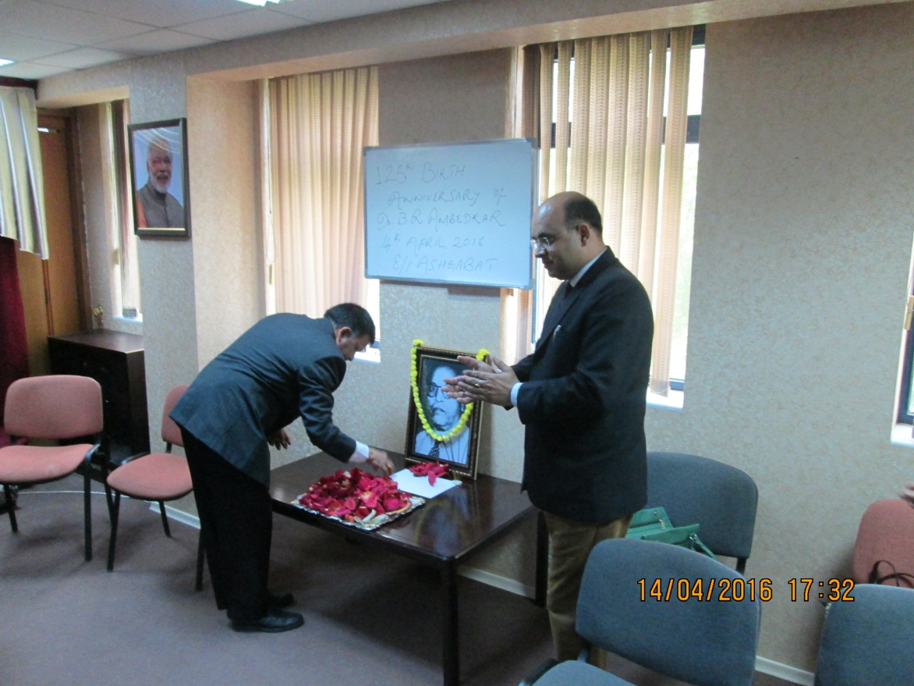
Ambassador Dr. T.V. Nagendra Prasad paying floral tributes
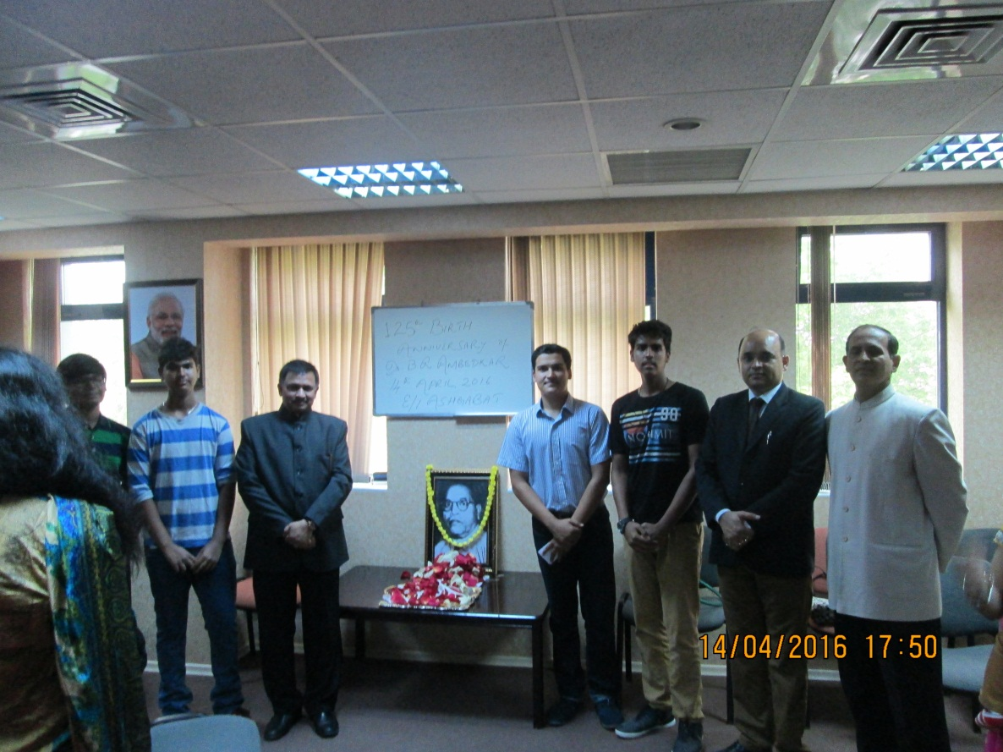
Ambassador Dr. T.V. Nagendra Prasad with children who spoke on the occasion

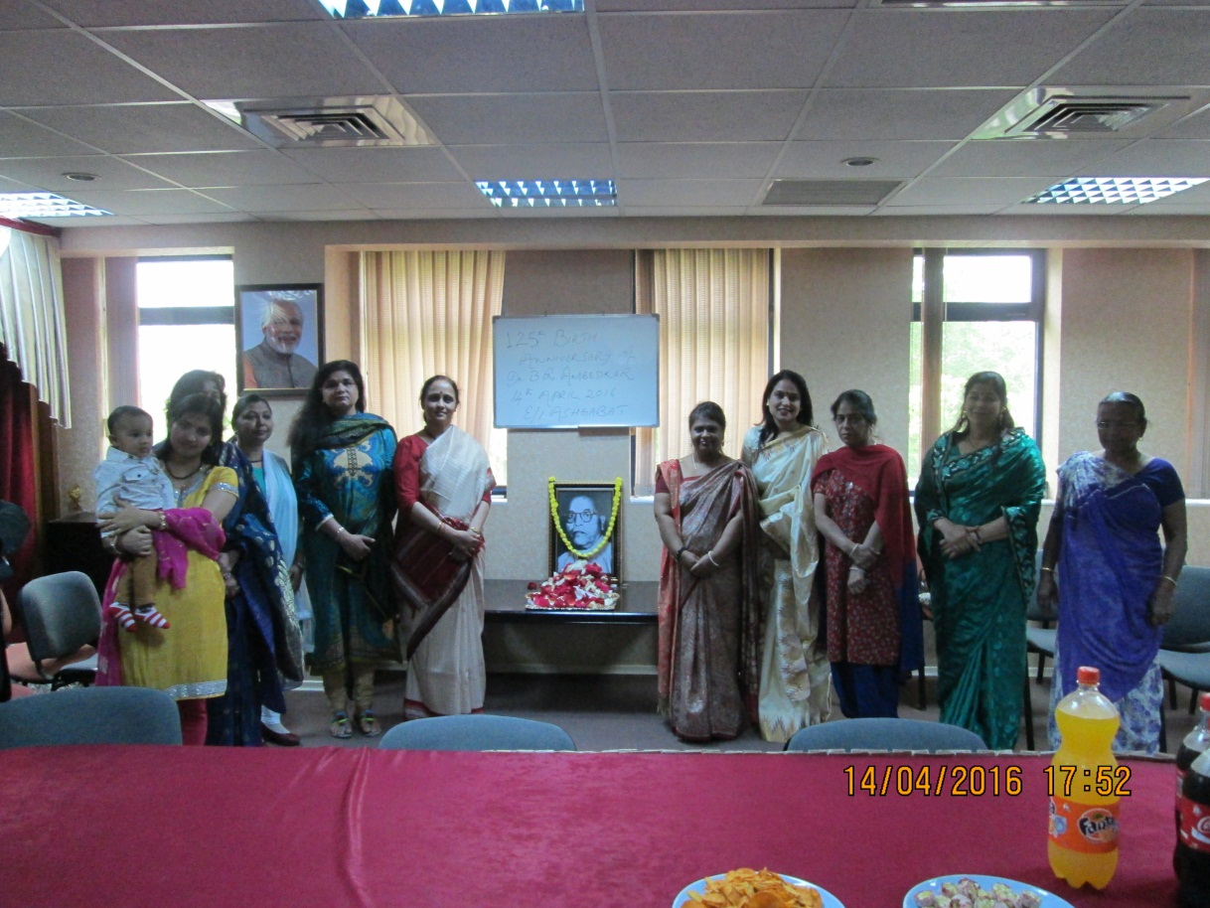

Embassy ladies paying tributes to Dr. B.R. Ambedkar

