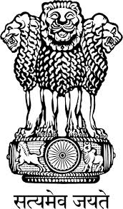
Embassy of India
Belgrade

Press Release

H.E. Mr. Aleksandar Vucic, Prime Minister of Serbia in a letter to Mr. Narendra Modi, Prime Minister of India has expressed Government of the Republic of Serbia’s and his personal condolences on the tragic accident that took place at the Puttingal temple in Kerala State of India on April 10, 2016.

Place: Belgrade
Date: April 11, 2016

*****

