24th Steering Committee Meeting of TAPI Gas Pipeline Project
Ashgabat, 7 April, 2016
………..

The 24th Steering Committee Meeting of TAPI Gas Pipeline Project was held in Ashgabat on April 7, 2016. The Indian delegation was led by Shri K.D. Tripathi, Secretary, Ministry of Petroleum and Natural Gas to participate in the meetings. A milestone was achieved during this meeting with the signing of the Investment Agreement between the parties. All the member countries and the Transaction Advisor ADB have appreciated the initiative of Turkmenistan on beginning of the construction of the pipeline from the Turkmen side. Ambassador Dr. T.V. Nagendra Prasad and senior officials of GAIL participated in the meeting from the Indian side.
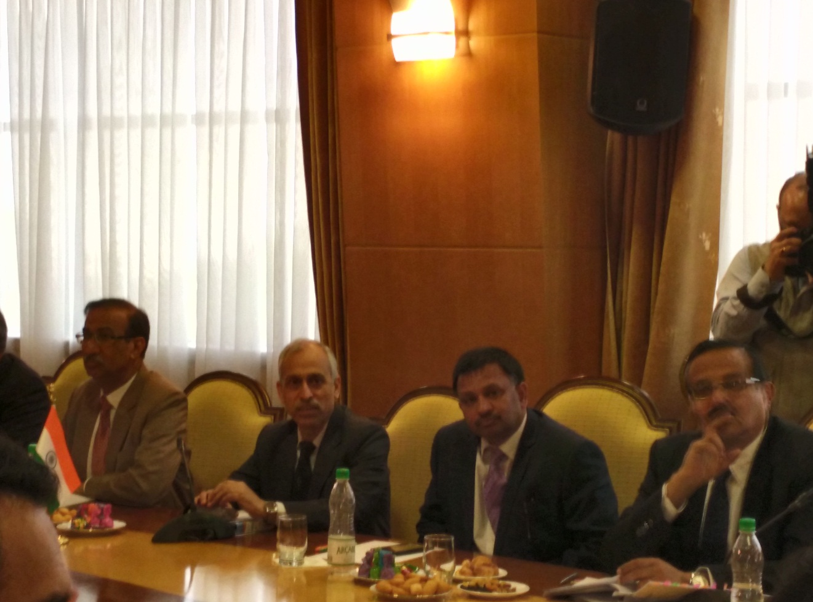
24th TAPI Steering Committee Meeting
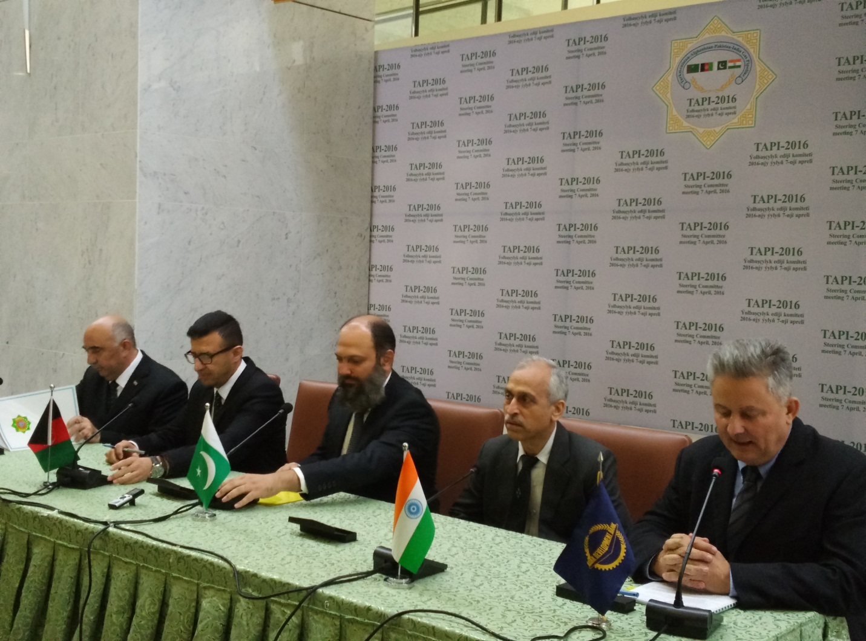
Delegates from TAPI countries

