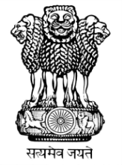 | भारत का राजदूतावास  मिंस्क  EMBASSY OF INDIA  MINSK

PRESS RELEASE

The 67th Republic Day was celebrated at the Chancery. Ambassador H.E. Mr. Pankaj Saxena hoisted the National Flag which was followed by collective singing of National Anthem by the gathered audience. Ambassador read out President’s address to the nation to the assembled audience of around 50 members from Indian community, OCI and Belarusian friends of India. Arrangements were also made by the Mission for the live telecast of Republic Day parade from New Delhi. The event was concluded with the serving of light Indian refreshments.

26th January 2016
Minsk
