TAPI Ground-breaking Ceremony, Mary, 13 December, 2015

……….

Hon’ble Vice President Shri M. Hamid Ansari along with President Gurbanguly Berdimuhamedov, President Ashraf Ghani and Prime Minister Nawaz Sharif participated at the traditional ceremonies of TAPI ground-breaking by signing the Memorial Document and pressing the push button to start welding of pipelines in Mary on 13 December, 2015 at a very impressive ceremony with the participation of people of Mary province. The leaders of member countries also signed on the Pipeline on the occasion. Hon’ble Vice President of India was accompanied by Hon’ble Minister of State (I/c) for Petroleum and Natural Gas Shri Dharmendra Pradhan and a high-level delegation.

Speaking on the occasion, Hon’ble Vice President termed the event as historic for the TAPI gas pipeline project and said that the time has come to write another chapter in the voyage through history and the idea of an economically integrated South and Central Asia, whose time has come. The highly successful event was witnessed by the people of Mary, Cabinet and senior officials of Turkmenistan, visiting delegations of India, Pakistan and Afghanistan and Ambassadors resident in Ashgabat.

………….

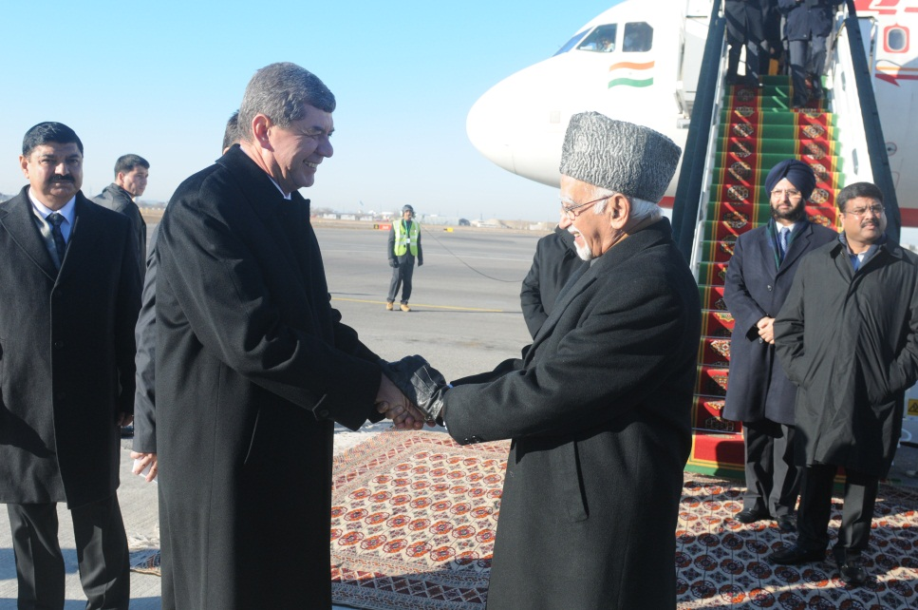
Hon’ble Vice President Shri M. Hamid Ansari being received at Mary Airport

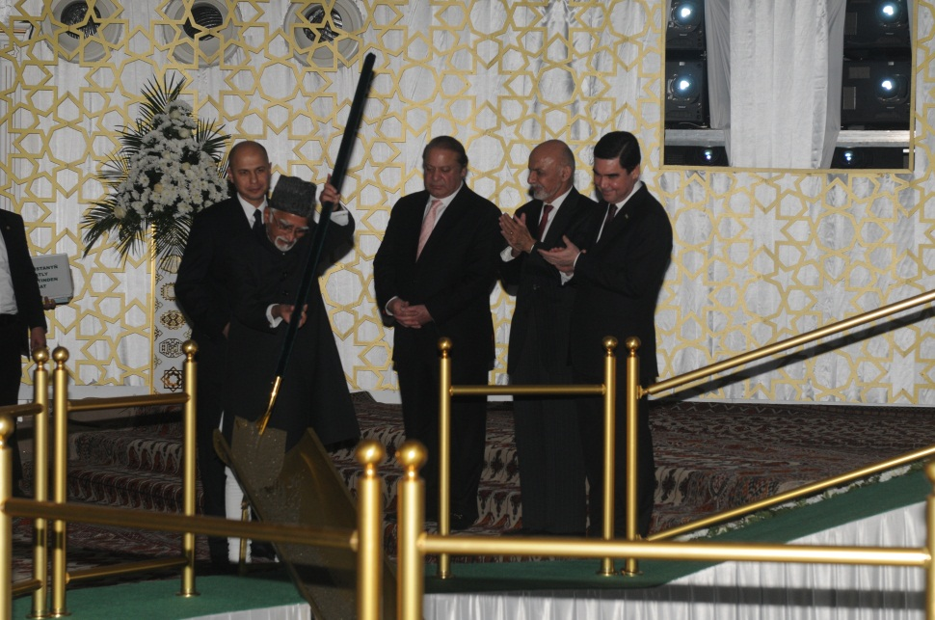
Hon’ble Vice President Shri M. Hamid Ansari at the TAPI ground-breaking traditional ceremony

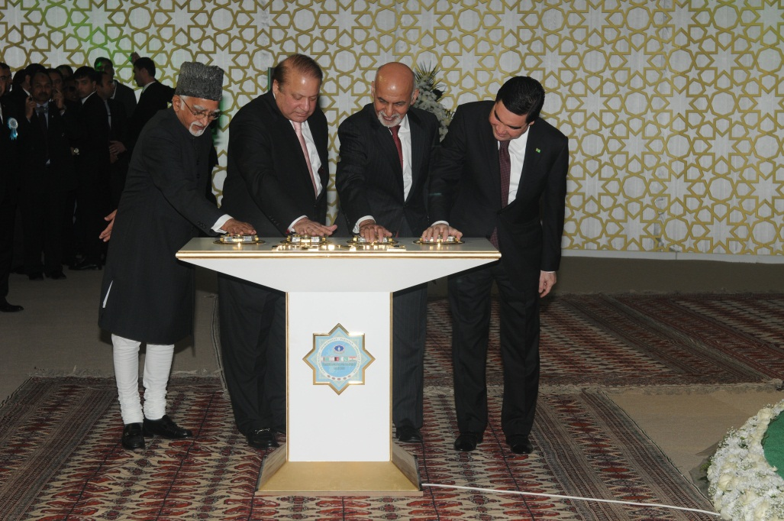
Hon’ble Vice President Shri M. Hamid Ansari, President Gurbanguly Berdimuhamedov, President Ashraf Ghani and Prime Minister Nawaz Sharif pressing the push button

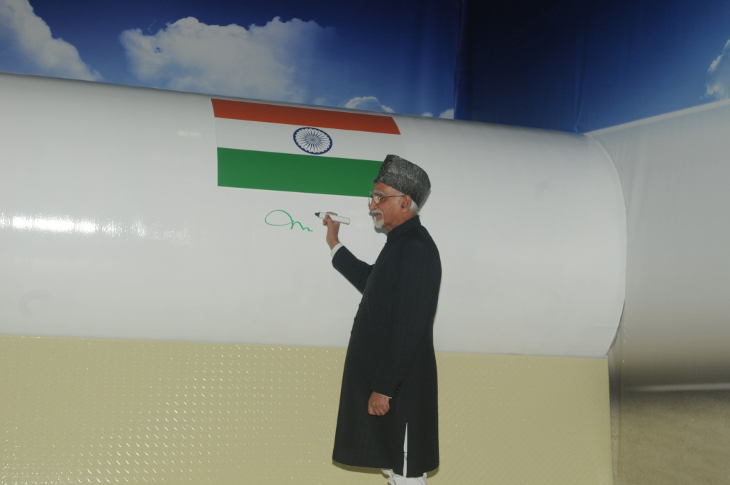
Hon’ble Vice President Shri M. Hamid Ansari signing on the TAPI pipeline at the TAPI ground-breaking traditional ceremony

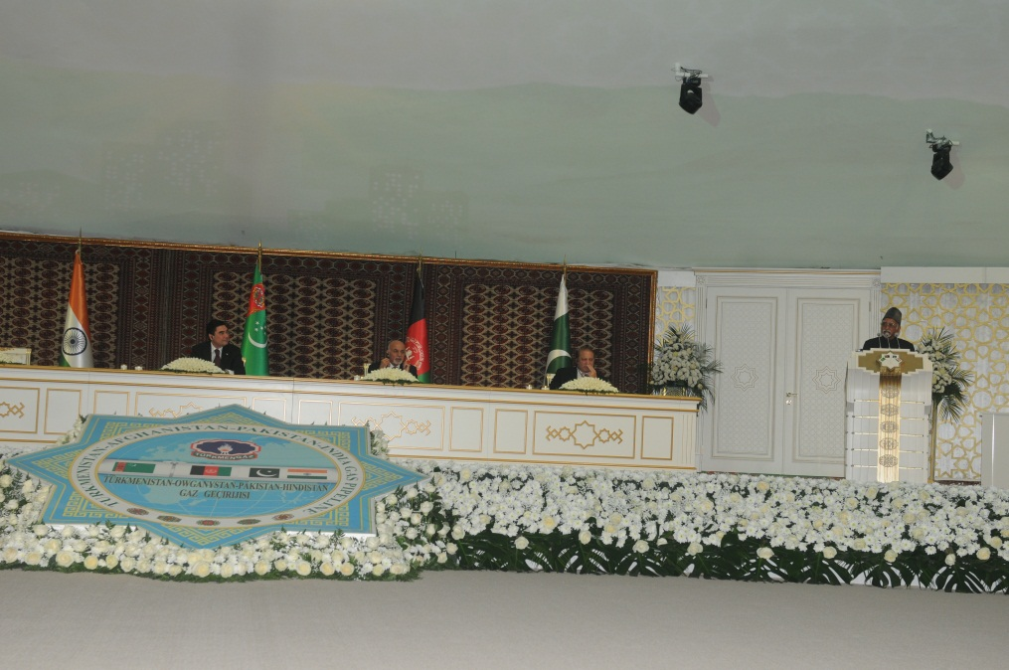
Hon’ble Vice President Shri M. Hamid Ansari speaking at the TAPI ground-breaking ceremony

