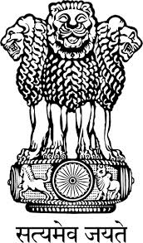

Embassy of India
Belgrade

Press Release

Diwali Concert of Indian Classical Dance “Bharatnatyam”
Embassy of India, Belgrade, in collaborationn with Indian Council for Cultural Relations (ICCR), New Delhi, has organised Diwali Concert of Indian Classical Dance “Bharatnatyam”, led by Ms. Jyotsna Jagannathan on November 30, 2015 at Terazije Theatre, Belgrade. The Group is also scheduled to perform at Cultural Centre, Zrenjanin on 1st December, 2015.
The performance will include different formats of Bharatnatyam, including Kolam (inspired by the decorative geometric patterns), Varnam (core of the Bharatnatyam repertoire), Padam (Lyrical section where the dancers speak of some aspect of love); Story of Ramayana (as told to the baby Krishan at bedtime), and Thillana (a joyous dance).

The Concert will be attended by large number of dignitaries, including members of the diplomatic corps and international organizations; senior officials of the Government of the Republic of Serbia, civil society, cultural institutions, members of the media, renowned personalities from the fields of music, art, films, etc.

Bharatnatyam is one of the most popular classical dances of India. Bharatnatyam dance is almost 2,000 years old. It is believed that Bharatnatyam was revealed by Lord Brahma to Bharata, a famous sage who then codified this sacred dance in a Sanskrit text called the Natya Shastra. The Natya Shastra is one of the fundamental treatises on Indian drama and aesthetics. The Bharatnatyam dance flourished in the Hindu temples of South India. The temple dancers flourished under royal patronage and religious devotion. Bharatnatyam is considered the mother art of most of the other classical dances of India and inspires many art forms like sculpture, painting, and icon-making.

Place: Belgrade
Date: November 27, 2015

