Deepawali celebrations at Embassy Residence
…………

Indian Embassy Ladies organized a Diwali function on 10 November, 2015 at the Embassy Residence in Ashgabat with the participation of Spouses of Heads of Missions and local women from different walks of life.
A rich cultural extravaganza, diverse food, Indian music, Mehendi, Rangoli and Indian Sari were showcased at the event. The participants enthusiastically participated and enjoyed Diwali by lighting lamps and a variety of Indian delicacies served on the occasion of Deepawali.
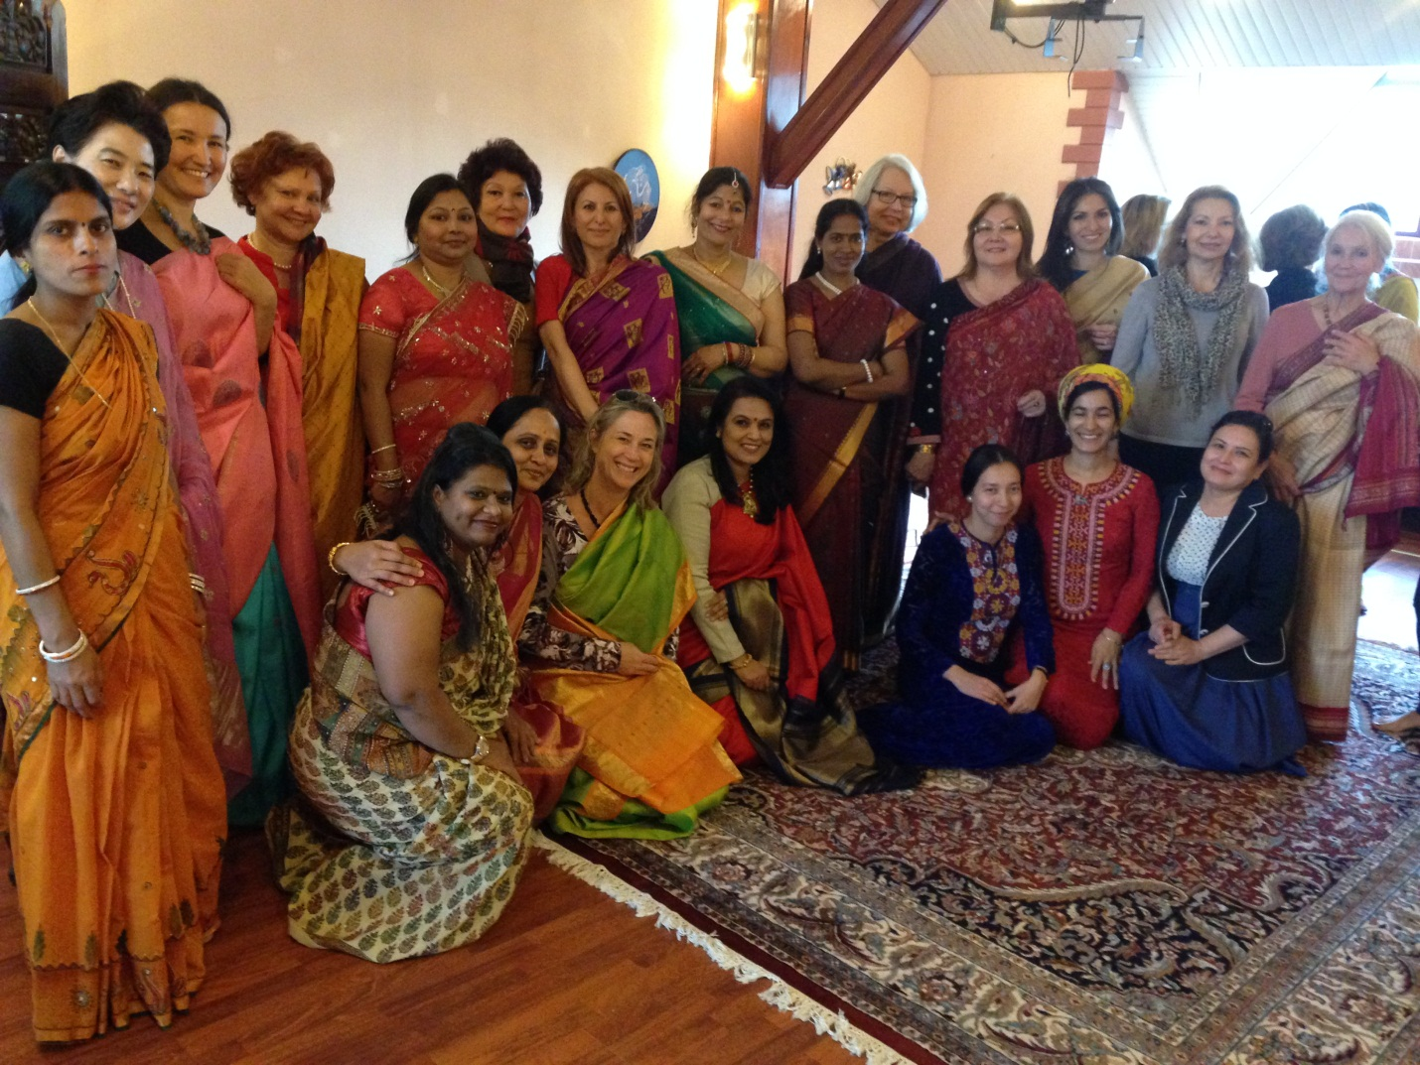
Celebrating Deepawali at Embassy Residence
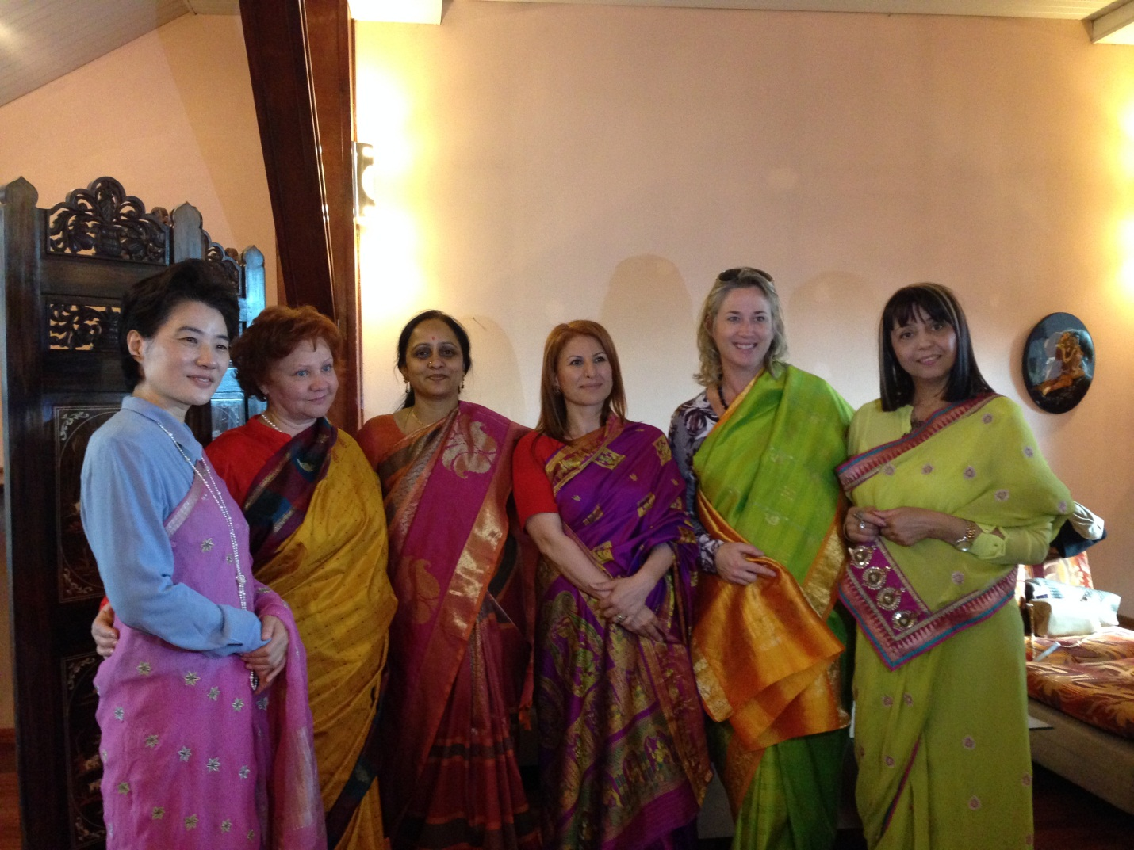

Spouses of HOMs resident in Ashgabat
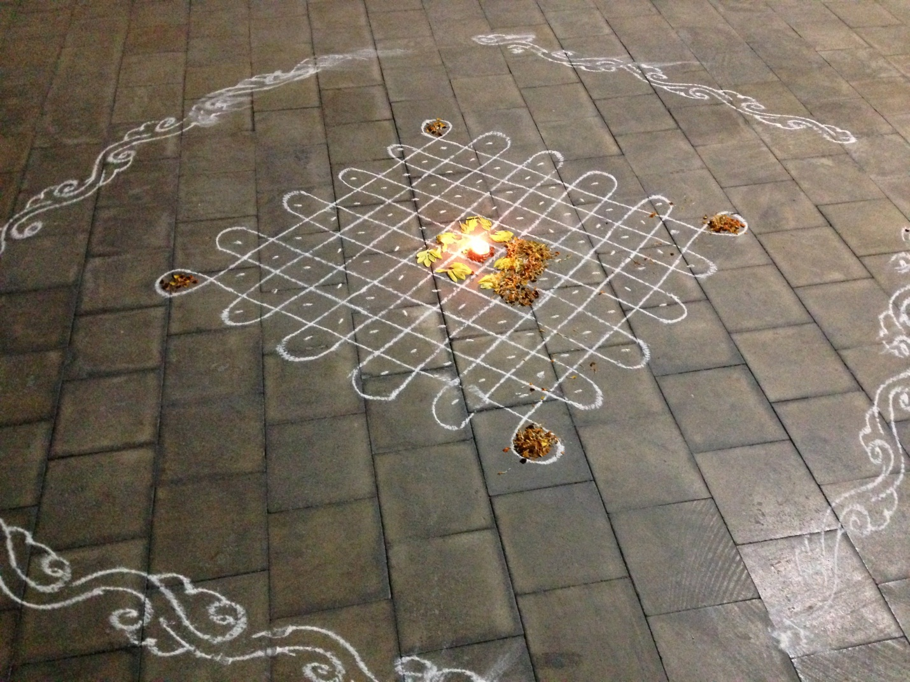

Rangoli at Embassy Residence

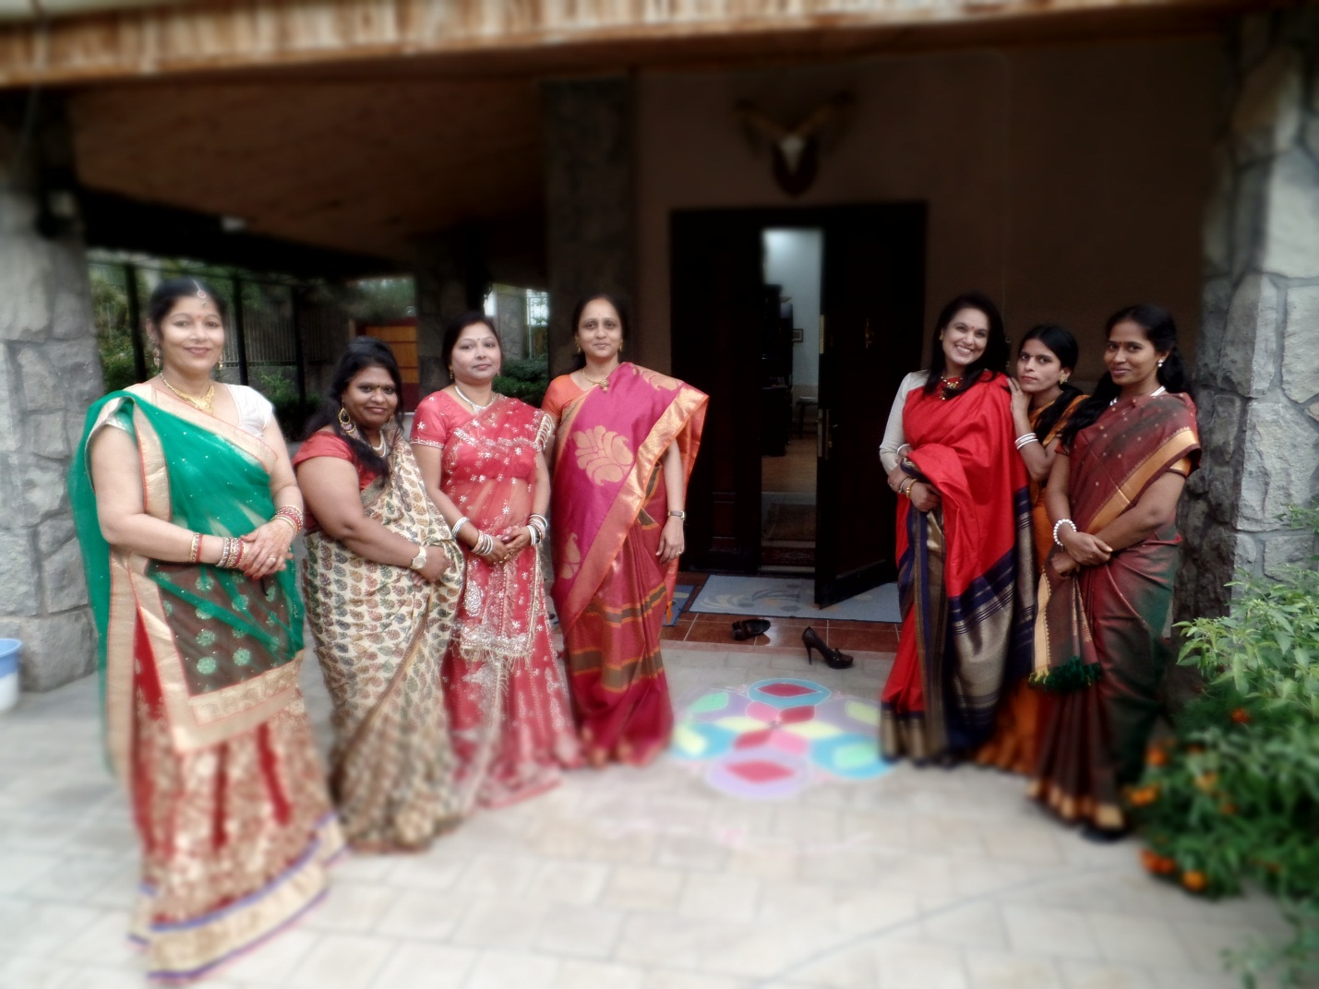

Celebrating Deepawali at Embassy Residence

