Gandhi Jayanti Celebrations in Ashgabat
02 October 2015
….

Gandhi Jayanti was celebrated in Ashgabat on 02 October, 2015 at the Mahatma Gandhi Bust installed at the Bagtyarlyk Sports Complex which was inaugurated by the Hon’ble PM Shri Narendra Modi on 11 July, 2015. The celebration was attended by Embassy officials, their families and children. Turkmenistan was represented by officials from the Ministry of Foreign Affairs and Mayor’s office.
The celebrations began with Ambassador garlanding the Gandhi’s Bust, followed by an address, singing of Bhajans, speeches by children on Gandhiji on his ideals and paying respects by all assembled at the venue. The Turkmen representatives also paid tributes to Gandhiji in their speeches and stressed on strengthening of India-Turkmenistan relations.
…………..
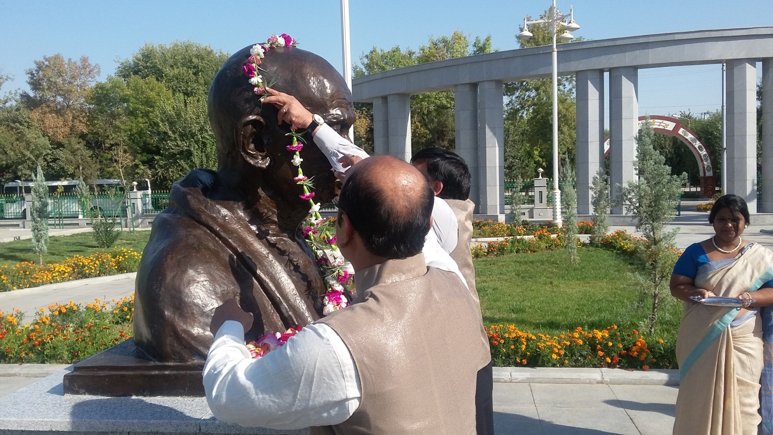
Ambassador Dr. T.V. Nagendra Prasad garlanding Mahatma Gandhiji’s Bust

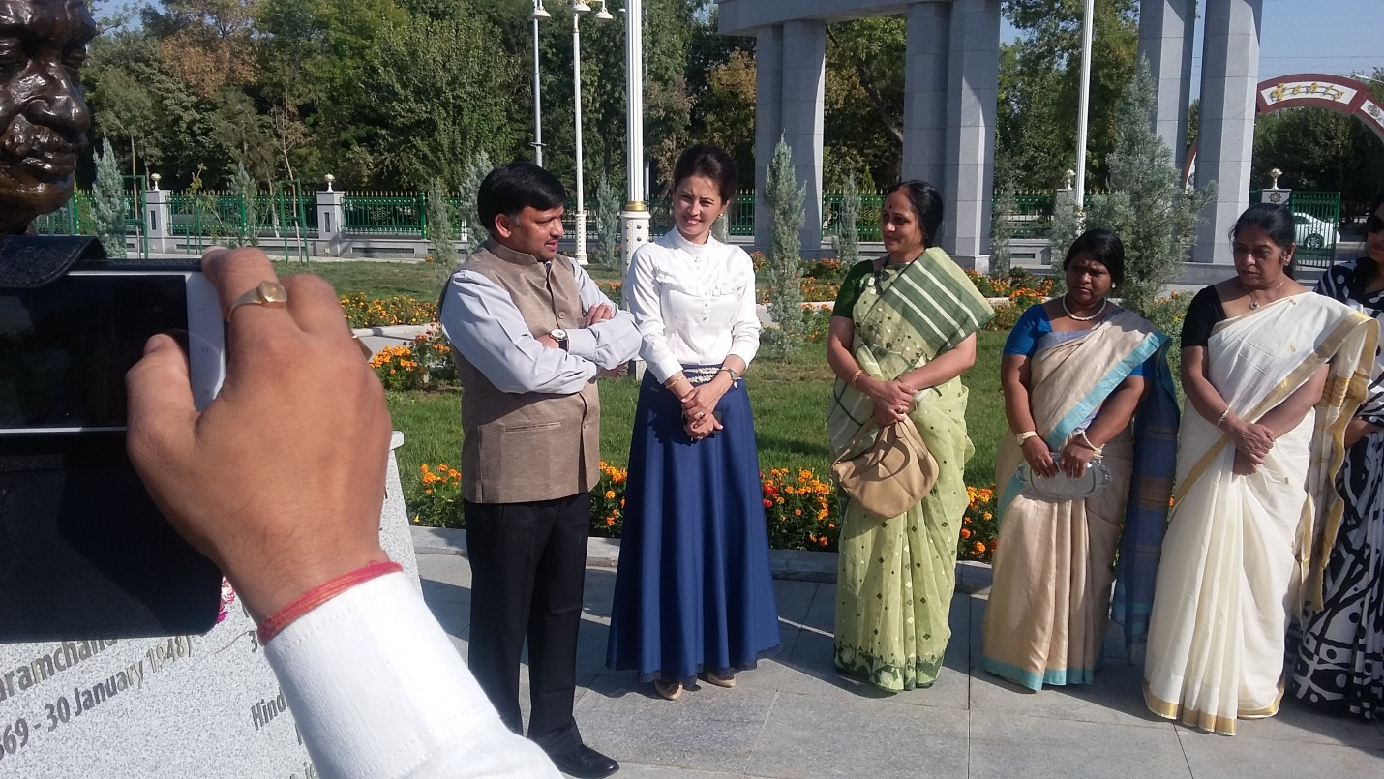
Ambassador Dr. T.V. Nagendra Prasad addressing the gathering

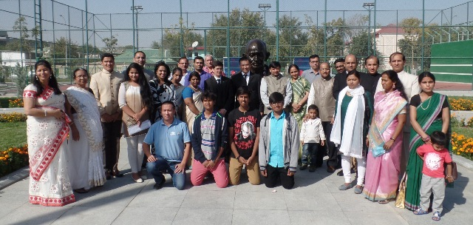

Group photo

