Independence Day celebrations in Ashgabat, Turkmenistan
…..

The Independence Day celebrations were held at the Embassy Residence on Saturday, 15 August 2015 with pomp. Indian community in Turkmenistan, PIOs and Embassy Officials’ families participated. Ambassador Dr. T.V. Nagendra Prasad hoisted the Flag followed by the national anthem. Ambassador read out the address of Hon’ble President Shri Pranab Mukherjee to the nation on the occasion. About 50 people assembled at the Residence for the celebrations.
………….

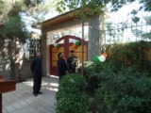

Unfurling the national flag by Ambassador

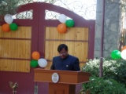

Ambassador Dr. T.V. Nagendra Prasad reading out President’s Message

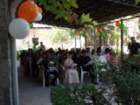

participants at the function

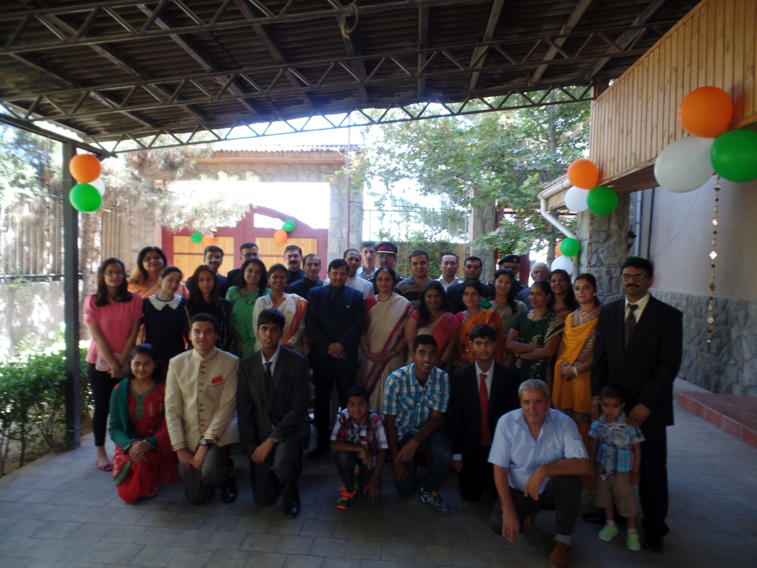

Embassy officials and their families

