HIGH COMMISSION OF INDIA
PORT LOUIS
MAURITIUS

PRESS RELEASE

EEZ SURVEILLANCE
BY INDIAN NAVAL SHIP TEG

(10 TO 29 JULY 2015)

Testimony to the deep rooted friendship and multifaceted cooperation between Mauritius and India, Indian Naval Ship Teg, a frontline Guided Missile Frigate of the Indian Navy has been deployed for a joint surveillance mission and will be patrolling the Northern reaches of the vast Exclusive Economic Zone (EEZ) of Mauritius from 10 July 2015, upon the request of the Government of Mauritius.
It is noteworthy to mention that the ship has previously participated in many anti-piracy operations in Gulf of Aden, North West Indian Ocean. The ship has also undertaken various successful HADR (Humanitarian Aid and Disaster Relief) missions.
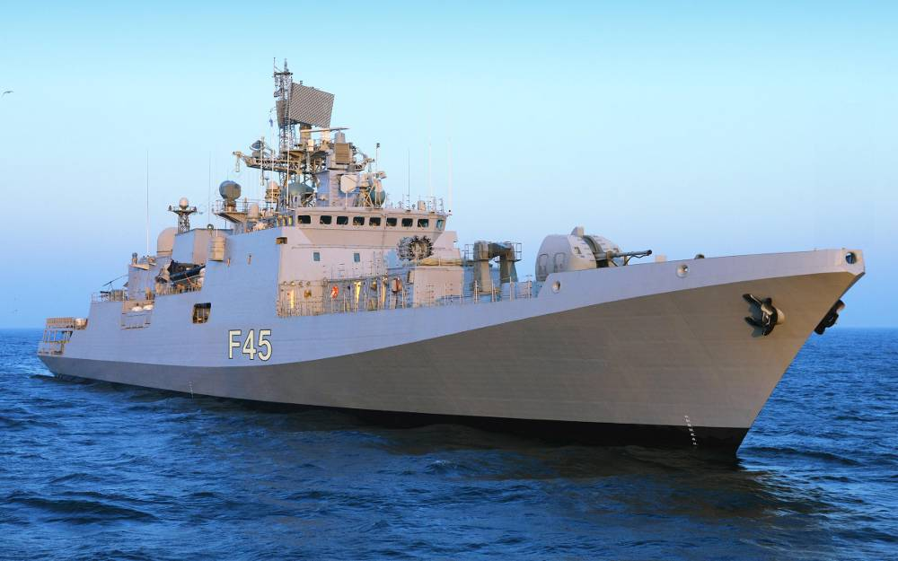

Indian Naval Ship ‘Teg’

INS Teg is a state-of-the-art Guided missile frigate with capacity to carry integral helicopter and is capable of prolonged surveillance missions. This feature makes it uniquely suited for surveillance and anti-piracy patrols at far-flung islands and coastal regions. The ship has a Chetak helicopter embarked and will undertake regular flying in Mauritian EEZ towards the joint EEZ Surveillance and Outer Island Support in conjunction with the Maritime Air Squadron (MAS) of the NCG.
This is the 18th dedicated deployment of an Indian Naval ship for joint EEZ Surveillance since 2009. These committed and custom-made deployments for joint patrol by Indian Navy ships with the NCG, underscore the strong relationship and cherished bonds of friendship between India and Mauritius. INS Teg has been conducting these patrols in coordination with the National Coast Guard of Mauritius to prevent illegal fishing activity and thwart the spread of piracy in the EEZ of Mauritius. With this deployment, the Indian Navy and the National Coast Guard, Mauritius would have undertaken more than 550 days of tailor-made dedicated joint EEZ surveillance which has indeed proven to be a deterrence against piracy and illegal fishing in Mauritian waters.
During the course of the deployment, the ship will be conducting free medical camps for the outer - islanders and also render expert technical assistance for the equipment located on these islands.

The ship is commanded by Captain Anand Sardesai and is scheduled to call at Port Louis from 13 - 16 July and 23 - 26 July 2015.

***

