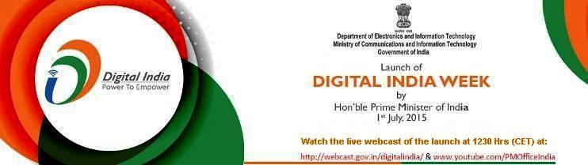
Embassy of India
Belgrade
Press Release

Live Webcast of Launch of Digital India Programme

Embassy of India, Belgrade will arrange live webcast of the launch of Digital India Programme, a flagship programme of Government of India aimed at transforming India into a digitally empowered society and knowledge economy, by Hon'ble Mr. Narendra Modi, Prime Minister of India, on Wednesday 1st July 2015 at 1230 Hrs at the premises of Embassy of India at Djordja Radojlovica 7A, Dedinje, 11040, Belgrade. A Digital India Week has been planned by the Government of India to deliver the message of Digital India to citizens.

Digital India is a programme to prepare India for a knowledge future. The focus is on being transformative, on making technology central to enabling change. The programme is envisioned to provide digital infrastructure as a utility to every citizen of India, governance and service on demand and digital empowerment of citizens. The programme further seeks to provide broadband highways; universal access to mobile connectivity; public internet access programme, e-governance; electronic delivery of services, information for all, electronics manufacturing; IT for jobs and early harvest programmes.

Media persons, think tanks and other prominent persons will have the opportunity to witness the live webcast of the launch of Digital India Programme on television in the premises of Embassy of India at the above given time. For further details, please contact indemb@eunet.rs or visit Embassy's website at http://eoibelgrade.gov.in. The webcast will be available on:

https://webcast.gov.in/digitalindia;
http://pmindiawebcast.nic.in;
https://youtube.com/PMOfficeIndia
Place: Belgrade
Date: June 29, 2015

