International Day of Yoga Celebrations at Gorki Park, Minsk
Sunday, June 21, 2015
The Embassy of India in Minsk, with the support of the Government of the Republic of Belarus, organized the International Day of Yoga (IDoY) in Gorki Park, Minsk on June 21, 2015.
The programme on June 21 started at 0900 hrs in Gorki Park with a welcome speech by Ambassador. His Excellency Mr. Boris V. Svetlov, Minister of Culture of Republic of Belarus, was the chief guest of the event. Ambassador read out the speech on International Day of Yoga by the Hon’ble Prime Minister of India, Shri Narendra Modi, to the audience.
The Surya Namaskar was performed by various Yoga schools between 0900 hrs to 1100 hrs in the huge Gorki Park, spread over the entire park of 6 hectares. Around 10,000 people visited the park and become part of the Yoga Day Celebrations.
The Government of the Republic of Belarus has actively supported this event. A lot of celebrities including Indian film star Mr. Prateek Patil were present.
Few pictures of the event are enclosed.

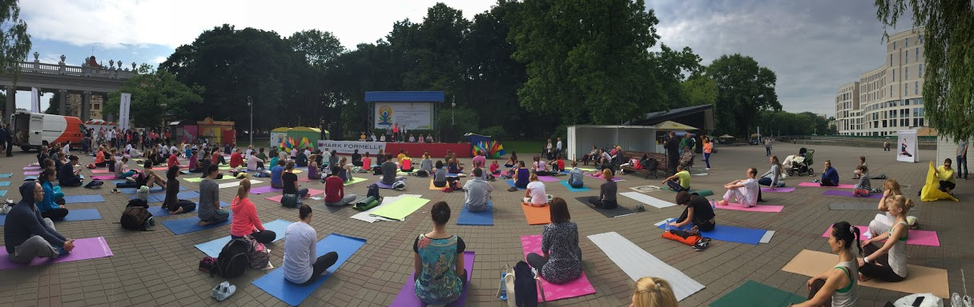
Panoramic view of one of the venues in Gorki Park, Minsk
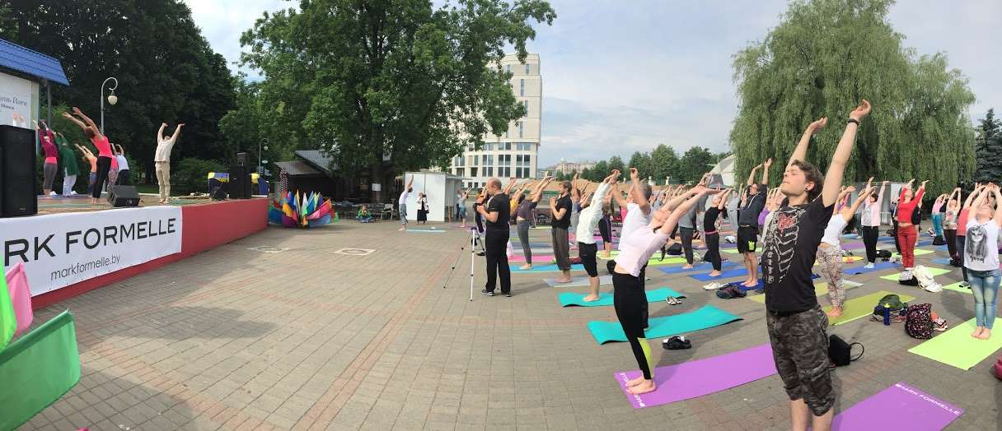
Performing Surya Namashkar

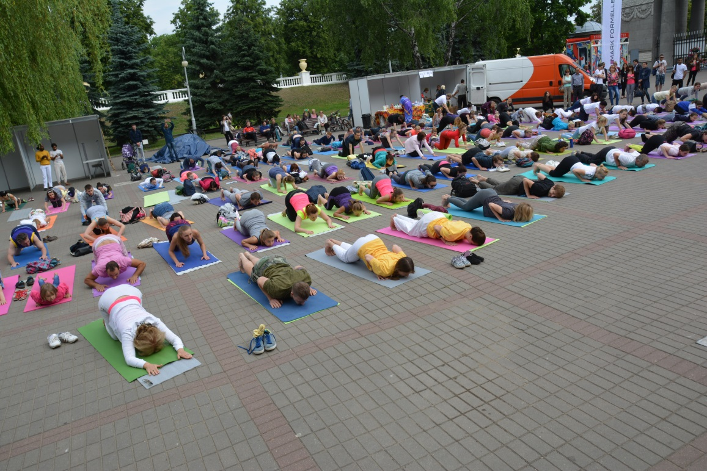
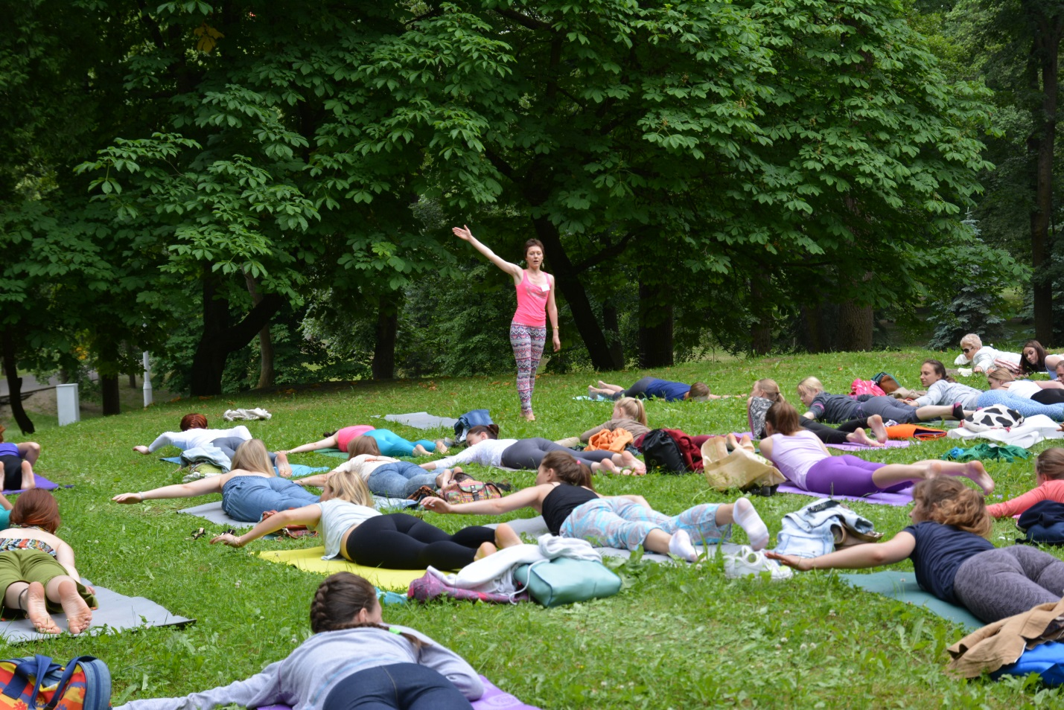
Qualified yoga instructors teaching asanas at different venues in Gorki Park
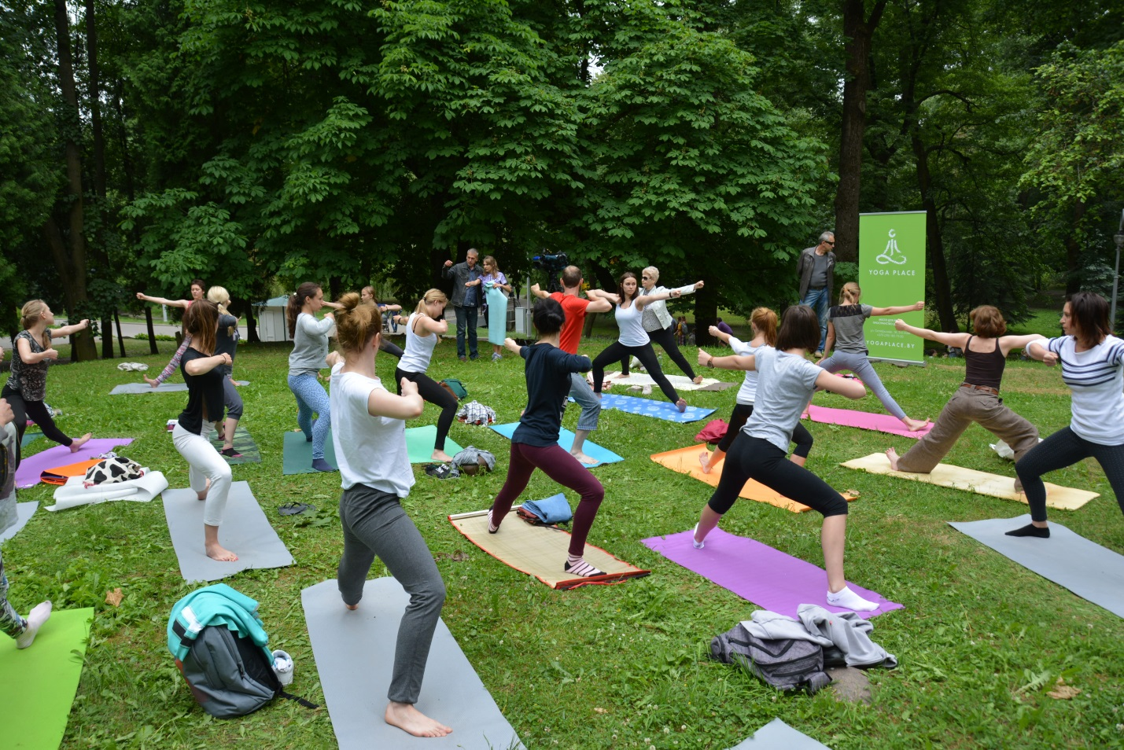

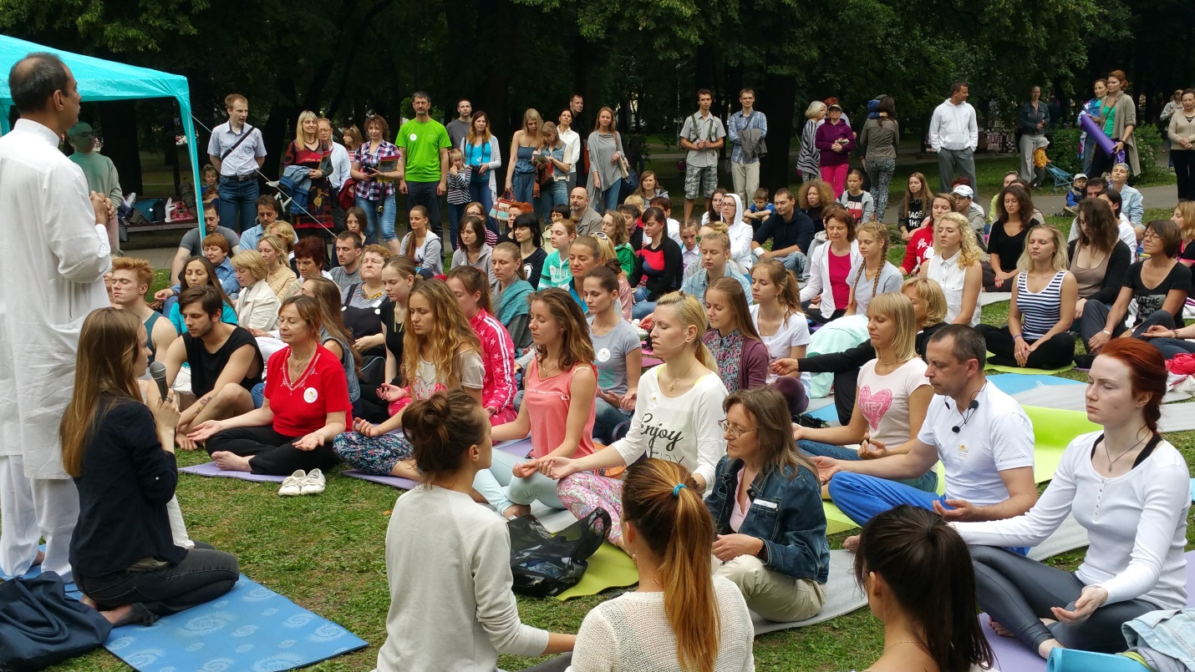
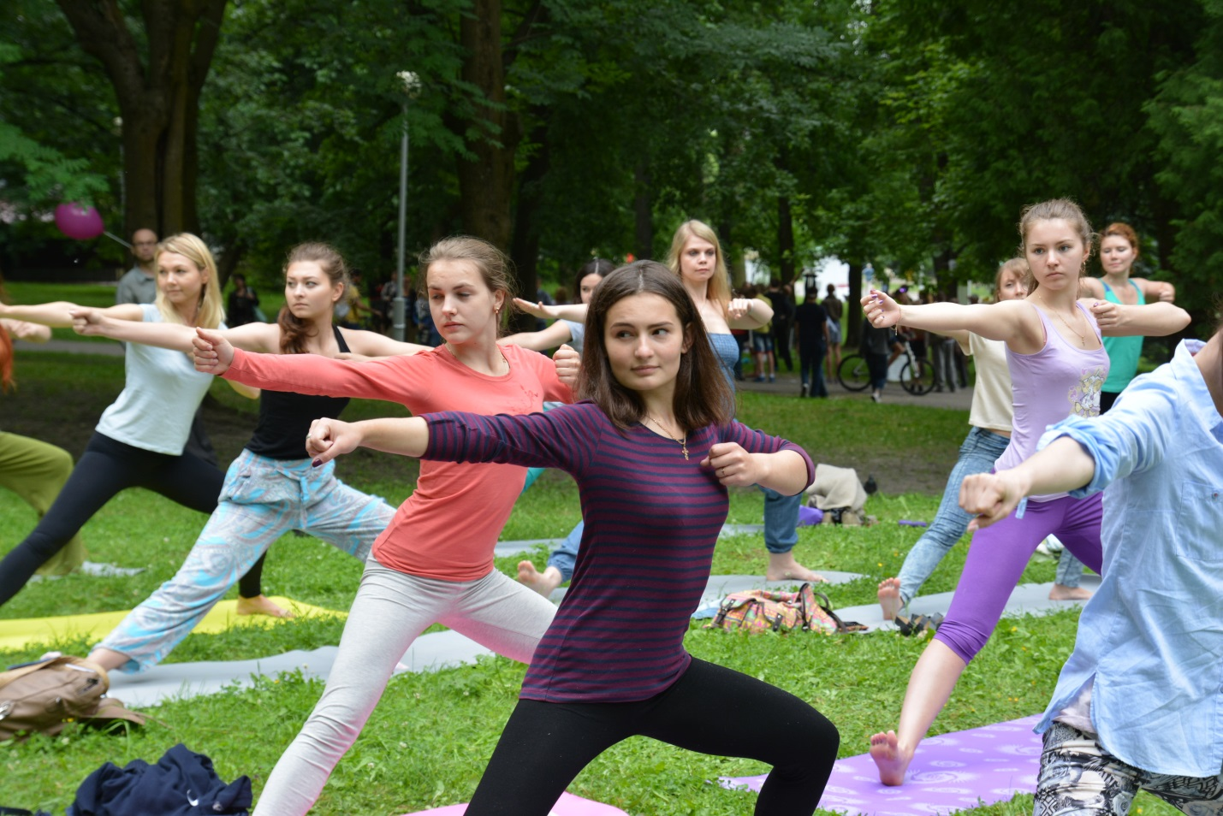
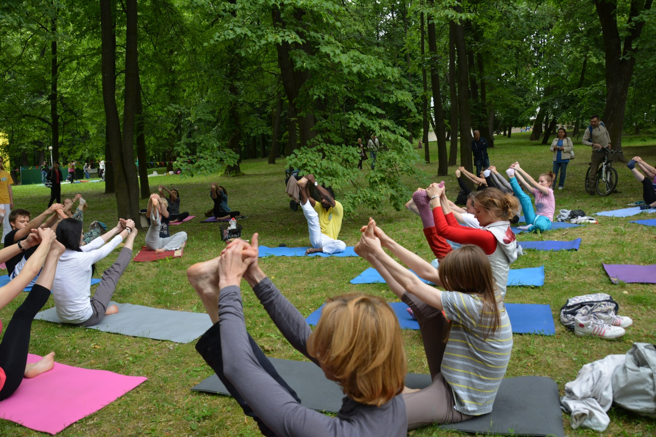
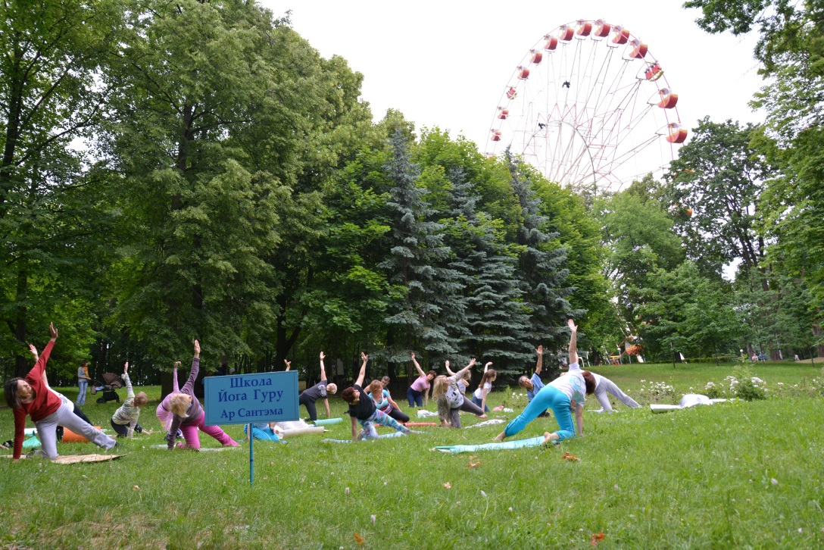
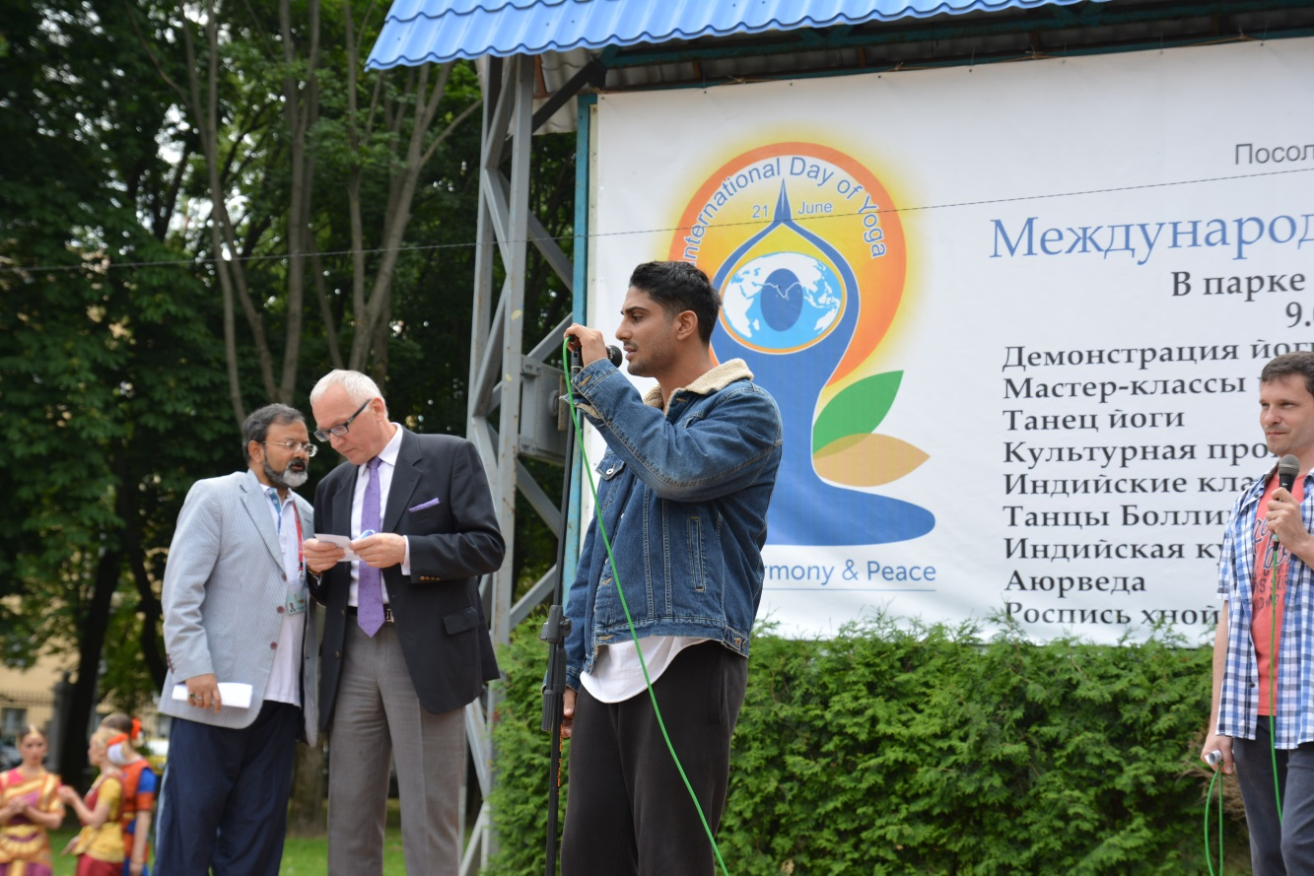
Ambassador with the Minister of Culture, Republic of Belarus. Bollywood Actor, Mr. Prateek Patil addressing the people gathered to celebrate IDoY in Minsk.

