PRESS RELEASE

Visit of the Hon’ble President of India Shri Pranab Mukherjee to the Republic of Belarus from 02 to 04 June, 2015
The Hon’ble President of India Shri Pranab Mukherjee has successfully concluded first-ever State Visit to Republic of Belarus from 02 to 04 June 2015. During the visit, President held bilateral discussions with his Belarusian counterpart, Mr. Alexander Lukashenko, Prime Minister of Belarus, Mr. Andrei Kobyakov. The list of agreements /MOUs in the field of economic, culture and political signed are as under :
List of Agreements signed between India and Belarus during the State Visit of President to Belarus
- Roadmap for India-Belarus Cooperation

- Protocol amending the agreement between the Government of the Republic of India and the Government of the Republic of Belarus for the Avoidance of Double Taxation and the Prevention of Fiscal Evasion with respect to Taxes on Income and on Property (Capital) of the 27th of September, 1997.

- MoU between Bureau of Indian Standards and the State Committee for Standardization of the Republic of Belarus on Cooperation in the field of Standardization and Information Support.

- MoU between Prasar Bharati (PB) and the National State Television and Radio Company of the Republic of Belarus (Belteleradio company) for cooperation on Broadcasting.

- MoU on Bilateral Cooperation between the Securities and Exchange Board of India and the Ministry of Finance of the Republic of Belarus.

- MoU between the Ministry of Textiles of the Republic of India and the Belarusian State concern for Manufacturing and Marketing of Light Industry Goods (concern "Bellegprom”).

The List of Educational MoUs signed during President's State visit of Belarus are as under:-
Belarusian State University – Exchange of MoUs in the presence of President of India
- Memorandum of Understanding between the Indian Institute of Technology Guwahati, India and the Belarusian National Technical University, Belarus in the field of Research Collaborations, Student and Faculty Exchange.

- Memorandum of Understanding between the Indian Institute of Technology Guwahati and the Belarusian State University of Informatics And Radio-electronics in the Field of Research Collaborations, Student and Faculty Exchange.

- Memorandum of Understanding between Indira Gandhi National Tribal University, Amarkantak, India and the Belarusian State University of Culture and Arts of Belarus for Development of Academic Cooperation in the Field of Research & Education, Twinning and Dual Degree Programs as per UGC.

- Memorandum of Understanding between Indira Gandhi National Tribal University, Amarkantak, India and the Belarusian State University of Informatics and Radioelectronics, Minsk, Belarus for Academic and Scientific Cooperation.

- Memorandum of Understanding between Indira Gandhi National Tribal University, Republic of India and the Belarusian State University Of Physical Culture, Republic of Belarus.

- Memorandum of Understanding between Visvesvaraya National Institute of Technology (VNIT), Nagpur, India and the Belarusian State University of Informatics and Radio-electronics, Belarus in the field of Engineering and Technology.

- Memorandum of Understanding between Visvesvaraya National Institute of Technology (VNIT), Nagpur, India and the Belarusian National Technical University, Belarus in the field of Engineering and Technology.

The President has also made an announcement that the Government of India had decided to extend line of credit for 100 million USD for jointly agreed projects. He also announced the decision of the Government of India to grant Market Economy Status to Belarus.
During the visit, a degree of Professor Honoris Causa was conferred upon the President by the Belarusian State University. He also inaugurated a bust of Mahatma Gandhi in the campus of the Belarus State University. The Grodno Power project completed by BHEL was jointly inaugurated by the two Presidents at the Business Forum. Nine business agreements were signed during the Business Forum.
Picture summary of the visit
The President of India, Shri Pranab Mukherjee with the President of Belarus, Mr. Alexander Lukashenko.
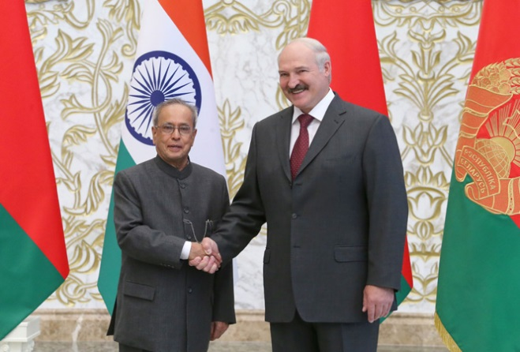
President at the luncheon Banquet hosted by Alexander Lukashenko, President of Belarus at the Place of Independence, Minsk
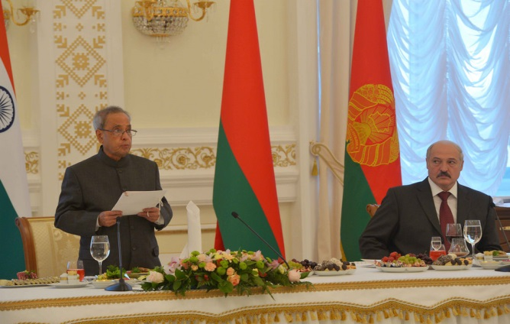
President being conferred a degree of professor Honoris Causa at Belarusian State University, Prof. Sergey V. Ablameyko, Rector of Belarusian State University and Mr. Zhuravkov Mikhail, Minister of Education of Republic of Belarus also present (03-06-15)
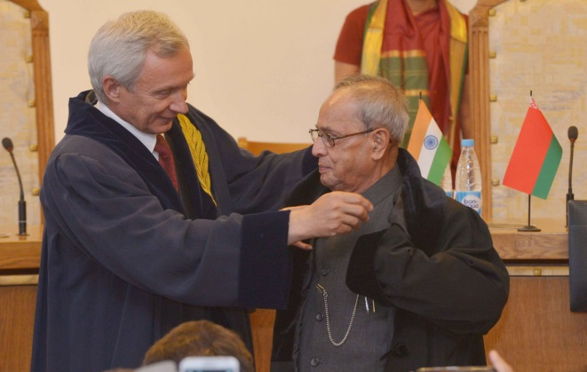
India-Belarusian Business Forum
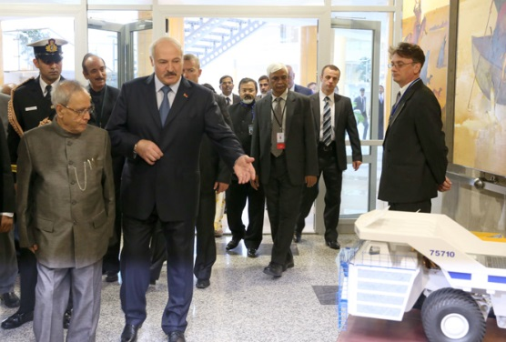

President meeting with the Prime Minister of Belarus Mr. Andrei Kobyakov, 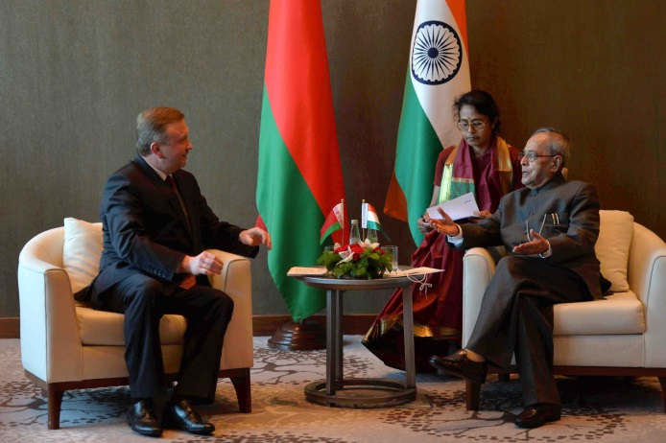
On 3 June, President Shri Pranab Mukherjee planted a tree in the Alley of Honorary Guests near the Palace of Independence.
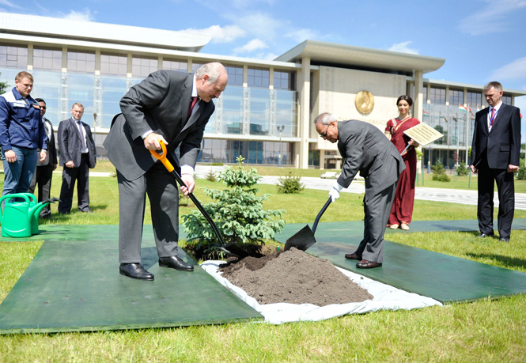
President unveiling of a bust of Mahatma Gandhi at Belarusian State University, Prof. Sergey V. Ablameyko, Rector of Belarusian State University and Mr. Zhuravkov Mikhail, Minister of Education of Republic of Belarus also present (June 03, 2015).
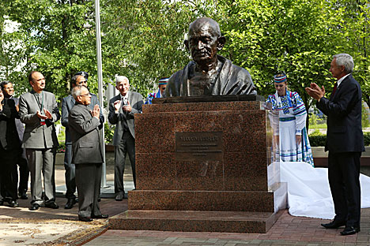
Wreath laying ceremony
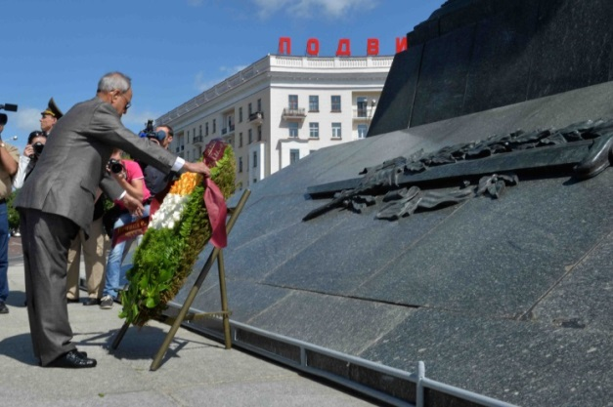
More pictures of the visit can also be seen at https://www.flickr.com/photos/meaindia/sets/72157653525821618

