Photo exhibition on Yoga held in Tbilisi (Georgia) on 2nd June 2015
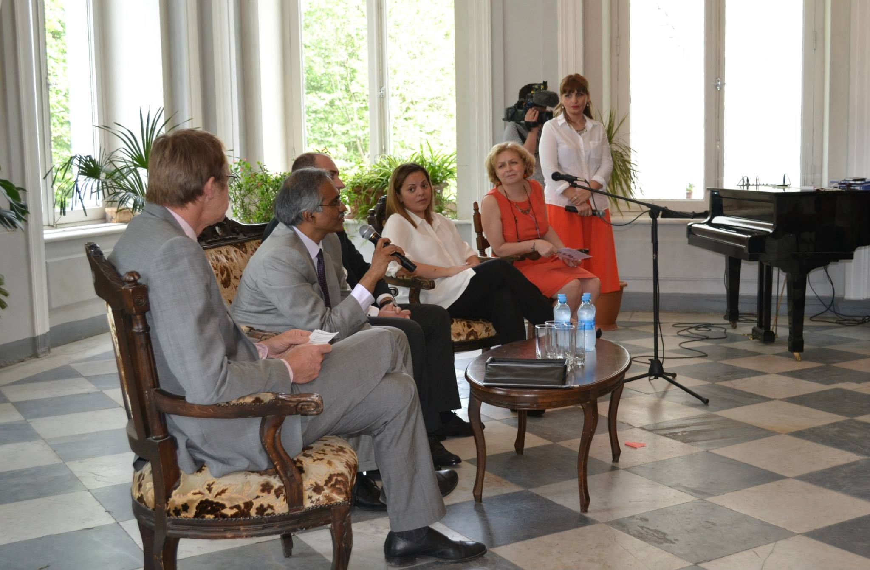
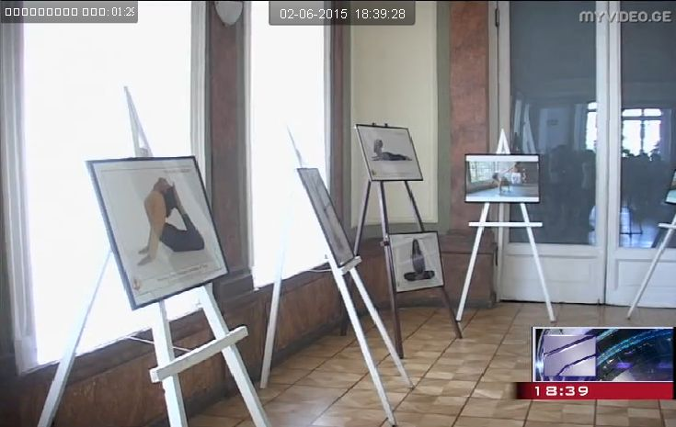
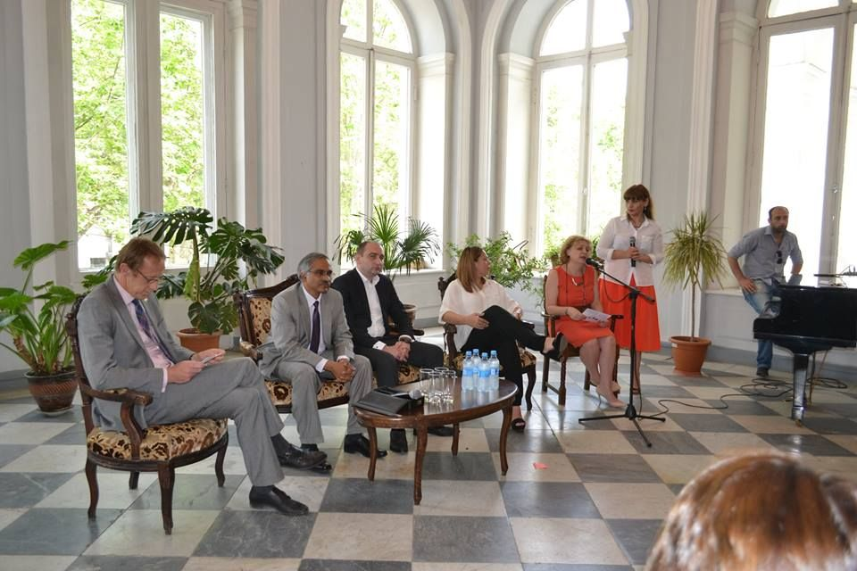

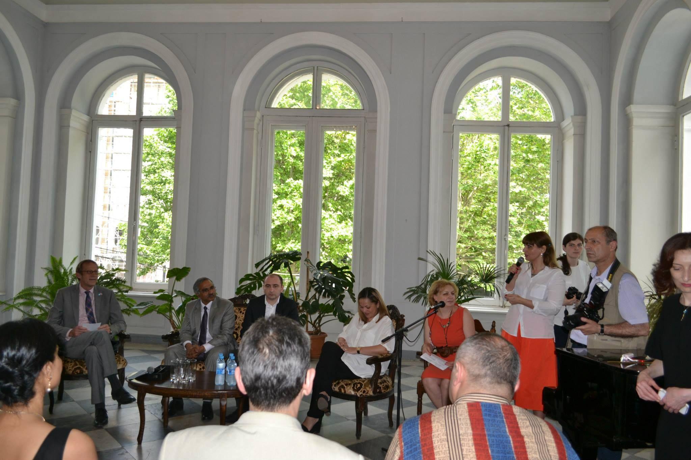
Activities in Georgia:
(i) In March, 2015, the Mission started preparations for the event by establishing contacts with all yoga centers operating in Yerevan; briefed them about the significance of the Yoga and adoption of the UN Resolution to declare 21 June, 2015 as the International Yoga Day and celebration of IYD on 21 June, 2015. Subsequently, HOM also discussed the IYD event with UN Representative and Deputy Mayor & Mayor of Tbilisi and sought their cooperation for logistic support.
(ii) Mission has involved the leading in Georgia yoga centre “Ananda Yoga Centre” which has offered assistance and coordination for organizing the events in Georgia.
(iii) Yoga Photo exhibition has been inaugurated on 2 June by HOM, Deputy Mayor and UN Representative which was followed with a media briefing by them (links and photos have been uploaded in the Fb account of the Embassy and sent to the Ministry yeserday). Mission is in regular touch with other local yoga organizations in Georgia which will also actively participate by encouraging their students/clients in the main event.
(iv) 200 T-Shirts with official IDY logo will be distributed free of cost in Georgia on 21 June to participants.
(v) Flyers and posters will be printed for the distribution in the Yerevan along with printing of posters and banners for effective publicity in the prominent places in the Yerevan city. Video clips on the event will be shown on giant electronic tabloos located in central parts of the city prior to the event.
(vi) A live demo of Yoga asanas along with a short talk show on local TV channels was done by HOM on 3 June 2015.
B. Time of Celebration: - 1630 hrs onwards on 21 June, 2015;
C. Venue: - Rikhe Park, Tbilisi
D. Participation: - Entry is free for all interested participants. We expect larger participants including representatives of diplomatic missions and government dignitaries.
E. Photos and Posters: - Yoga photos for exhibition, publicity material (video/digital/hard copies/banners/fliers) and social media will be used for the purpose.

