Ambassador’s Remarks at the Event on ‘Meet the Nehru-Wangchuk Scholars’ at NWCC Conference Hall, Thimphu [ 27th April 2015 ]

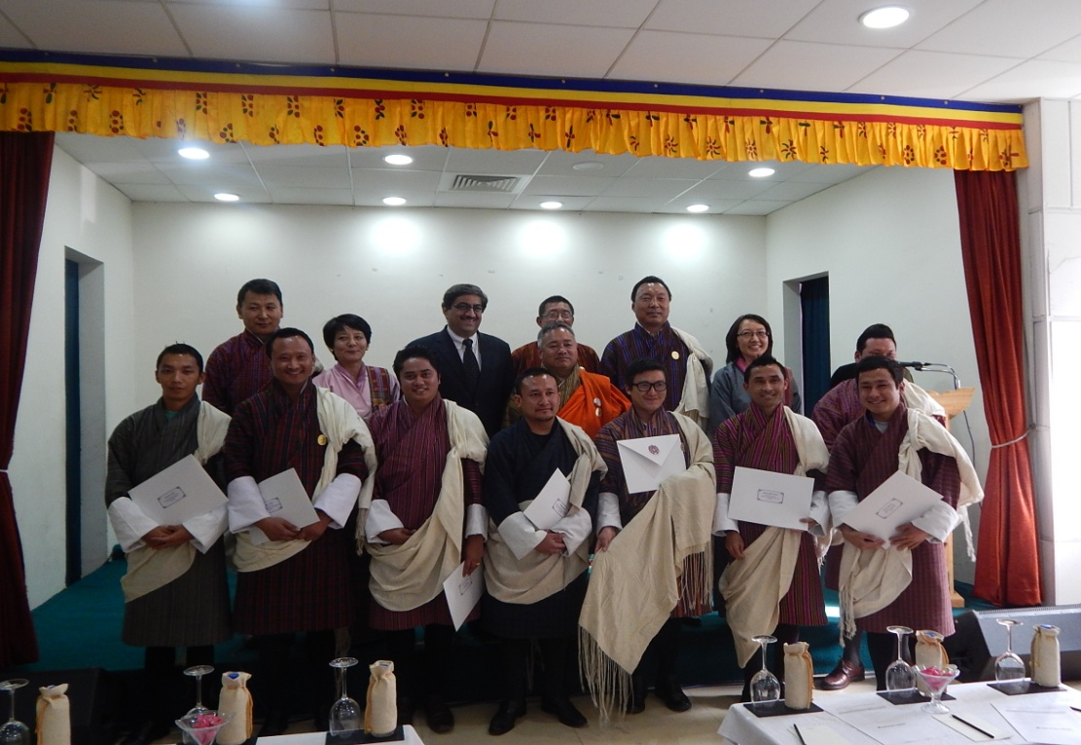

Hon’ble Lyonpo,
Dashos,
Ladies and Gentlemen,
Representatives of the Media
I extend a very warm welcome to all of you. Thank you for being with us this afternoon to ‘Meet the Scholars’ of the prestigious Nehru-Wangchuck Scholarship Scheme of the Government of India.

2. Let me begin by saying that over the past six months, the Embassy of India to Bhutan and the Royal Civil Service Commission have been working extremely hard to ensure that the Nehru-Wangchuck Scholarship Scheme lives up to its objective of being the premier Government of India Scholarship for Bhutanese students. As you know, this Scholarship is for post-graduate study in India. It aims at choosing the most outstanding Bhutanese students and placing them in premier educational institutions in India.

3. For the new academic year which will commence in June, 2015 we have chosen 8 Nehru-Wangchuck Scholars who are sitting here in front of us all. We have taken some measures to increase the attractiveness of this Scholarship. First, we have raised the monthly stipend to Rs. 50,000/- per month. Second, we have newly instituted the Nehru-Wangchuck Alumni Association of which all Nehru-Wangchuck Scholars will be automatic members. The Embassy of India to Bhutan and the Royal Government of Bhutan will remain connected with past and present Nehru-Wangchuck Scholars through this Association. Third, and most importantly we have worked extremely hard in obtaining admission for these 8 scholars to some of the best educational institutions in India. Mr. Prakash Gautam who will be studying M.Tech in Civil and Construction Engineering has secured admission to the prestigious Indian Institute of Technology, Gandhinagar. It is after eight or nine years that a Bhutanese student has been admitted to an Indian Institute of Technology. Let me congratulate Mr. Gautam on his achievement and wish him the very best for his studies. Those of you who may wish to interview him could do so after the formal part of this Press interaction is complete. Similarly, we have one of our scholars who will be studying engineering at VIT in South India or what was earlier known as the Vellore Institute of Technology. Two of the scholars will be proceeding for management studies to the prestigious Symbiosis International University at Pune in Western India. One Scholar has received admission from the National Institute of Tourism and Hospitality Management at Hyderabad. All 8 scholars have been admitted to well-known and prestigious institutions of education in India.

4. This satisfactory outcome has been made possible because of hard work and effort from many people. First, I would like to congratulate all 8 Nehru-Wangchuck Scholars for their dedication and industry. I would also like to thank the Royal Civil Service Commission and the Ministry of Labour and Human Resource for their efforts. Hon’ble Lyonpo, Neema Sangay Tshempo has always been a source of support and strength in this endeavour. The Chairman of the Royal Civil Service Commission has stood by us rock-steady in this effort. I would, personally, like to thank Madam Karma Hamu Dorjee, Commissioner of the Royal Civil Service Commission who has led the current effort. I also want to thank my colleagues at the Embassy who have worked very hard indeed, especially, Deputy Chief of Mission, Mr. Bishwadip Dey.

5. Ladies and Gentlemen, our goal of ensuring that the Nehru-Wangchuck Scholarship Scheme becomes the most prestigious Government of India Scholarship for Bhutanese citizens is not a one time effort but will continue in the coming years and will become the rule. I am very confident that in the years ahead, the Nehru-Wangchuck Scholarship Scheme will indeed become one of the most sought after scholarships at the post-graduate level for Bhutanese candidates.

6. Thank you for being with us this afternoon.

