Embassy of India
Panama

31st March, 2015

The Bridge of Friendship- ITEC Day Celebrated In Panama
Celebrating the 50th Anniversary of the Indian Technical and Economic Co-operation ( ITEC) at India House on 30th March, 2015, there was a wide gathering of Panamanian professionals, including professors of Science and English, architects, Information Technology engineers and media persons, etc. They were all ITEC alumni. The event was also graced by local dignitaries and senior bureaucrats from the government of Panama. Ambassador Shamma Jain addressed the gathering and mentioned that the event would be centred around the narration of anecdotes, by the ITEC alumni, of their India experience. Dr. Jorge A. Motta, the National Secretary of SENACYT (The National Secretariat of Science, Technology and Innovation of Panama) was present on the occasion.
The ITEC alumni, some of whom have visited India under ITEC scholarships during the last 15 years, were invited to share their experience of training and stay in India. In their reminiscences, they commended the level of professionalism of their Indian mentors. They said that their experience in India was also spiritually stimulating and that they made “ not friends, but brothers” in India. The training also helped them network with other ITEC scholars from diverse countries like The Phillipines, Kenya, Kazakhstan, Vietnam and Central and South America etc. Dr Motta listened to the alumni with great interest and said that their accounts were an “eye opener” for him.
The cuisine at India House brought back for them, fond memories of India. While some trainees had found the food in India rather spicy, the others quite relished it.
It was evident that the ITEC scholarships for short to medium term courses, fully paid for by the government of India have given India many Panamanian friends and “ brothers”. The bridge of friendship between India and Panama has been further strengthened by such amity.

(To learn more about the ITEC programme, please visit www.itec.mea.gov.in/ )

*****

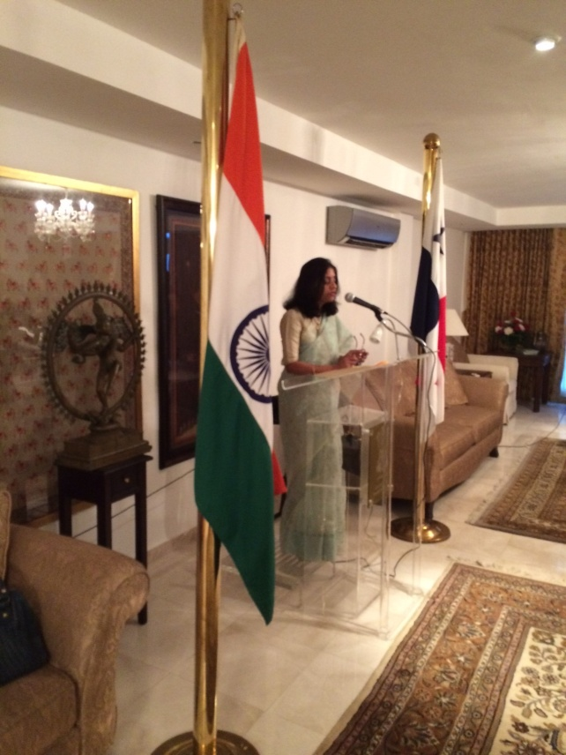
Ambassador Speaking on the Occasion Of the 50th Anniversary of ITEC celebrations.
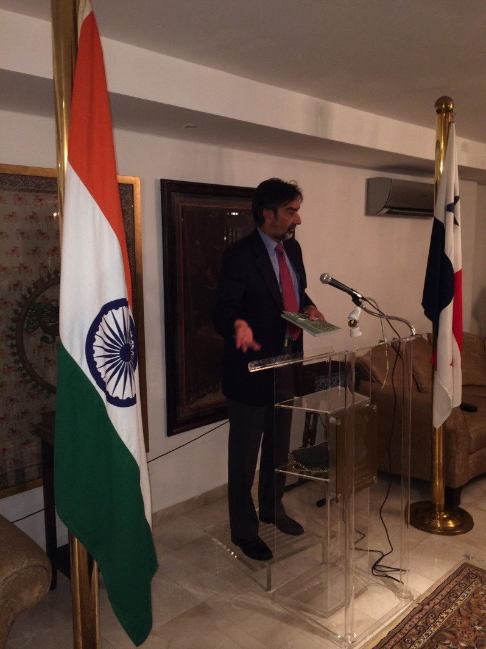
Dr Motta listened to the alumni on the occasion and said that their accounts were an “eye opener” for him.

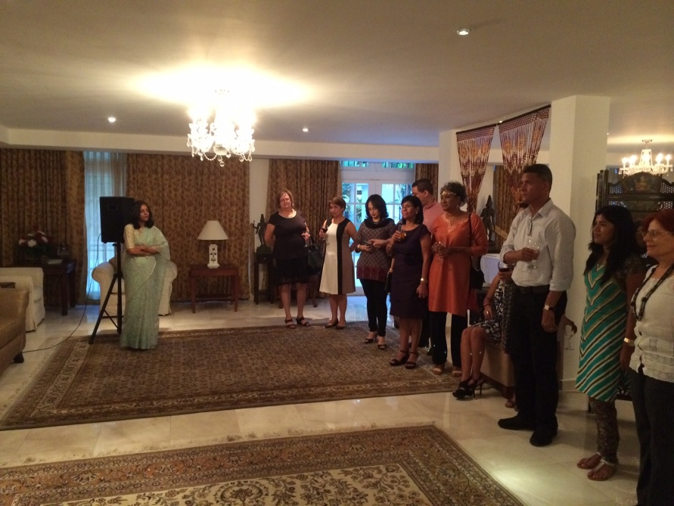
Ambassador interacting with the Panamanian ITEC alumni.

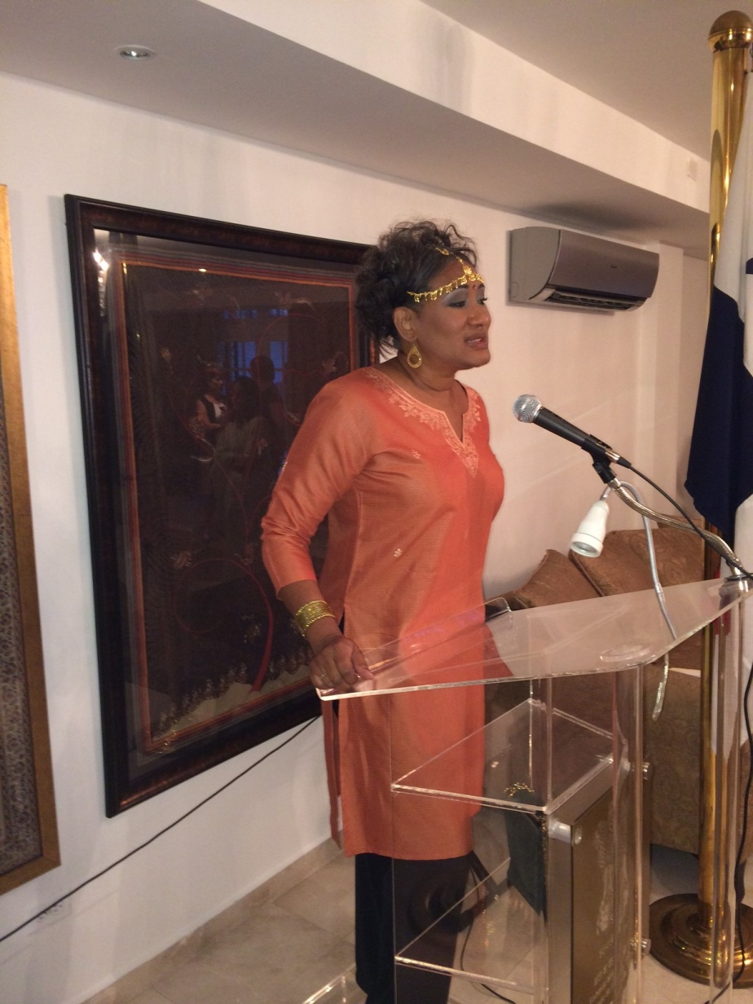
An ITEC alumnus speaking of her India experience.
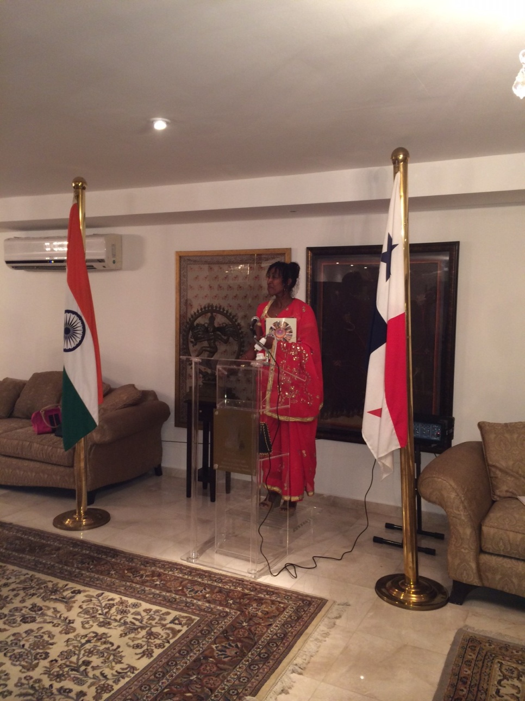
An ITEC alumnus speaking of her India experience.

