Winners of "India is in my Imaginations" to visit India
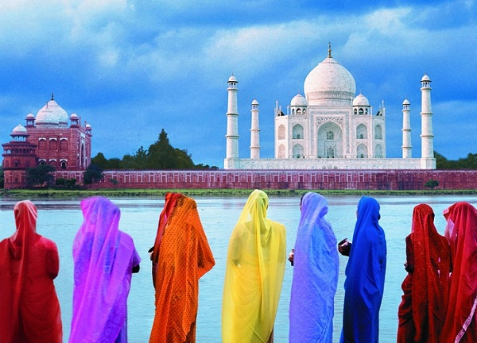
YEREVAN, MARCH 13, ARMENPRESS. The Embassy of India in Armenia in collaboration with the Ministry of Education and Science of the Republic of Armenia and TUMO Center for Creative Technologies conducted All-Armenia Painting and Essay Competition "India is in my imaginations" among the schoolchildren of Armenia among two age groups in December 2014. This first ever event has encouraged over 1500 children to participate in this competition and create their own image of India. The second, third and consolation prize winners received their certificates and prizes during the Reception dedicated to the 66th Republic Day of India on 26 January, while the first prize winners had to hold their breath in joy, as the first prize was a one wee k trip to India. The Embassy of India to the Republic of Armenia informed "Armenpress" about this.
"Today, the Embassy is glad to announce that all the four children, who have won the first prize, will be enjoying their spring vacation in India from 16-24 March 2015. Their programme includes visit to Delhi, Agra and Jaipur, known as "Golden Triangle" in tourism world. They will also get an opportunity to tour in Rashtrapati Bhavan (official Residence of the President of India) during their stay in Delhi. The visit of the Armenian children is sponsored by the Ministry of Tourism of the Government of India,' said the statement.
http://armenpress.am/eng/news/797587/

