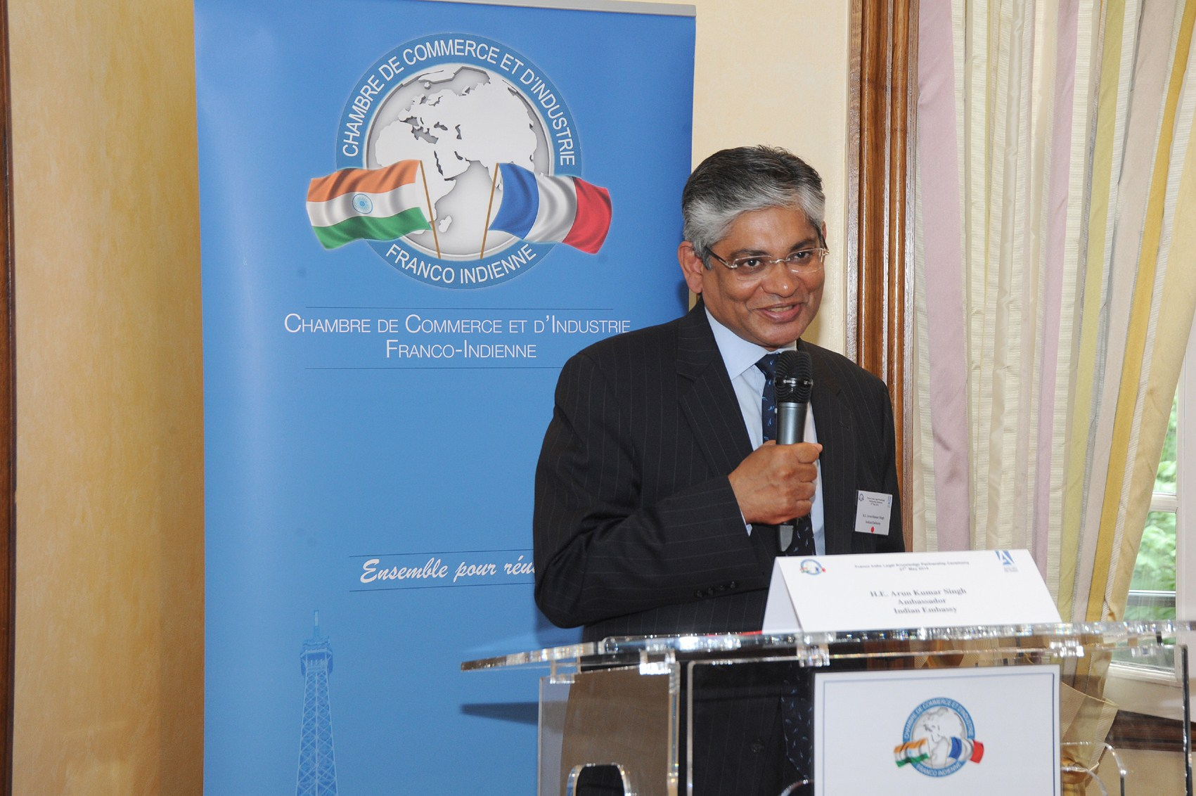

Ambassador Arun K. Singh delivered the keynote address at the event held in the historic Paris Bar building on 27 may 2014 to mark the signing of signing of Memorandums of Understanding between EFB Paris Bar School and National Law University Delhi and between the Paris Bar Association and the Society of Indian Law Firms, as part of the efforts to create an India-France Legal Knowledge Partnership. Mr. Pierre Olivier Sur, President of Paris Bar Association, Dr. Ranbir Singh, Vice-Chancellor of National Law University, Delhi, Mr. Jean-Louis Scaringella, Director, EFB Paris Bar School, Ms. Manjula Chawla, Vice-President of the Society of Indian Law Firms, Mr. Laurent Martinet, Vice-President of the Paris Bar Association and Mr. Dan Oiknine, Chairman, CCIFI were also present for the event. The two MoU’s provide for exchange of law students between India and France to develop a better understanding of each other’s legal systems.
Addressing the meeting, the Ambassador underlined the need for encouraging greater exchange of students between India and France in all fields, including the legal field to deepen the strategic relations between the two countries.

