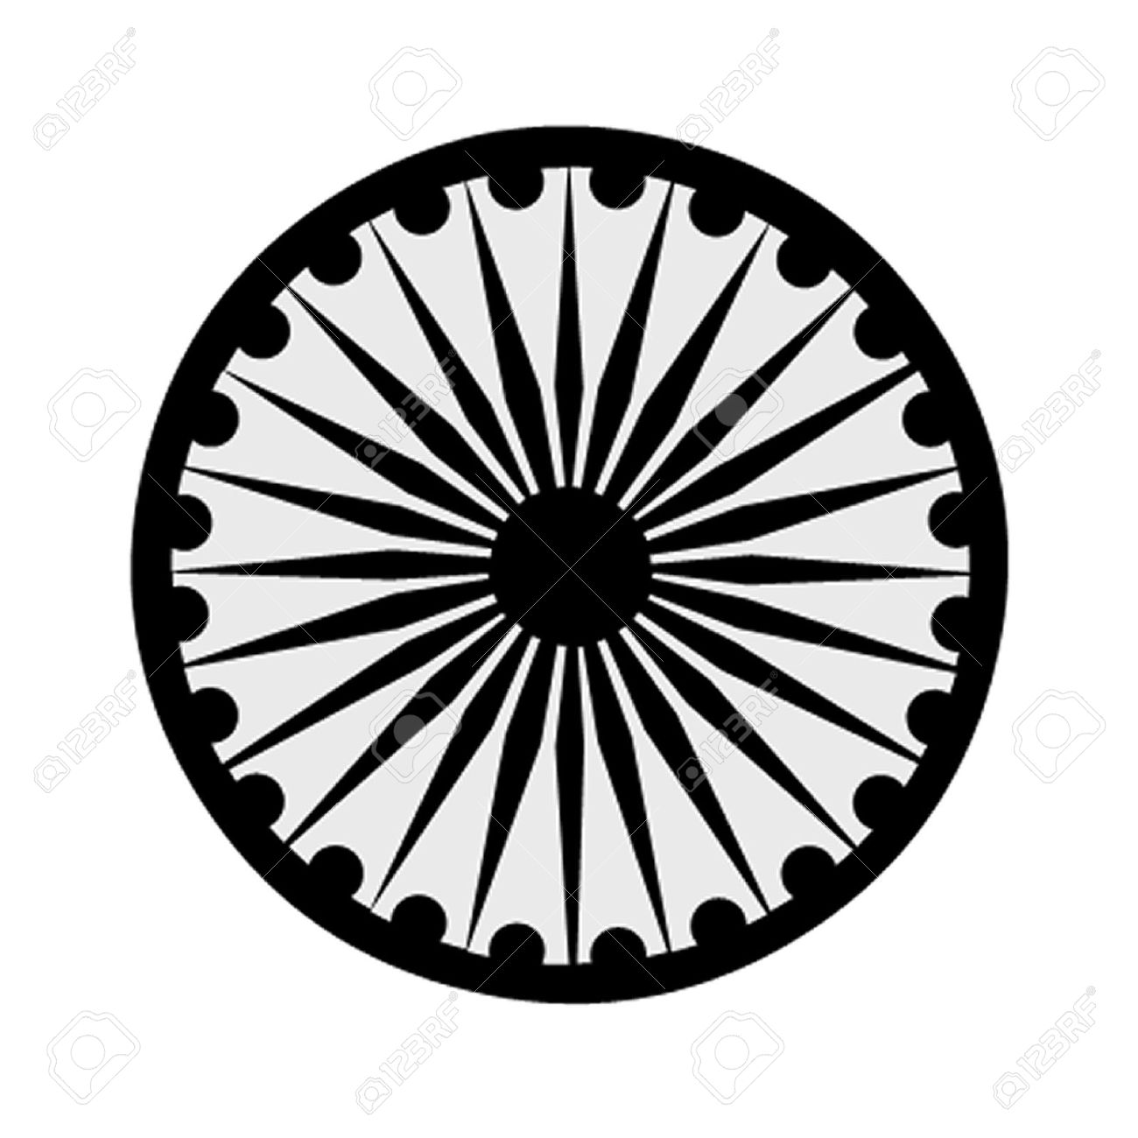 | HIGH COMMISSION OF INDIA, BRUNEI DARUSSALAM  P.O. BOX 439, LAPANGAN TERBANG LAMA  BANDAR SERI BEGAWAN BB 2339685  Telephone: 2339947 / 2339685  Fax: 2339783  E-mail: hoc.brunei@mea.gov.in  Website: www.hcindiabrunei.gov.in

Press Release No. 02/2024

PRESS RELEASE

World Hindi Day; Brunei Darussalam

The World Hindi Day, 2024 was celebrated in Brunei Darussalam on 22 February, 2024.

2. Jointly co-hosted by the the High Commission of India, alongwith the Seri Mulia Sarjana International School, Brunei, the occasion was witnessed by nearly hundred and fifty attendees comprising of students, faculty and representation from academic, scholarship, and the Indian diaspora.

3. High Commissioner of India H.E. Ambassador Alok A. Dimri, read Prime Minister Shri Narendra Modiji’s message to the nation on this occasion. H.E. thanked Sarjana School for co-hosting the event and for their contributions in the fields of education and youth.

4. H.E. Ambassador Alok A. Dimri encouraged the students and youth to expand their linguistic horizons by exploring classic languages including Sanskrit and Hindi.

5. A Hindi-Malay Quiz Competition, poem recitals, and cultural performances by school children were other highlights of the event. A dictionary of Hindi-Malay words of common origin was also mooted on the occasion.

Appreciation-gifts and refreshments were organized on the occasion.

****

22 February, 2024
Brunei Darussalam

