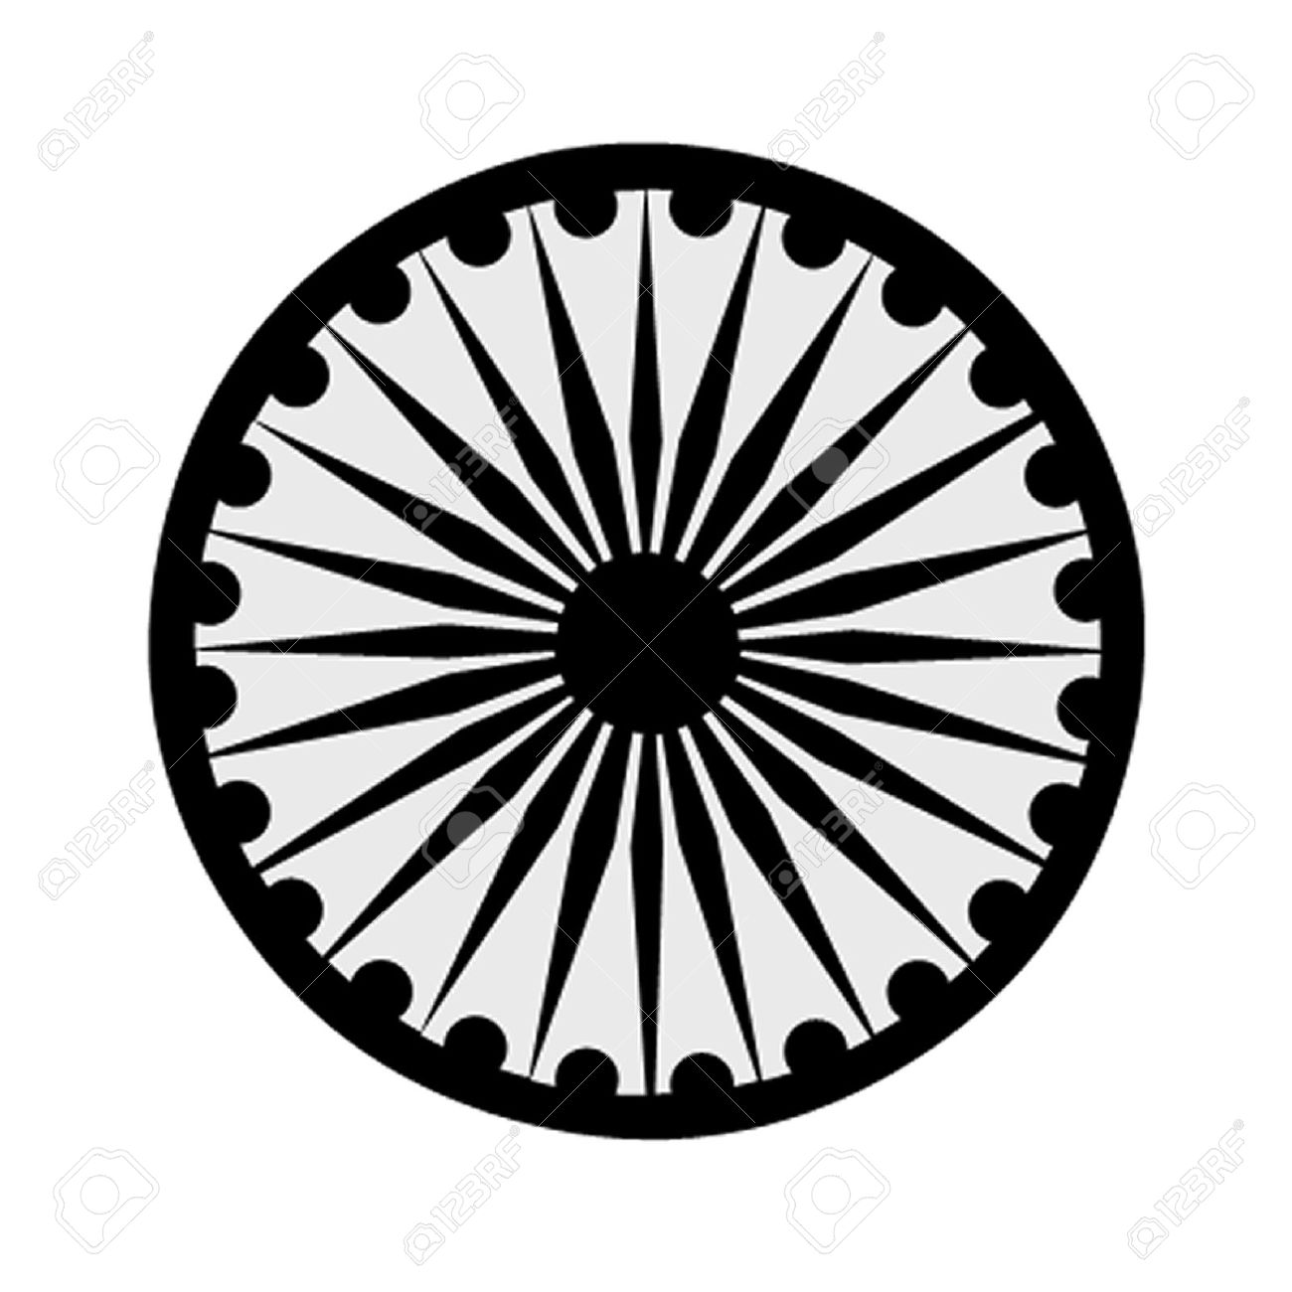 | HIGH COMMISSION OF INDIA, BRUNEI DARUSSALAM  P.O. BOX 439, LAPANGAN TERBANG LAMA  BANDAR SERI BEGAWAN BB 2339685  Telephone: 2339947 / 2339685  Fax: 2339783  E-mail: hoc.brunei@mea.gov.in  Website: www.hcindiabrunei.gov.in

Press Release No. 08/2024

PRESS RELEASE

10th International Day of Ioga (IDY)-2024

The tenth International Day of Yoga, #IDY-2024, was celebrated in Brunei Darussalam on Sunday, 23rd June, 2024 at the “India House”, the official Residence of the High Commissioner of India; “Yoga for Self and Society” being the theme for the
year.

2. High Commissioner, H.E. Alok A. Dimri welcomed the participants and shared the significance of the IDY. International Day of Yoga is being celebrated every year since 21 June, 2015 as part of Prime Minister Shri Narendra Modiji’s global commitment to universal physical & mental health of the humanity, with the practice of yoga. He also stated that Yoga is for everyone, young and old, and is a way towards healthy life. He stressed on Yoga's potential to provide both health and happiness by improving the physical and mental well-being of people.

3. Members of the community, youths, yoga-enthusiasts, practitioners and Friends of India, and the Diplomatic Corps participated in the Yoga practice on the occasion. A live Yoga session was conducted by Mr. Bramhanand Tichkule, an avid-practitioner in Brunei.

Light Indian refreshments were served at the occasion.

****

23 June, 2024
Brunei Darussalam

