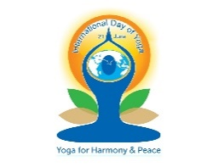  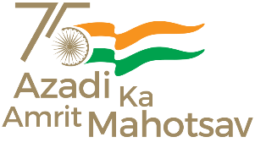

**High Commission of India**

**Suva**

**Press Release**

**International Day of Yoga 2023**

**(21 June 2023)**

As part of the ongoing 'Azadi Ka Amrit Mahotsav', to mark 75 years of Indian Independence, the High Commission of India (HCI) in Suva and the Swami Vivekananda Cultural Centre (SVCC) celebrated the 9th International Day of Yoga (IDY) on 21 June 2023 (Wednesday) with Yoga demonstration at the iconic Grand Pacific Hotel (GPH) in Suva.

The theme for IDY 2023 is “Yoga for Vasudhaiva Kutumbakam” which means 'Yoga for the Welfare of All as One World-One Family.’ The theme embodies the essence of Yoga, which connects and unites everyone.

In her speech, Acting High Commissioner Mrs. Neerupma S. Kararha highlighted the various benefits of Yoga, some of which include increased flexibility, physical strength, and improved cardio and circulatory health. She also emphasized on the importance of Yoga and encouraged guests to incorporate some form of yoga in their daily lives.

The IDY Event at GPH Suva was attended by more than 100 Yoga enthusiasts including senior dignitaries, members of the diplomatic corps, Government officials, members of Indian diaspora organizations and prominent members of business community.

In the spirit of Vasudhaiva Kutumbakam, IDY celebrations is also being held in three other Pacific Island countries under the Mission’s jurisdiction. On 17 June 2023, the first IDY celebration was held in the beautiful island of Funafuti, Tuvalu in collaboration with Tuvalu Ministry of Local Government and Agriculture. Today, on 21 June 2023, Kiribati is also celebrating IDY in the nation’s capital of Tarawa followed by the Kingdom of Tonga on 24 June 2023. In Fiji, a pre-IDY session was held in Seaqaqa, Labasa with a large number of yoga enthusiasts in attendance. IDY celebration will also be held in Lautoka on 25 June 2023.

______________________________________________________________________

21 June 2023

Suva